Baltimore LHMP 2023-2028: VTrans Transportation Flood Resilience Planning Tool (TRPT)
Link to online tool: https://roadfloodresilience.vermont.gov/#/map
Additional info: https://vtrans.vermont.gov/planning/transportation-resilience
Road segment resilience is rated Low, Medium, or High; rating is based on criticality and vulnerability

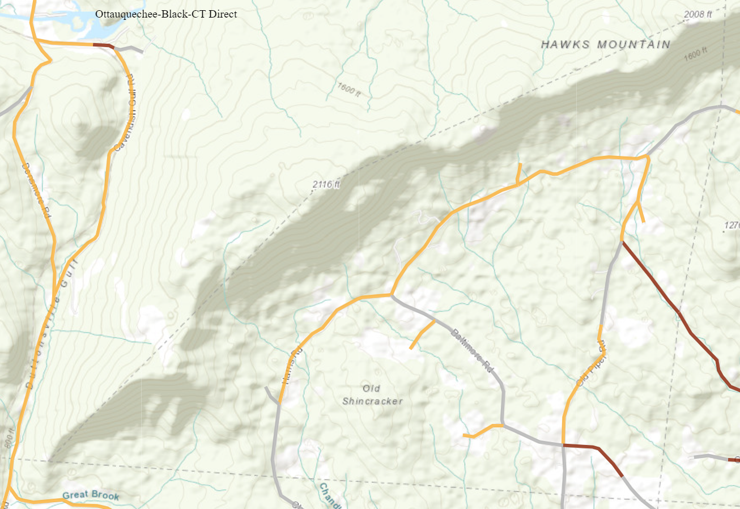
Roads:

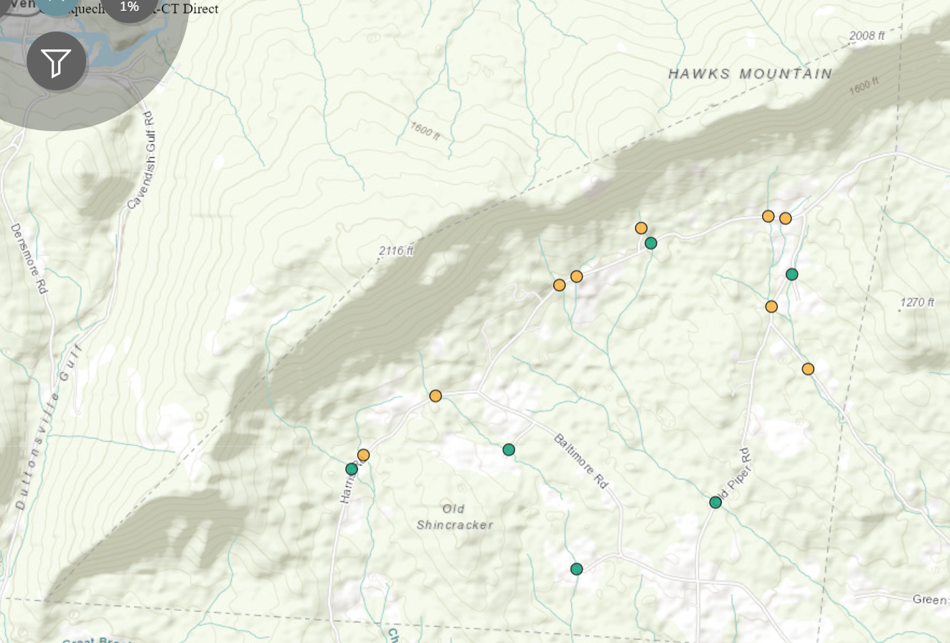
Culverts:

