Baltimore LHMP 2023-2028: Municipal Roads General Permit – Road Erosion Inventory
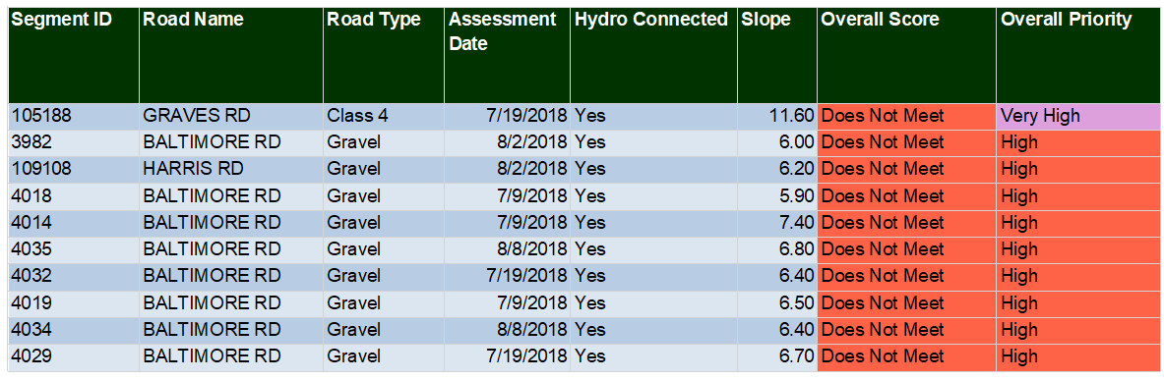

Notes:

