Baltimore Town Plan
DRAFT: January 24, 2024
Adopted:

Effective:
Planning Commission Public Hearings – Selectboard Public Hearings –

Table of Contents
Section I. Introduction 2
A. Purpose of the Town Plan 2
B. Town Plan Process 3
Section II. Community Profile 4
A. Background Information and History 4
B. Population 4
C. Economy 6
Section III. Housing 8
Section IV. Energy 11
A. Solar Electricity and Transmission Siting 13
Section V. Utilities and Facilities 17
Section VI. Transportation 20
Section VII. Education 21
Section VIII. Emergency Preparedness 22
Section IX. Community Health 23
Section X. Natural and Cultural Resources 25
A. Water Resources 25
B. Forest and Wildlife Habitat 26
C. Agriculture 26
D. Earth and Mineral Resources 27
E. Outdoor Recreation 27
F. Historic Resources 27
G. Scenic Resources 27
Section XI. Land Use Planning 30
A. Existing Land Use 30
B. Future Land Use 30
Section XII. Flood Resilience 34
Section XIII. Plan Implementation and Relationship to Other Plans 36
A. Plan Implementation 36
B. Relationship to Local and Regional Plans 37

Section I. Introduction

Purpose of the Town Plan
It is the intent of this document to plan a course that will benefit the people of the Town of Baltimore and its future generations by encouraging actions that are in the town’s best interest. Vermont law 24 VSA Chapter 117 (the Vermont Municipal and Regional Planning and Development Act) enables any municipality in the state to “prepare, maintain, and implement a plan within its jurisdiction.”
The Baltimore Town Plan seeks to:
- Clearly define a vision for future growth and development in Baltimore
- Recommend actions to be taken to secure this vision
- Guide those interested in subdividing and developing land
- Provide a basis for town regulations and standards for Act 250 and Section 248 review
- Provide a source of information about the town
- Provide policies and guidelines for the local, regional, and state decision-makers
The Town of Baltimore is committed to creating a culture of inclusion and access for all our citizens, businesses, and visitors. We will strive and work together to enact inclusive policies, build stronger community relationships, improve business opportunities, especially for historically disadvantaged and vulnerable communities.
The Town of Baltimore would also like to acknowledge the traditional, ancestral territory of the Abenaki ethnic and indigenous groups on which we are living, learning, and working today. We would like to thank and honor all the ancestral stewards of this land on which we meet today.

Town Plan Process
A town plan is developed, and amended as needed, by the Planning Commission, and adopted by the vote of the Selectboard. Town plans expire five years after the date of adoption, at which time they may be re-adopted either with or without changes. Town plans may be amended at any time. The Baltimore Planning Commission believes that public input should guide any town planning process. During May and June of 2015, the Baltimore Planning Commission conducted a scientifically valid survey to gather public opinion on planning related issues. There were 95 surveys mailed to every property owner in Baltimore. There were 40 surveys returned, establishing a 42% response rate for this survey. The Baltimore Town Plan states goals, which are intended to provide a direction for the future. These goals have come directly from the residents and homeowners of Baltimore through their survey responses.
When people were asked in the Baltimore survey what they liked about the town and what they did not want to change, the most frequent answers were: rural atmosphere, peace and quiet, sense of community, a reasonable tax rate and the views. It is clear from the survey that this small mountain town has plenty to offer its residents.
When people were asked to name the top three things that they did not like about Baltimore and wanted to change, the most frequent responses were: better road maintenance, slow down the traffic, better internet access, have a town gathering, and nothing.
The results of the Baltimore Survey of 2015 have been incorporated in this 2015 update of the Town Plan. The information derived from the survey is a highly relevant tool to inform and guide the planning and vision for the town.

Section II. Community Profile

Background Information and History
The towns of Weathersfield, Springfield, Chester, and Cavendish surround the town of Baltimore. The town consists of approximately 3,000 acres of woodland, pasture, homes, and rural farms. The land that is now the town of Baltimore was once part of the town of Cavendish. Hawks Mountain created a natural division between the two parts of town. Baltimore broke away from Cavendish by an act of the legislature in 1793. Several times in the history of Baltimore, the residents desired to expand the town’s boundaries. In 1797, the town “...voted to receive the northeast corner of Chester to be annexed to the Town of Baltimore with all the privileges equal with the Town of Baltimore.” In 1826, Baltimore residents voted to annex parts of Springfield, Weathersfield, and Chester. Baltimore’s petitions to annex land were not favorably received by neighboring towns. In 1835, another attempt was made by Baltimore residents to increase the town’s size by approximately 6,000 acres. The entire area of North Springfield would have become part of Baltimore, but once again, Springfield refused the petition. Baltimore is destined to remain a small town.
In 1795 there was no road connecting the northern and southern parts of the Town. Baltimore currently has only dirt roads, with one main road called Baltimore Road. The town is nestled in the southeastern face of Hawks Mountain. The land is a mix of open pastures, woodland, and residential development.
This poem composed by Annie M. Pollard, a resident of Baltimore, captures the feelings residents have for Baltimore:
“Close to the side of Hawks Mountain
Where the sun’s rays brightly fall,
Nestles a town
of some renown
Because of its areas small.
A three-cornered clipping from Eden,
A haunt for the birds and flowers,
No place is more blest
In all east and west
Than this land that we love and call ours.”

Population
The population chart below shows that Baltimore’s population steadily increased between 1910 and 2021. After a high population of 207 in 1810, farmers moving to the Midwest caused the population to drop dramatically to a low of 54 in 1910. U.S. Census figures indicate that population growth between 1990 and 2000 was 31.6% while that figure decreased from 2000-2010 to -2.4%. From 2010 to 2020, the population growth was 33.9%. According to the 2021 American Community Survey, Baltimore ranked 254th out of 277 in population size among all towns within Vermont. The third figure shows the Town of Baltimore’s population size compared to the other Mount Ascutney Regional Commission (MARC) member towns.

Economy
Over the years, farming and forestry have played an important role in Baltimore’s land use and local economy. Many farms have ceased to operate and today Baltimore serves as a residential community relying on the commerce and industry of surrounding towns such as Springfield, Cavendish, Chester, and Ludlow. Due to the lack infrastructure, e.g. water and sewer lines it is unlikely that new business will choose to locate in Baltimore. However, the town can support and encourage home-based businesses. Unfortunately, this means the majority of the tax base is limited to the residential properties. According to the 2021 Annual Town Report, residential tax rate distribution allocates 82% for education, 6% for highway maintenance and costs, and the remaining 12% for town operating costs.
Farming, logging, mining, and home-based businesses are the types of income generation most likely to take place in Baltimore. According to the Baltimore Survey, 82% of respondents did not want to encourage mining or mineral extraction and 64% did not want to encourage commercial logging or wood processing.
The 2019 US Census Bureau Longitudinal Employer-Household Dynamics data reported that of the 132 residents that are aged 16 and over and were employed, only 13 worked in Baltimore. This is an indication of Baltimore residents’ dependence on outside towns for employment. The chart below outlines the towns to which Baltimore residents commute.

Where Baltimore Residents Work (Top 5 Towns) | Number of Workers
Springfield | 19
Ludlow | 16
Hartford | 10
Windsor | 6
Rutland | 6
Source: U.S. Census Bureau, LODES

North Springfield has an industrial area about a 15-minute drive from Baltimore. An increase in jobs in the North Springfield area might increase the demand for housing in Baltimore. Springfield has a long history of precision tool manufacturing. While most Baltimore residents are employed in Springfield, other surrounding towns offer a number of jobs to Baltimore residents. The Mack Molding plant in Cavendish offers manufacturing jobs and the region’s top employer, Okemo Mountain Resort, is located in Ludlow. Since most residents work outside of town, regional economic prosperity is important to Baltimore. The table below demonstrates the type of jobs available in the area by showing employment numbers and percentages by industry sector.

Jobs by NAICS Industry Sector (2019)
Industry | Number | Percentage
Agriculture, Forestry, Fishing and Hunting | 1 | 0.8%
Mining, Quarrying, and Oil and Gas Extraction | 0 | 0.0%
Utilities | 2 | 1.5%
Construction | 9 | 6.8%
Manufacturing | 16 | 12.1%
Wholesale Trade | 4 | 3.0%
Retail Trade | 17 | 12.9%
Transportation and Warehousing | 1 | 0.8%
Information | 2 | 1.5%
Finance and Insurance | 1 | 0.8%
Real Estate and Rental and Leasing | 4 | 3.0%
Professional, Scientific, and Technical Services | 8 | 6.1%
Management of Companies and Enterprises | 0 | 0.0%
Administration & Support, Waste Management and Remediation | 3 | 2.3%
Educational Services | 15 | 11.4%
Health Care and Social Assistance | 21 | 15.9%
Arts, Entertainment, and Recreation | 2 | 1.5%
Accommodation and Food Services | 17 | 12.9%
Other Services (excluding Public Administration) | 2 | 1.5%
Public Administration | 7 | 5.3%
TOTAL | 132 | 100.0%
Source: U.S. Census Bureau, LODES

In 2021, according to the American Community Survey, Baltimore had a median family income of $69,545. Of the towns in the southern Windsor County region, only West Windsor and Andover had a higher median family income.

Economic Goal:
1. Encourage farming, small-scale forestry, home-based business and other types of economic development in Baltimore that maintains Baltimore’s rural character and lessens the need for commuting and dependence on jobs sources from surrounding towns.
Economic Policies:
1. Encourage home occupations, as defined by the Unified Bylaw.
2. Support home-based businesses through zoning, subdivision regulations, and incentive programs.
3. Support farming and small-scale forestry activities that meet Vermont Accepted Agricultural Practices.
Economic Recommendations:
1. Review surrounding towns’ economic status and job availability to ensure there is an adequate local job market.
2. Encourage people to ride-share when commuting to work; create a ride-share sign up.

Section III. Housing
When asked about which types of housing the Town should encourage under the Baltimore Survey in 2015, the majority of respondents (90%) felt that single family homes should be encouraged. The majority of respondents do not want to encourage the other types of housing included in the survey. Of the other housing options, multi-family units received the strongest support with 33% wishing to encourage; however, 51% do not want to encourage multifamily housing. 80%, 82%, and 85% of respondents do not want to encourage apartments, townhouses, and condominiums, respectively. Additionally, 64% of respondents do not wish to encourage mobile home units.
However, Vermont statutes identify a significant planning goal for housing: “to ensure the availability of safe and affordable housing for all Vermonters.” The recent changes (2004) to the statutes as part of the revisions to Chapter 117 strengthen this goal by providing for housing accessory dwelling units and requiring towns to include zoning that allows for multi-family housing units and mobile home parks in their plans.
According to the 2021American Community Survey 5-Year Estimates, there are a total of 132 housing units in Baltimore with 128 occupied and 4 vacant. There were 11 mobile homes in Baltimore, accounting for 8% of the total housing units, compared to 25% in 1990. Mobile homes help to address affordable housing by providing lower cost alternatives to traditional single-family residential housing.

The U.S. and Vermont State Housing goals for affordable housing include the achievement of housing costs at or below 30% of household income for households at or below the county median income level. For rental housing this includes rent and utilities (fuel for heat, hot water, and cooking; electricity for lights; water and sewer charges; and trash removal). For home ownership housing, this includes mortgage (principal and interest), taxes, and property insurance. Thus, in Baltimore at the 2021 median family income of $69,545, no more than $1,739 per month would go toward mortgage payments or rent, heat, electricity, water, housing related taxes or fees, and other similar housing expenses.

2022 Average Listed Values for Residential Properties

 | R1 |  | R2 |  | MHU |  | MHL |  | V1 |  | V2
 | Count | Value | Count | Value | Count | Value | Count | Value | Count | Value | Count | Value
Andover | 152 | $ 238,337 | 227 | $ 414,375 | 0 | -- | 7 | $ 98,500 | 3 | $ 43,067 | 7 | $ 115,371
Baltimore | 41 | $ 169,698 | 38 | $ 241,526 | 0 | -- | 11 | $ 79,109 | 0 | -- | 4 | $ 186,125
Cavendish | 445 | $ 172,460 | 240 | $ 327,593 | 0 | -- | 57 | $ 76,239 | 9 | $ 93,322 | 12 | $ 107,950
Chester | 848 | $ 188,225 | 440 | $ 337,014 | 7 | $ 22,700 | 110 | $ 113,064 | 12 | $ 53,158 | 28 | $ 126,154
Ludlow | 1498 | $ 453,615 | 334 | $ 493,802 | 82 | $ 27,415 | 30 | $ 118,793 | 11 | $ 238,955 | 6 | $ 127,183
Reading | 147 | $ 170,549 | 211 | $ 467,624 | 0 | -- | 8 | $ 84,225 | 17 | $ 41,406 | 20 | $ 147,760
Springfield | 2594 | $ 118,290 | 444 | $ 239,239 | 2 | $ 5,500 | 80 | $ 64,795 | 5 | $ 45,340 | 1 | $ 157,500
Weathersfield | 640 | $ 166,963 | 437 | $ 272,495 | 130 | $ 29,343 | 137 | $ 91,678 | 6 | $ 69,933 | 8 | $ 122,925
West Windsor | 313 | $ 238,305 | 316 | $ 522,060 | 0 | -- | 9 | $ 151,711 | 2 | $ 118,000 | 0 | --
Windsor | 964 | $ 158,255 | 108 | $ 282,913 | 34 | $ 15,307 | 30 | $ 94,066 | 6 | $ 224,205 | 5 | $ 555,294

Source: 2021 Statewide standardized parcel data, VT Center for Geographic Information
*Property definitions are as follows:
R1 - Residential on less than 6 acres
R2 - Residential on greater than 6 acres, not including working farms
MHU - Mobile home - unlanded (set up on land not owned by the owner of the mobile home, as in mobile home parks)
MHL - Mobile home - landed (set up on land owned by the owner of the mobile home)
V-1 – Vacation property with less than 6 acres
V-2 – Vacation property with 6 or more acres

In 2021, there were 41 residential homes on less than six acres in Baltimore that averaged $169,698 in Listed Value, according to the Department of Taxes. There were 11 landed mobile homes (located on land owned by the owner of the mobile home) that averaged $79,109 in Listed Value. . Based on the figures above, it appears that Baltimore’s moderately priced mobile homes and residential homes on less than six acres offer housing that is affordable to low and moderate income residents. However, these figures do not take into account the transportation costs associated with living in a rural community such as Baltimore. According to the Center for Neighborhood Technology’s Housing & Transportation index, Baltimore residents spend 54% of their household income on housing and transportation costs.
Housing Goal:
1. To guide housing development in Baltimore to meet the needs of residents of all income levels and meets State and Federal standards of quality and livability.
Housing Policies:
1. Allow for mobile home parks, multi-family housing and higher density development of single family housing, such as accessory apartments, to provide for the housing needs of low and moderate-income residents.
2. Continue to monitor and review the housing needs of Baltimore.
Housing Recommendations:
1. Continue to review surrounding towns’ job market and economy.
2. Support housing that is consistent with the goals of 24 V.S.A., Chapter 117.

Section IV. Energy
There are a variety of home heating fuels utilized by residents of Baltimore. Many residents use wood stoves as their primary or secondary source of heat. Heating oil and propane are readily available from dealers in Springfield; however, high costs for fuel oil, propane, and electricity make it increasingly difficult for many families to afford to heat their homes in the winter. Home heating costs can be reduced utilizing modern construction and insulation techniques, and through careful siting of buildings.

Most Baltimore residents travel to surrounding towns for employment. High fuel costs have increased the cost of transportation for commuters. Residents may wish to investigate carpooling as an option for reducing the cost of transportation.
Green Mountain Power provides electricity in town. Baltimore is a small, rural town that is primarily forested. Open lands that do exist are either used for agricultural purposes or serve as important scenic resources and help define Baltimore’s rural character. As such, utility or commercial scale solar arrays do not make sense and are discouraged from locating in the town. However, residential scale solar is encouraged in order to help residents increase their energy independence.

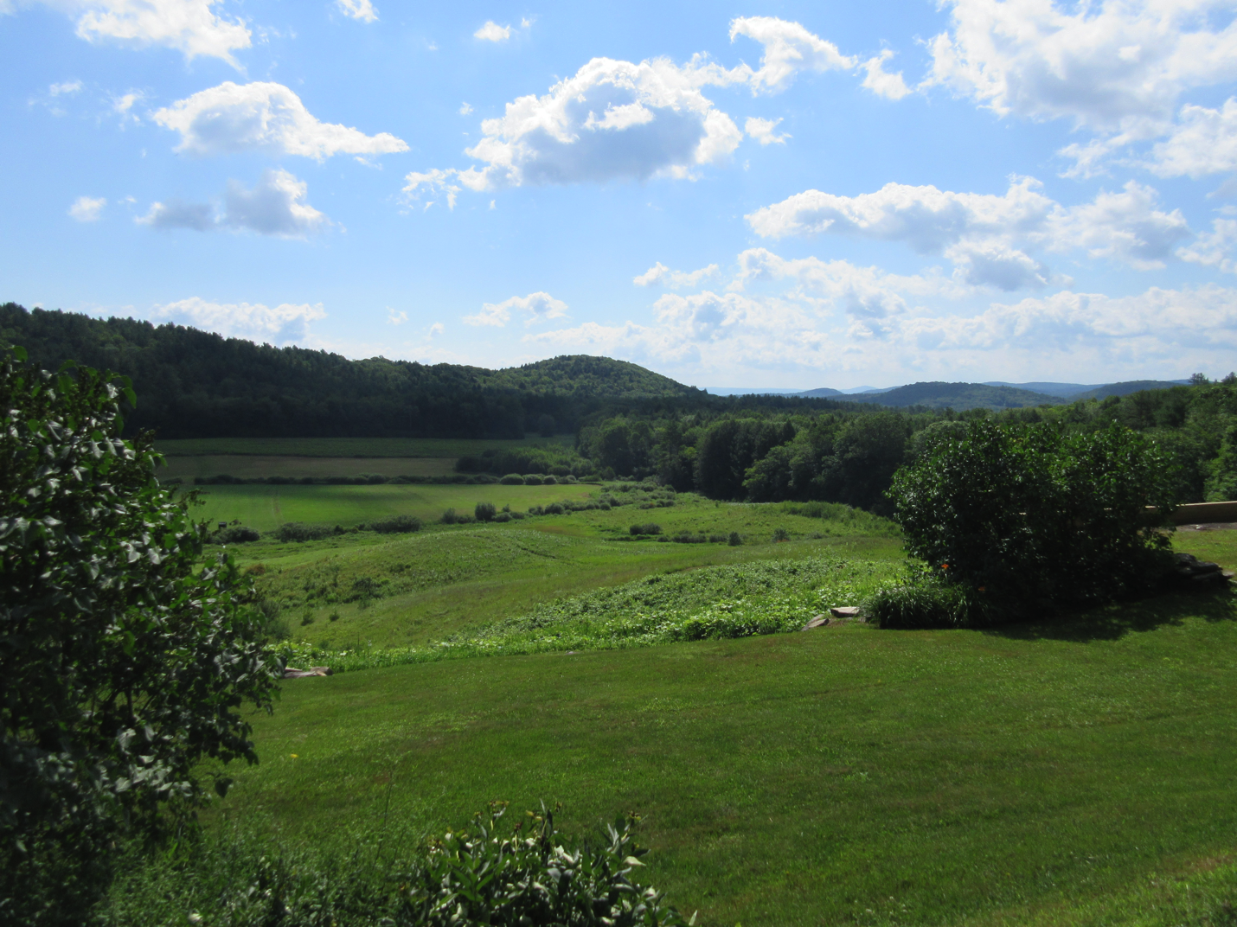

Figure 1: View from Harris Road, an Example of the Scenic Resources the Town Would Like to Protect

During calendar year 2009, the Town of Baltimore spent $2,616.33 on energy. $1,237.95 (47%) was for the 354 gallons of heating oil, $440 (17%) was spent on 1,562 KWH of electricity, and $938 (36%) was spent on fuel for road operations. During the calendar year of 2014, the town spent $3,892.28 on energy. $1,981.51 (51%) was spent on heating oil for the Town Hall, $630.11 (16%) was spent on electricity at the Town Hall, and $1,280.66 (33%) was spent on fuel for the grader. During the calendar year of 2021, the town spent $1,162.61 on heating, $508.76 on electricity, and $1,779.64 on fuel for the grader.
While there are no significant scarcities or problems, the Town seeks to pursue more affordable, efficient energy. The Town also seeks to improve weatherization at Town Hall.

In 2018, the Town of Baltimore adopted a solar electricity generation and transmission siting amendment (below) This amendment sets forth standards for solar facility development and discusses Section 248 review by the Public Utilities Commission. It also establishes that any new commercial solar facilities and proposed upgrades should be consistent with the Vermont Comprehensive Energy Plan, as well as the VT Long-Range Transmission Plan and utilities Integrated Resource Planning (IRP). The benefits of a proposed facility must outweigh the potential adverse impacts to local residents.

A. Solar Electricity and Transmission Siting

The term "solar facility" shall have the following meaning: a solar electricity generation and transmission facility with a 150kW(AC) or greater capacity, including all on-site and off-site improvements necessary for the development and operation of the facility.
The Town of Baltimore has developed community standards and siting standards for the development of solar facilities for reference by facility developers and local property owners and for consideration in Section 248 proceedings (30 VSA §248). These standards are set forth below. In addition, The Baltimore Planning Commission, in consultation with the Southern Windsor County Regional Commission, will identify and map those areas of Baltimore that are most suitable for commercial solar facility development based on facility siting requirements and municipal energy, conservation and development policies and objectives set forth in the Baltimore Town Plan, and the Baltimore Land Use and Development Regulations.
Pursuant to 30 VSA Sec. 248, prior to the construction of a solar facility, the VT Public Utility Commission (PUC) must issue a Certificate of Public Good. A Section 248 review addresses environmental, economic, and social impacts associated with a particular project, similar to Act 250. In making its determination, the PUC must give due consideration to the recommendations of municipal planning commissions and its respective plan. Accordingly, it is appropriate that Baltimore’s Town Plan address these land uses and provide guidance to town officials, regulators, and facility developers.
The Town of Baltimore may participate in the Public Utility Commission's review of new and expanded generation facilities as necessary to ensure that local energy, resource conservation and development objectives are identified and considered in proposed utility development. This may include joint participation in collaboration with other affected municipalities and the Southern Windsor County Regional Commission for projects that may have significant regional impact. H.40, passed in 2015, gives the host municipality automatic party status in the PUC permitting process. It is acknowledged that the PUC's prime focus is on administering state public policy and regulating actions that are directed at ensuring that utility services promote the general good of the state.
The Planning Commission, in consultation with the Baltimore Select Board, should develop guidelines to direct local participation in Section 248 proceedings for the review of solar facilities located in Baltimore or in neighboring communities which may affect the town. The guidelines should reflect levels of participation or formal intervention in relation to the type, location, scale, and magnitude of a proposed project, and its potential benefits and impacts to the community.

Community Standards
The following community standards are to be considered in undertaking municipal solar electricity projects and programs, in updating Baltimore’s Land Use and Development Regulations to address commercial solar facilities subject to local regulation, and in the review of new or upgraded commercial solar facilities by the Town of Baltimore and the Public Utility Commission (Section 248 review).
Plan Conformance: New commercial solar facilities and proposed system upgrades should be consistent with the Vermont Comprehensive Energy Plan, the Vermont Long-Range Transmission Plan, and utilities Integrated Resource Planning (IRP).
Benefits: A demonstrated statewide public need that outweighs adverse impacts to local residents and resources must be documented for municipal support of new solar facilities located within or which may otherwise affect Baltimore. Facility development must benefit Town of Baltimore and State residents, businesses, and property owners in proportion to the impacts of the proposed development.
Impacts: New solar facilities must be evaluated for consistency with community and regional development objectives and shall avoid undue adverse impacts to significant cultural, natural and scenic resources identified by the community in the Baltimore Town Plan.¹ When evaluating impacts of a solar facility under the criteria set forth in this Town Plan, the cumulative impact of existing solar facilities, approved pending solar facilities and the proposed solar facility shall be considered. It is explicitly understood that a proposed solar facility that individually may not have an adverse impact may have an adverse impact when the cumulative impacts of the proposed solar facility and existing solar facilities and pending approved solar facilities are considered.
Decommissioning: All facility certificates shall specify conditions for system abandonment and decommissioning, including required sureties (bonds) for facility removal and site restoration to a safe, useful, and environmentally stable condition. All hazardous materials and structures, including foundations, pads and accessory structures, must be removed from the site.

Solar Facility Siting
Baltimore supports responsibly sited and developed solar facilities within its boundaries. It recognizes that financial considerations require projects to be located in proximity to electric power lines capable of transmitting the load proposed to be generated and easy access from major transportation networks for construction. However, the town desires to maintain the open landscape and scenic views important to Baltimore’s sense of place, tourism economy and rural cultural aesthetic. The same desires inform Baltimore’s Natural and Cultural Resource Goals and Policies,² Land Use Goals and Policies,³ and Zoning Bylaws, which apply to all potential commercial and other development. The following criteria are consistent with those governing all commercial development within Baltimore. Not all commercial or community scale solar facilities proposed can meet this standard. Projects must meet the following criteria in order to be supported by this Town Plan:
Siting Requirements: New solar facilities shall be sited in locations that do not adversely impact the community's traditional and planned patterns of growth, surrounded by a rural countryside, including working farm, open fields and forest land. Solar facilities shall, therefore, not be sited in locations that adversely impact scenic views, roads or other areas identified in the Scenic Resources Inventory,⁴ nor shall solar facilities be sited in locations that adversely impact any of the following scenic attributes identified in the Scenic Resource Inventory: views across open fields, especially when those fields form an important foreground; prominent ridgelines or hillsides that can be seen from many public vantage points, such as our town roads, and thus form a natural backdrop for many landscapes and scenes that include important contrasting elements such as water.
Preferred Areas: The following areas are specifically identified as preferred areas for solar facilities, as they are most likely to meet the siting requirements:
- Roof-mounted systems;
- Systems located out of view of the following scenic roads:
  - Baltimore Road
  - Harris Road
  - Gould Road
- Proximity to existing hedgerows, forest growth or other topographical features that naturally screen the entire proposed array;
- Areas specifically identified as suitable for solar facilities on a map approved
by the Select Board

Prohibited (Exclusion) Areas: In addition to those areas that do not meet the siting requirements set forth above, solar facilities shall be excluded from (prohibited within), and shall not be supported by the town in the following locations:
- Floodways shown on Flood Insurance Rate Maps (FIRMs) - none identified within Baltimore at this time;
- Class II and III wetlands;
- A location that requires fragmentation of Baltimore’s working landscape, including certain areas of undeveloped forestland and primary agricultural soils (as defined in Act 250 and as mapped by the U.S. Natural Resource Conservation Service);
- Ridgelines (Hawks Mountain)
- Steep slopes (>25%)
- Surface waters and riparian buffer areas (except for stream crossings);
- Areas specifically identified as unsuitable for solar facilities on a map approved by the Select Board;
- Topography that causes a facility to be visible against the skyline from common vantage points from public and private vantage points such as roads, homes and neighborhoods;
- A site in proximity to and interfering with a significant view shed identified in the Scenic Resource Inventory;
- A location where a site cannot be screened from the view of neighbors and thus prohibits them from exercising the peaceful enjoyment of their property;
- Open fields that are adjacent to or in view of our town roads.

Mass and Scale
New solar facilities larger than 10 acres, individually or cumulatively, cannot be adequately screened or mitigated to blend into the municipality's landscape and are, therefore, explicitly prohibited. Solar facilities smaller than 10 acres are expected to provide the same level of landscaping and screening that is required of all commercial and industrial uses and of mobile home parks in Baltimore.

Energy Goal:
1. To reduce local demand for non-renewable energy resources.
2. Encourage the use of residential scale renewable energy resources such as wood, solar, and wind for both new homes and homes being renovated or enlarged.
3. Encourage land development patterns likely to result in the conservation of energy.
Energy Policy:
- Encourage new home construction and additional construction to use modern building materials and techniques in order to conserve energy and lower home heating costs.
- Builders of new homes shall complete a Vermont Residential Building Energy Standards Certificate. Standards for new construction should specify insulation, lighting, heating, and appliance performance levels.
- Encourage the development of solar facilities that conform with the town’s Solar Siting amendment; develop guidelines to direct local participation in Section 248 proceedings for facilities in Baltimore or neighboring communities which may affect the town.
Energy Recommendations:
1. Amend subdivision regulations and/or adopt site plan review procedures for review of the building and insulation materials, and the siting of new homes (for passive solar).
2. Increase awareness among residents about incentives for energy conservation through programs such as Efficiency Vermont, which promote energy audits, weatherization, and upgrades to energy efficient appliances to reduce consumption.
3. Consider density bonuses for energy efficient building construction (LEED, Energy Star).

Section V. Utilities and Facilities

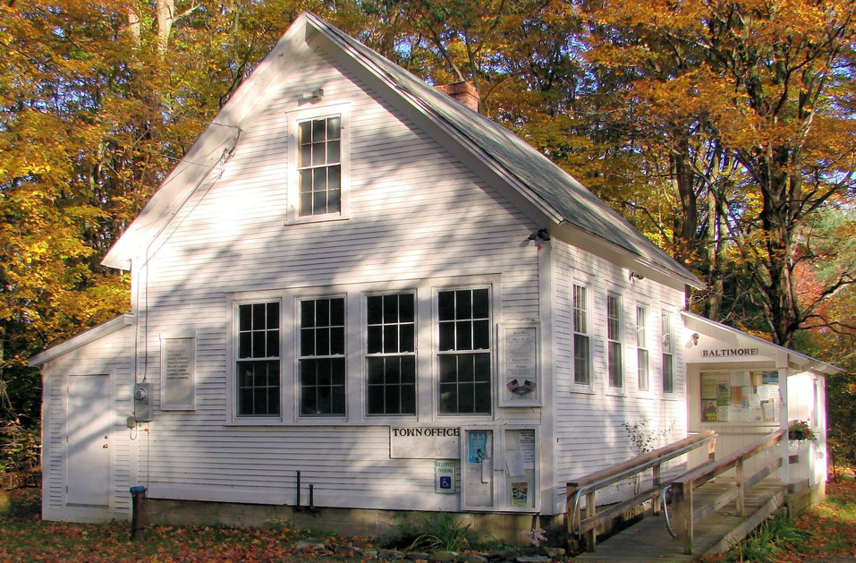
The siting of electrical facilities and transmissions lines, telecommunication and broadcasting towers involve health, safety and aesthetic issues. These structures can alter mountaintops and ridgelines in ways that negatively affect scenic resources vital to Baltimore’s economic and cultural future. In addition, there are unanswered questions about health effects from the electromagnetic fields generated by these facilities on the people and animals living near them. Any proposed wireless communications facilities must utilize existing facilities before new sites are considered. New sites should blend into the surrounding landscape in both size and appearance. As less intrusive designs evolve through technological advances, those designs should be utilized.
Figure 2: Baltimore's Town Office
Electric service is available to Baltimore residents through Green Mountain Power. Local telephone service is available through TDS Telecom.
Baltimore conducts its business from its Town Office, formerly the old Baltimore School. The Town Office is the only town-owned facility. There is one cemetery and no recreational fields or town-maintained walking trails. All residents rely on private wells for drinking water and private septic systems.
Baltimore is one of thirteen member towns in the Southern Windsor/Windham Counties Solid Waste Management District (SW/WCSWMD). SW/WCSWMD is a union municipal district dedicated to providing solid waste management authority, services, and planning to its member towns. The District was chartered in 1982 and serves: Andover, Baltimore, Cavendish, Chester, Grafton, Ludlow, Plymouth, Reading, Rockingham, Springfield, Weathersfield, West Windsor, and Windsor.
Most Baltimore residents use the Springfield Transfer Station for disposing of their recyclables. They may also pay to dispose of their trash at the Transfer Station using a ticket system. Household hazardous waste collections are held in on the second Saturdays in May and September at the Transfer Station for District residents. For more information, visit www.vtsolidwastedistrict.org.
There are no registered childcare facilities in Baltimore. Residents rely on informal childcare arrangements in town or in surrounding towns or on regional resources that are either licensed or registered. The childcare resource and referral agency for Baltimore is the Springfield Area Parent Child Center, which is located in North Springfield.
There is a significant need for improved internet speeds and coverage. There are currently no cable or fiber routes that run through the Town (see Broadband Deployment map below). Improving internet coverage is a high priority for the town, especially in the “post-COVID” environment with several residents working from home. The Town needs reliable internet for communications, entertainment, and education services as well.
Broadband High-Speed Internet Availability in MARC Towns
Town | Total Buildings | Percent Served 100/100 Mbps | Percent Served 100/20 Mbps or Better | Percent Served 25/3 Mbps or Better | Percent Served 4/1 Mbps or Better
Andover | 481 | 100% | 99.8% | 100.0% | 100.0%
Baltimore | 113 |  | 0.0% | 88.5% | 100.0%
Cavendish | 980 |  | 78.2% | 88.9% | 97.7%
Chester | 1770 | 100% | 99.9% | 99.9% | 100.0%
Ludlow | 2452 | 0% | 90.2% | 95.5% | 99.6%
Reading | 513 | 98% | 98.6% | 98.6% | 99.2%
Springfield | 3865 | 100% | 100.0% | 100.0% | 100.0%
Weathersfield | 1596 | 6% | 80.1% | 88.2% | 97.2%
West Windsor | 749 | 99% | 99.5% | 99.5% | 99.6%
Windsor | 1478 | 1% | 95.7% | 97.3% | 99.5%
Source: VT Department of Public Service Broadband statistics, last updated 2021
Broadband Deployment Map
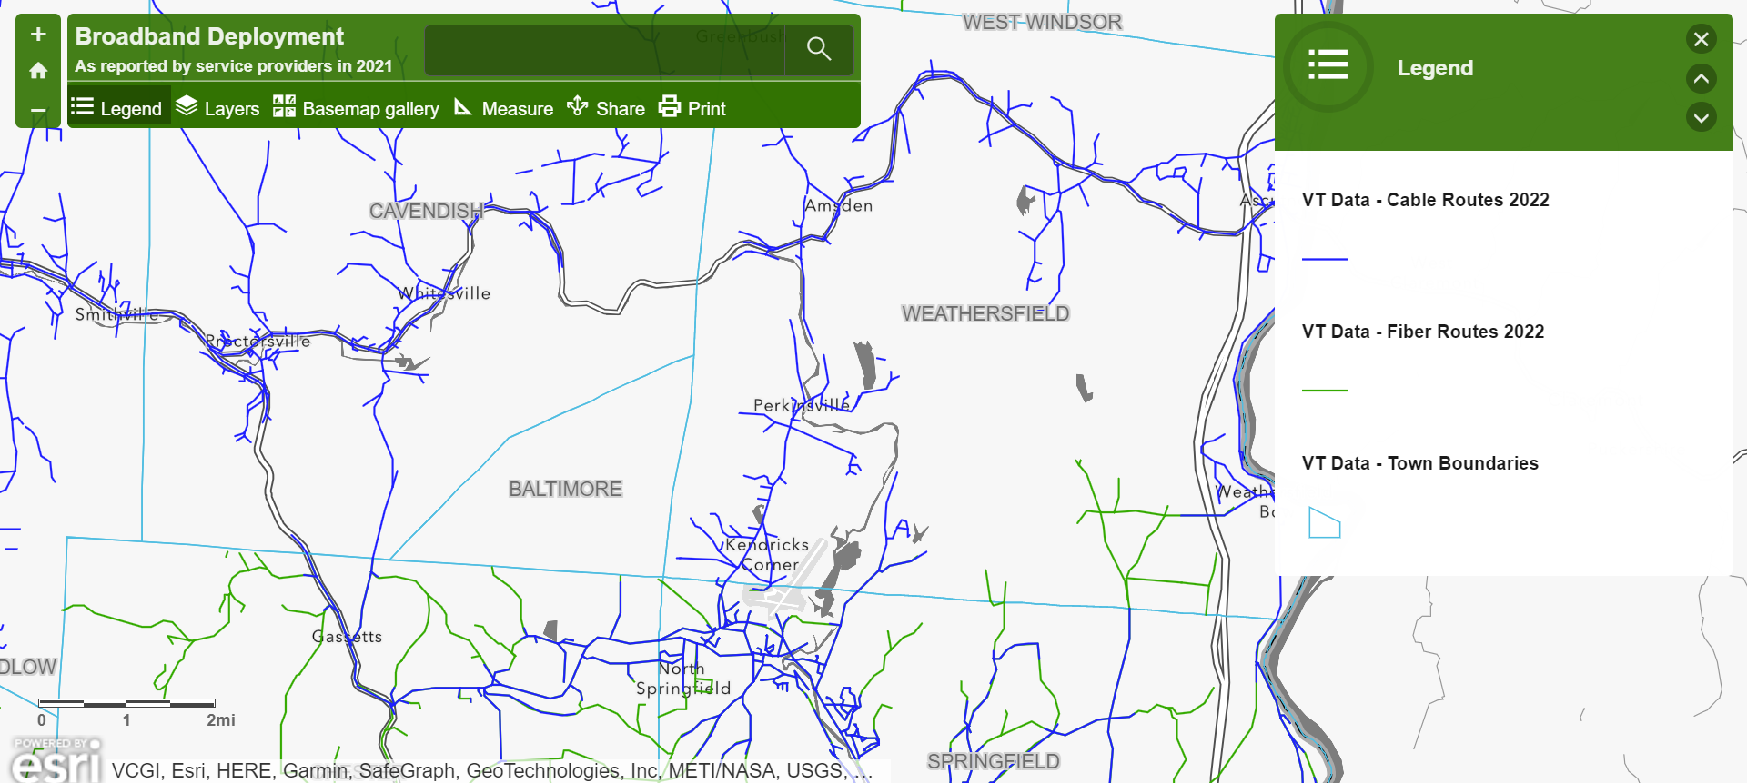
Utilities and Facilities Goal:
1. Accommodate the necessity of utilities and telecommunication towers while minimizing the economic, aesthetic and environmental impact upon the town.
Utilities and Facilities Policies:
1. Allow new facilities only as necessary to meet the changing needs of residents and businesses.
2. New utility lines shall be planned along existing roads whenever possible and should not detract from the important scenic resources.
3. Telecommunication towers and antennas should be placed on existing structures whenever possible. No tower should be placed on Hawks Mountain.
4. Continue routine maintenance on Town Hall.
Utilities and Facilities Recommendation:
1. Consult the Baltimore Zoning Regulations and Future Land Use Map for the specific conditions of siting and construction of any electrical, telecommunication or broadcasting tower or facility (commercial or private).
2. The town should plan for the future demand for childcare services that are safe and affordable and integrate childcare issues into the planning process as appropriate.
3. The town should work to achieve the goals and action steps outlined in the District’s Solid Waste Implementation Plan.
4. The town should work with MARC and internet service providers to bring broadband services to Baltimore.

Section VI. Transportation
There are no state routes in Baltimore; the closest state routes are VT Route 131 to the north, VT Route 106 to the east, VT Route 10 to the south, and VT Route 103 to the west of Town. 2015 Vermont Agency of Transportation highway mileage reports for Baltimore include:
- 4.36 miles of Class 2 Town Highways
- 2.81 miles of Class 3 Town Highways
- 0.15 miles of Class 4 Town Highways
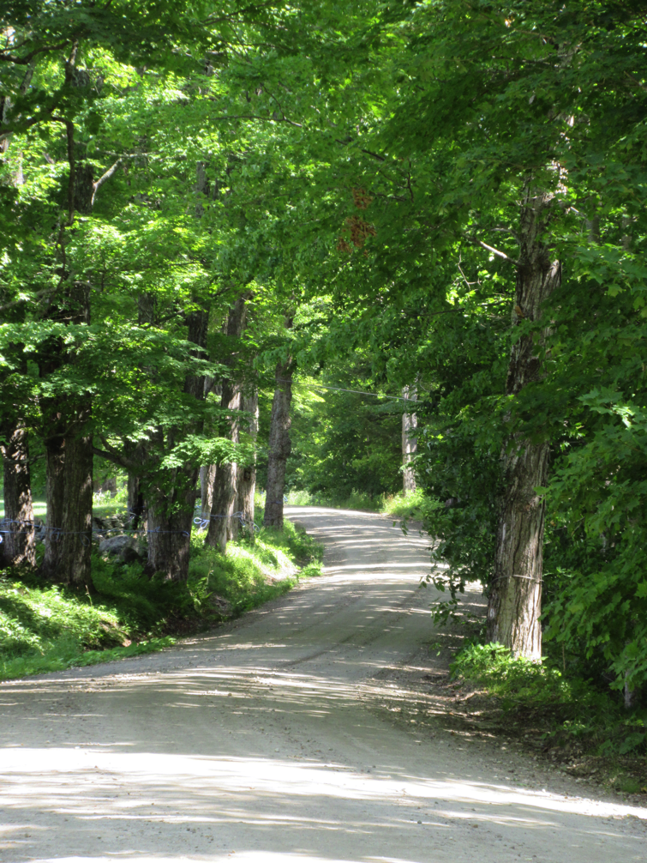
- 0.69 miles of Legal Trails
Figure 3:Baltimore Road
The Baltimore Selectboard adopted road and bridge standards in 2019. An inventory of Town bridges and culverts was conducted in 2002 and most recently updated in 2014. Additionally, a road inventory was completed in 2014 and a road erosion inventory was completed in April of 2016. Currently the road network in Baltimore is sufficient with no additional roads needed.
The Baltimore Survey results indicated that most people would like to keep the roads unpaved and many improvements to road condition and drainage have been made in the last few years. No additional roads are needed at this time in Baltimore. The Town does not maintain class 4 Town Highways and trails. They are valued for hiking, bicycling, snowmobiling, and other recreational uses.
There are no airports in Baltimore. However, the Hartness State Airport is located in North Springfield and provides access for corporate jets, flight instruction and gliding opportunities.
In recent years, the State has seen many proposals for privately owned helipads and airstrips. These facilities can have negative impacts while providing a private benefit to few. The Town can regulate this development through the Town land use and zoning regulations, based on the following:
Helipads: Helicopter Takeoff and Landing Area
Helipad: An area of defined dimensions designated for the landing and takeoff of helicopters, requiring permit approval from the Vermont Transportation Board under 5 V.S.A., Section 207 and involving more than 10 takeoffs or landings each year.

The Development Review Board (DRB) or Zoning Administrator may issue a Conditional Use permit for the operation of a helipad after finding that all the following conditions are met:
- A minimum setback of 200 ft. from property lines.
- The hours of operation are limited from 7:00 AM to 7:00 PM.
- There shall be no more than 2 landings per day.
- There shall be no more than one helipad per property.
- The use of helipads shall be limited to persons occupying the property and their guests.
- The helipad shall not be lighted.
- All takeoff, landing, and parking areas must be surfaced with a dustproof material.
The DRB or Zoning Administrator may waive any of these provisions for a helipad used for emergency management operations or medical evacuations.
Connecticut River Transit (CRT) offers on-demand public transportation services in Baltimore with at least 48 hours’ notice. According to CRT this service was utilized only once in 2014 and not at all during 2015 (these numbers are based on CRT’s fiscal years).
During the 2015 legislative session, the Vermont legislature passed Act 64, the Vermont Clean Water Act. Act 64 will have significant transportation implications as it created a permit system aimed at addressing stormwater runoff from unpaved roads. Under the DEC Municipal Roads General Permit, Baltimore will need to develop and implement a stormwater management plan. Some of the possible implementation strategies include completing an inventory of municipal roads and their connections to surface waters, upgrading ditches, ensuring roads are correctly crowned, and upgrading culverts. The deadline for application for the municipal roads stormwater permit was July 1, 2021. Since 2021, Baltimore has made significant progress toward ensuring road segments are in compliance with the MRGP guidelines. The town currently has only 4 segments remaining to be improved by 2028.
The Vermont Clean Water act will also regulate areas of impervious surfaces greater than 3 acres, increase the role of Tactical Basin Plans, and regulate agricultural runoff through the Required Agricultural Practices.
The Vermont Clean Water act will also regulate areas of impervious surfaces greater than 3 acres, increase the role of Tactical Basin Plans, and regulate agricultural runoff through the Required Agricultural Practices.
Transportation Goal:
1. Provide safe and adequate town roads.
Transportation Policies:
1. Keep the roads in Baltimore unpaved.
2. Preserve public rights-of-way on Class 4 Town Highways and trails for recreational uses.
3. Do not accept new roads under Town ownership unless they clearly meet the public interest.
4. Permit private helipads or airstrips provided that all local land use and siting requirements are met.
Transportation Recommendations:
1. Seek funding sources for a new grader (possibly grants).
2. Seek funding sources to improve the emergency preparedness conditions of the roads.
3. Start planning for compliance with the Vermont Clean Water Act (Act 64).

Section VII. Education
In 1894 the Baltimore School House was built. Not much money was spent on education back then. The teachers were boarded out into houses of families that bid for them. In the earlier days, school only met for two months in the winter and two months in the summer. Grades 1-8 were offered in the Baltimore School until the late 1960's. Grades 7-8 were sent to Springfield Junior High School and Green Mountain High School. The Baltimore School closed in June of 1988, and in March of 1989 the Town of Baltimore was granted possession of the schoolhouse from the Baltimore School Board. Currently, all Baltimore students attend elementary school in Cavendish or Chester, and all students attend Green Mountain Union High School. A large percentage (72%) of respondents to the Baltimore Year 2015 Survey were either neutral or have indicated there are adequate educational resources in the area.
A number of schools in the area offer a wide range of educational services. The River Valley Technical Center in Springfield offers high school students from the region the chance to learn a technical trade. Vermont Community College in Springfield and New Hampshire Technical College in Claremont, NH offer college level courses, associates degrees, and adult continuing education.
The Vermont Legislature passed Act 46 in 2015. It provides various incentives for school districts to voluntarily merge. In 2018 unmerged districts may be realigned provided the realignment is necessary, possible, and practicable for the area.
Education Goal:
1. To provide and maintain adequate educational services and, when possible, provide more educational opportunities for the residents of Baltimore.
Education Policies:
1. Ensure all residents have access to traditional and non-traditional educational resources.
Education Recommendation:
1. Monitor the ongoing implementation of Act 46.
2. Inform residents about educational opportunities in the area.

Section VIII. Emergency Preparedness
Vermont Emergency Management has requested that all towns fill out a Local Emergency Management Plan in order to provide a more informed state response to local disasters. The Local Emergency Management Plan (LEMP) provides contact information for those involved in local emergency response. Also included are shelter locations, pre-designated local emergency operations centers, and Incident Command System flow charts. The most recently adopted LEMP is adopted by reference as part of this town plan. The LEMP is updated yearly, after Town Meeting day, and submitted to Vermont Emergency Management by May 1st each year.
In 2014, the Southern Windsor County Regional Planning Commission (now the Mount Ascutney Regional Commission) received FEMA approval of its Multi-Jurisdictional All-Hazard Mitigation Plan. The Selectboard approved the Baltimore annex on March 5th, 2014. This appendix, when used with the appropriate sections of the SWCRPC Multi-Jurisdictional All Hazard Mitigation Plan, is an All-Hazard Mitigation Plan for the Town of Baltimore. This plan made Baltimore eligible to join the National Flood Insurance Program and eligible to apply for mitigation project grants. Baltimore was admitted to the NFIP in 2014, but has no Special Flood Hazard Areas identified.
In February 2015, Vermont Emergency Management notified the town of its successful grant application for a new single jurisdictional hazard mitigation plan. The grant period of performance end date for the award is February 4, 2018. The goal of a stand-alone Hazard Mitigation Plan is to help identify risks and provide local mitigation strategies the community can take to become more disaster resilient.
Since 2018, the Town of Baltimore has updated its local hazard mitigation plan. The new plan, adopted September 2018, is effective until 2023 (5 year plan cycle).
Baltimore relies heavily on the surrounding towns for medical and fire assistance. The closest hospital is Springfield Hospital (about 20 minutes away). The closest full time fire station is the Springfield Fire Department (also about 20 minutes away). The closest volunteer fire station is West Weathersfield Volunteer Fire Station, located at Downers Corners in Weathersfield (15 minutes north on Route 106). For Baltimore residents, Riverside Middle School in Springfield serves as the local shelter and the Baltimore Town Hall is equipped with a back-up generator to continue service during a power outage and serve as the local Emergency Operations Center. There is no town water source and if the town lost power, most residents would have to rely on privately owned generators to power their water pumps.

Emergency Preparedness Goal:
1. To ensure that the community can respond to a local emergency.
Emergency Preparedness Policy:
1. Review and correct the Local Emergency Operations Plan on an annual basis.
2. Work with surrounding towns to complete mutual aid agreements.
Emergency Preparedness Recommendations:
1. Have the road commissioner identify road sections, bridges, and culverts that need maintenance or replacement.
2. Work with the Regional Planning Commission to seek funding for emergency preparedness in Baltimore.
3. Maintain enrollment in the National Flood Insurance Program.

Section IX. Community Health

The health and safety of Baltimore residents is of the utmost importance. Baltimore’s vision for health, wellness and safety is that all citizens in the community have access to high quality, affordable, physical and mental health services through local providers; that employers and individuals support healthy lifestyles and environments; that the well-being of children is a central focus; that prevention, personal wellness and reduction of pain are strong areas of focus from birth to death; that domestic violence and substance misuse are unacceptable in our families and community; that the elderly and disabled citizens have adequate health and wellness support to remain in their homes and remain integrated in their community; and that all residents have access to prompt and effective services in the event of an emergency.
The Town of Baltimore seeks to elevate the vitality of its citizens by including a comprehensive element dedicated to health and wellness in its Town Plan. Although the Community Health and Wellness Element is not a state-mandated element, the Town believes that its inclusion in the Plan ensures that public health and wellness remains a top Town priority. Many other elements of this Town Plan also have an impact on health, including preservation of green space; clean water; sidewalks that encourage walking; and design of new development to promote human interaction, reduce the use of vehicles, and support local and healthy food.
Improving the built environment in ways that promote active living, healthy eating, social and mental health, and safe environmental conditions, among others, benefits the health of an entire community. It is therefore imperative that Baltimore prioritizes planning for health in all policies and emphasizes health as a priority for a community’s overall success.
There are no medical health facilities in Baltimore; residents rely on services in surrounding towns. The Town of Baltimore is a “dry town”; alcohol purchases are not available in town.
The town does have a representative on the Council of Aging; their Senior Solutions program provides medical, nutritional, and other support services to residents aged 60 and up. For transportation to medical appointments, grocery shopping, and recreational activities, the Moover bus provides free public transportation throughout Windsor county. The Southeastern Vermont Community Action (SEVCA) provides family services, to include fuel and utility assistance.
The Town hosts the following annual events that build community and support health and wellness through outdoor recreation: Green Up Day VT, Fishing Derby, and a town-wide yard sale.
Community Health Goal:
1. Promote health and wellness in Baltimore.
Community Health Policies:
1. Increase access to healthy foods.
2. Maintain sufficient affordable housing.
3. Minimize the risks to human health and the environment posed by hazardous sites.
4. Promote active transportation through walking and biking.
Community Health Recommendations:
1. Promote and expand farmers markets and community gardens.
2. Work with local housing authorities to create a variety of housing types and maintenance options.
3. Protect water quality of rivers, streams, lakes, and wetlands.
4. Promote use of park and recreation facilities.
5. Consider accessibility when developing public spaces and recreational opportunities.
6. Raise awareness of connection between community health and municipal planning.

Section X. Natural and Cultural Resources

Water Resources
Wetlands are defined in VSA 24, Section 4303 as, “...those areas that are inundated by surface or groundwater with a frequency sufficient to support vegetation or aquatic life that depend on saturated or seasonally saturated soils for growth and reproduction.” Wetland benefits include fish and wildlife habitat, flood and erosion protection, nutrient and pollution filtration, groundwater recharge, and sites for educational activities, recreation and scenic enjoyment. Wetlands over three acres in size are identified by the National Wetland Inventory.
The largest bodies of surface water in Baltimore are brooks, including Beaver Meadow Brook and Chandler Meadow Brook. Baltimore residents are aware of the importance of their water resources. In the Baltimore Year 2015 Survey, 100% of the respondents agree or strongly agree with the statement, “Protection of our water resources is important.”
Tactical basin plans (TBP) for Vermont’s watersheds are developed by the Vermont Agency of Natural Resources according to the goals and objectives of the Vermont Surface Water Management Strategy to protect, maintain and restore the biological, chemical, and physical integrity, and public use and enjoyment of Vermont’s water resources, and to protect public health and safety. Baltimore is within the Black River watershed. The Basin 10 Plan, which includes the Black River watershed, is being updated by the state in 2016. The town should coordinate with the Vermont Agency of Natural Resources in the development of tactical basin plans to help identify appropriate strategies to improve the water quality of the surface waters in Baltimore.

Forest and Wildlife Habitat
The majority of land in Baltimore is woodland or forest. Early colonialists have deforested Vermont and the rest of the New England states three times since the settlement of America. The predominant canopy species has changed since pre-settlement. The forest and woodlands of Baltimore are currently a mix of broadleaves and conifers. The age of the trees are typically 50 years old or younger, with some older trees mixed in (usually left because of the poor lumber quality or remote location). Sugar Maple, Red Maple, Red Oak, White Oak, Black Oak, Eastern Red Cedar, Eastern Hemlock, Ash, Willow, Cottonwood, Beech, White Birch, Yellow Birch, Cherry, Buckthorn, White Pine, Red Spruce, and Black Spruce can be found throughout the Town. Red and Black Oak are generally the most valuable timber in the region but other species such as White Pine and Yellow Birch can be valuable if they are large and straight enough.
The sap from the Sugar Maples is boiled down to make maple syrup, an important source of food, income, and identity to the residents of Baltimore. Sugar Maples have been reported to be declining in the United States due to warming annual temperatures.
According to the Baltimore Survey, 97% of the respondents agree or strongly agree that protection of our forests is important. A number of animal species depend on the forest and woodland for their habitat requirements. Forests provide shelter and food for a variety of mammals, reptiles, amphibians, and birds. Whitetail deer, fisher cats, porcupines, black bear, rabbits, skunks, and wild turkey are a few of the animals that can be found in Baltimore.

Agriculture
The days of when Vermont had many working farms are over. There are only a few small farms currently operating in Baltimore. Farms provide open space and the rural atmosphere that people enjoy about Baltimore. There are a number of people with rural properties that resemble farms but they are not “working farms.” A working farm is one where the farm is the owner/operator’s primary source of income. Open fields and agricultural lands are important scenic resources in Baltimore. Haying of open fields continues to leave these lands open.

Earth and Mineral Resources
The bedrock of the area is identified as pegmatite, granite, and granite gneiss and represents some of the oldest rock in the Northeast. Overlying the bedrock is a dense basal till of low permeability, with particle sizes ranging from the fine silts and clays to boulders. The depth of the till varies from zero to possibly ten feet. There are a few exceptions to this, as isolated deposits of sands and gravels with a higher permeability than the tills exist. These are probably of glacial-fluvial origin.
Mining impacts the environment, peace and quiet, and aesthetics of a community. Most of the respondents to the survey felt that mining or mineral extraction should not be encouraged (82% of respondents).

Outdoor Recreation
There is ample opportunity to enjoy the outdoors in Baltimore. A number of residents enjoy hunting and take part in whitetail deer and turkey hunting seasons (wild turkey have been successfully reintroduced to New England). Hiking, biking, horse riding, and walking can be done on town roads or trails located throughout the town. Snowmobiles are also popular during the winter months.
New England has historically supported the English Common Law concept of allowing hunting and recreational use on private property unless posted as “no trespassing”.

Historic Resources
The Town Hall was formerly the old school built in 1894. There are a number of homes in Baltimore that were built in the 1800s. Currently, the Loomis House is the only structure in Baltimore listed on the State Register of Historic Places. This building is built with the Snecked Ashlar construction technique, a form of stone masonry believed to have been brought to the area by masons from Scotland in the 1800s.
The preservation of historic resources was identified in the survey as being a positive and worthwhile Town effort. Eighty percent (80%) of respondents agreed with the statement that historic buildings should be preserved.

Scenic Resources
Baltimore possesses landscape features that are extremely important to the rural character, which the residents have defined as one of the top ten things that “should not change.” The maintenance of these scenic resources is important to the people of Baltimore. A wide range of questions was asked in the survey to gather public opinion about the importance of the natural aesthetics in Baltimore. Town residents overwhelmingly support the preservation of existing scenic resources. As such, land in the scenic view areas identified on the Future Land Use Map shall only be used for single-family residences or agricultural purposes.
Open fields and working farms help to define the rural landscape of Baltimore. The protection of farming and open agricultural land will help preserve the scenic and cultural resources of Baltimore.

Open space, natural areas, and wildlife habitat are other rural characteristics that residents of Baltimore would like to protect. Baltimore is located on the side of Hawks Mountain, giving residents beautiful views of the Connecticut River Valley. Hawks Mountain itself is also valued as a scenic resource to Baltimore residents. A majority of survey respondents said there should be no development and no telecommunication towers on Hawks Mountain.
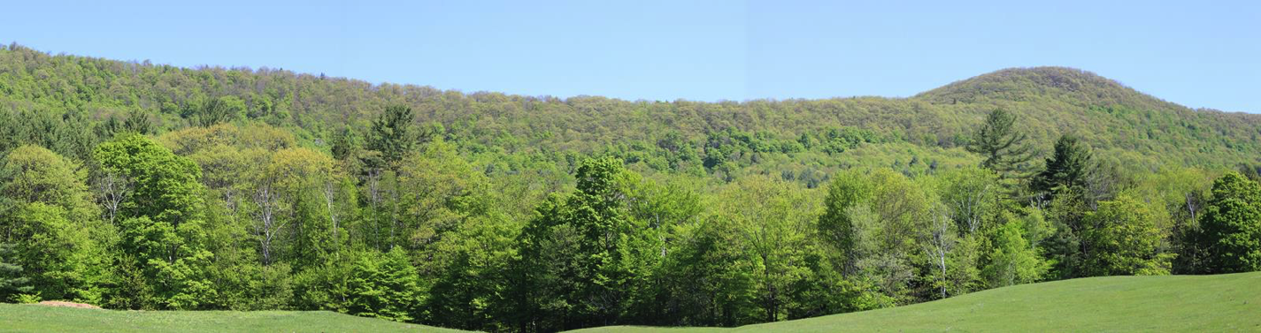
Figure 4: Example of a Scenic View of Hawks Mountain

Natural and Cultural Resources Goals:
1. To protect the land uses and natural features which define Baltimore’s rural character by preserving agricultural land, forest and woodland, wildlife habitat, wetlands, water resources, steep slopes, good air quality, natural and scenic areas.
2. To encourage and promote the preservation of agricultural land for open space and scenic views.
3. To foster an environment and habitat where wildlife can thrive.
4. To encourage the continued use of agricultural lands for farming.
5. To protect and preserve historic and cultural resources for future generations to enjoy.
6. To protect against loss of peace and privacy in the community.
7. To maintain access to important recreational resources.
Natural and Cultural Resources Policies:
1. Protect existing water resources and wetlands from contamination or disruption from development.
2. Ensure that the use, storage, and disposal of hazardous materials (junk cars, batteries, trash, used oil, etc.) is done in such a manner that it does not have an adverse effect on the water resources in the Town.
3. Ensure that streams, brooks, and watercourses are maintained in a natural state.
4. Ensure that any new water supply system or waste water system does not deplete or contaminate the existing water supply.
5. Deter development from Class I and II wetlands, as identified by the VT Agency of Natural Resources.
6. Natural and manmade features which contribute to the scenic beauty of Baltimore should be protected.
7. Scenic views should be considered when planning location of development. Additionally, land in the scenic view areas identified on the Future Land Use Map shall only be used for single-family residences or agricultural purposes.
8. Telecommunication towers shall not be constructed on Hawks Mountain.
9. Residential development on or near Hawks Mountain shall not be clearly visible.
10. There shall not be any development on the ridgeline of Hawks Mountain.
11. Plan development to minimize the impact on fish and wildlife habitat.
12. New or existing developments are encouraged to avoid clear-cutting large acreage (large acreage is defined for the purposes of this Town Plan as over ten acres).
13. Maple sugaring should be encouraged as a long-standing Vermont and Baltimore tradition.
14. Encourage working farms to stay in operation.
15. Discourage the conversion of quality farmland and agricultural soil to other uses through zoning and subdivision regulations.
16. Discourage the development of mining operations that would negatively impact the environment, peace and quiet, or aesthetics of the community.
17. The recreational use of the land shall be encouraged, providing that private property and natural resources are not negatively impacted, and permission for use is granted where required.
18. Residents and non-residents should ask the owners first before hunting or using motorized vehicles on private property.
Natural and Cultural Resources Recommendations:
1. Support the local Health Officer’s enforcement of State and Federal regulations for the protection of surface and ground waters.
2. Commercial wood harvesters are encouraged to leave buffer strips of trees and vegetation near the borders of roads, wetlands, and streams to deter negative impacts to aesthetics and water quality.
3. Encourage conservation of forest and woodlands for recreation, wildlife habitat, wood products, maple sugaring, scenery, and important recreation areas.
4. Encourage roadside farm stands in order to provide a local means of food distribution.
5. Utilize the Regional Planning Commission to record and apply to the National and State Registers of Historic Places.
6. Seek grant-funding sources, such as Municipal Planning Grants made available by the State of Vermont to Towns with approved Town Plans, to help in the identification and recognition of historic buildings and structures.
7. Work with proposed mining operations to minimize impacts to residential property and the environment.
8. People who hunt, trap, and fish are advised to read and understand all of the State of Vermont’s Laws pertaining to hunting and fishing.

Section XI. Land Use Planning

Existing Land Use
Baltimore is a rural town with much of the land in forest or brush (approximately 2,606 acres). Forests provide wildlife habitat and variety of scenic, recreational, and economic resources (such as timber and maple sugaring). The next largest land use is agriculture, covering approximately 303 acres of land (pastures and hayfields are included in this estimate). The third largest use of land in Baltimore is residential, covering approximately 75 acres. Baltimore does not fit into the typical historic settlement pattern of Vermont. There are no villages or hamlets (a small area of concentrated development with one or more commercial establishments) in Baltimore.

Future Land Use
The village of North Springfield and the areas surrounding the North Springfield Industrial Park and Hartness State Airport are anticipated to grow over the next several years. Easy access to Routes 106 and 10, the proximity of a major employment center and the availability of municipal services are variables that could stimulate growth in Baltimore. There currently are no growth centers in Baltimore and the existing homes are fairly spread apart.
According to the Baltimore survey, the qualities of Baltimore that residents would like to maintain are peace and quiet, the rural atmosphere, a sense of community, the reasonable tax rate, and views. The greatest threats to these qualities are rapid and widespread residential development that could fragment large areas of undeveloped forest land and open fields, and detract from the scenic views that help to define Baltimore’s rural character. In light of Baltimore residents’ desire to maintain the rural, scenic nature of their town, a future land use map was developed.
The definitions of land use categories that follow are descriptions of areas shown on the Future Land Use Map. They are meant to serve as a guide to the types and intensities of uses appropriate to each area by describing the values that each category provides for the Town. The definitions do not prescribe or prohibit a specific use or set of uses for any category; the actual uses of the land will have some overlap between categories. For example, forest/wildlife or agricultural land can continue to support rural residential development, as long as that development does not negatively impact the primary values or functions attributed to the forest/wildlife or agricultural land uses. Development is inappropriate in any one category if, whether alone or combined with other uses in the area, it threatens the values described below.
The Future Land Use Map is general in nature, and the boundaries of different categories were drawn with this in mind. They are not meant to be detailed representations of present conditions, nor are they intended to be precisely bounded areas of completely segregated land uses in the future.

Forest/Wildlife
The majority of undeveloped land in Baltimore is forested. The contiguity of large areas of forestland is important for many types of wildlife, especially for large mammals such as deer, bear, and moose. The State Agency of Natural Resources has identified several large areas within the town as deer wintering areas and bear habitat. Any development that occurs in forest areas should be designed so that these important habitat areas and their functions are maintained wherever possible. Forest areas are also important for their recreational, aesthetic, and economic resource values. The ability of Forest areas to provide these benefits should not be significantly impaired. Development in these areas should be undertaken in ways that protect their value and ensure the continued presence of healthy forest ecosystems in the Town, e.g. siting building lots to minimize forest fragmentation and habitat impacts.
Agriculture
Agricultural land has historically been important to the Town’s economy, food supply, and cultural heritage. It contributes to the land use patterns and aesthetic qualities that make the Town a desirable place to live. Land in agricultural use, and idle open land with agricultural potential both possess these values. The potential for agricultural use and production should not be impaired in designated agricultural areas. As such, land in this area shall only be used for residential or agricultural purposes. Residential development may be considered in these areas as long as the scenic qualities of the open fields and farmland are not impaired, and the overall density remains low.
Residential
Rural Residential areas can support a number of different uses, including low density residential, forest, agricultural (including tree farms and other horticultural uses), open, and transitional (scrub/shrub). They have been designated based on their current uses and accessibility from existing roads. The primary concern in rural areas shall be to discourage sprawl and strip development, and to maintain existing settlement patterns. Cluster development is encouraged wherever possible, as long as the overall density remains low. Access to open space and recreational resources should be preserved wherever possible. New residential development may occur in Rural Residential areas only where accessible by existing town roads.
Conservation/Steep Slopes/Ridgeline
Conservation areas are lands that possess outstanding value or potential as wildlife habitat, recreation areas, educational resources, fragile natural areas, or aesthetic resources. Conservation lands represent relatively pristine areas of the Town that residents wish to preserve in their natural state for future generations, and shall receive the highest level of protection from development. Special care shall be taken in any resource management or extraction plans to maintain the character and value of these areas. Conservation areas are especially beneficial when surrounded by compatible uses such as forest and agriculture.
The Conservation area on the Baltimore Future Land Use Map covers the ridgeline and steep slopes of Hawk’s Mountain. These areas are important because of their scenic qualities and fragile soils, and because they are difficult to access without destroying some of the qualities that make them valuable to the town. This area also abuts State Forest land that makes up the northwest slope of Hawk’s mountain in the town of Cavendish. Much of this State land is harvested; however, the land is managed for wildlife and the area provides trails for recreational use.
Special Considerations
There are several important resources that may occur within any of the land use categories above, and which merit special attention and protection. They include: vegetated areas next to surface waters; wetlands; Natural Heritage Inventory sites; critical deer wintering habitat and bear habitat as defined by the Vermont Agency of Natural Resources; significant historic sites; and other locally defined sensitive natural areas and scenic resources. Development should avoid and minimize negative impacts to these resources. In addition, special considerations should be observed in the following areas:
High elevations and steep slopes — At high elevations (greater than 1,500 feet) the soil tends to be thinner, cooler, and less able to support a wide range of plant life. If areas are disturbed the potential for severe erosion is great. Land at 1,500 feet and above as well as lands with steeps slopes (greater than 25%) shall be protected from any development that could reasonably be expected to cause soil erosion.
Ridgelines — Any development proposed at higher elevations should demonstrate that every measure has been taken to ensure the development is not visually obtrusive to surrounding neighbors or from public roadways.
While residential development may be expected in almost all land use categories, higher densities should be concentrated in existing residential areas. Residential development should be compatible with the land use and housing goals of this plan, and should not conflict with the values defined in the land use categories of this plan.
Timing of Development
Baltimore is a rural community that has historically seen family-by-family growth. Baltimore residents wish to continue this steady and well-paced pattern of growth, and to the extent possible, prevent sudden large increases in population which would place undue stress on Town services and rural character.
Land Use Goal:
1. To encourage development that is compatible with the existing rural character of Baltimore.
Land Use Policies:
1. Protect the residential areas from incompatible industrial activity.
2. Subdivisions and new development shall not detract from the scenic views, disrupt wetlands, or negatively impact surface water.
3. Special consideration should be given to any development or subdivision on Hawks Mountain for its impacts on the scenic views, wildlife habitat, and water resources.
4. Encourage agricultural and forestland use through zoning, subdivision bylaws, and tax incentives.
5. Discourage the conversion of agricultural and forestland to other uses.
6. Protect against loss of peace and privacy in the community.
7. Development above 1,500 feet or on a slope greater than 25% shall be prohibited.
8. Commercial development along major transportation routes (i.e., strip development) is discouraged. Innovative commercial development that maintains the rural nature of the town may be considered.
9. Home occupations are encouraged as long as they are appropriate to adjoining land uses, and do not adversely affect air, water, or scenic resources or cause noise, dust, or traffic that is offensive to surrounding neighbors.
10. Development adjacent to significant natural resources (waterways, large forested areas, wildlife habitat, etc) should be compatible with the value of those resources and should be mitigated with buffer strips or visual screening if necessary.
11. Programs that help owners of farm and forestland bear the financial responsibility of resource protection should be supported, e.g. the Current Use Program.
12. Land in the Scenic View and Agriculture areas identified on the Future Land Use Map shall only be used for single-family residences or agricultural purposes.
Future Land Use Recommendations:
1. Encourage citizen participation in local decisions, making local government accessible through a continuous planning program.
2. Review the subdivision and zoning regulations for their ability to implement the goals of the Town Plan.
3. Initiate the development of a Conservation Commission in order to protect significant cultural resources, farmland, forestland, and significant plant and animal species and their habitat.

Section XII. Flood Resilience
In order to encourage towns to prepare for future flood events, the Vermont legislature passed Act 16 in 2013, which requires town plans to include a “flood resilience” element. Act 16 also added a new State planning goal “to encourage flood resilient communities” and the following sub-goals:
- New development in identified flood hazard, fluvial erosion, and river corridor protection areas should be avoided. If new development is to be built in such areas, it should not exacerbate flooding and fluvial erosion.
- The protection and restoration of floodplains and upland forested areas that attenuate and moderate flooding and fluvial erosion should be encouraged.
- Flood emergency preparedness and response planning should be encouraged.
Generally speaking there are two types of flooding seen in Vermont, inundation and fluvial erosion. Inundation occurs when water rises onto low-lying land. Fluvial erosion occurs when a river wears down its banks – sometimes gradually, sometimes suddenly - undermining or sweeping away adjacent development in the process. The National Flood Insurance Program (NFIP) addresses inundation hazards while the Vermont ANR’s River Corridor and Floodplain Management Program addresses fluvial erosion hazards.
The Federal Emergency Management Agency (FEMA) has not designated any special flood hazard areas within Baltimore and the only Vermont Agency of Natural Resources designated river corridor area within town results from a 50’ top of bank setback included on those streams too small to have mapped river corridor areas. However, flooding is identified in Baltimore’s All-Hazard Mitigation Plan as a significant natural hazard facing the town. As a result, the town has mapped flood prone areas and regulates development within these areas thus allowing residents to participate in the NFIP.

Baltimore Flood-Prone Areas
The flood-prone areas designated by the Town of Baltimore are as follows and are shown on the Natural Resources Map:
- Beaver Pond, Beaver Pond wetland and the area of land within fifty (50) feet of the high water mark surrounding these waters;
- The area of land within fifty (50) feet from the center line of the stream on both sides of Beaver Brook, Chandler Meadow Brook, Converse Brook and its branches and Hammonds Brook and its northerly and westerly branches; and
- The high water mark of other unnamed ponds and wetlands in the community, and stream bank limits of other unnamed streams in the community.
Natural Protection From Flooding And Fluvial Erosion
Baltimore primarily consists of upland forests and small, steep headwater streams. These upland forests along with wetlands and vegetated stream buffers help protect from damage caused by flooding and fluvial erosion. These natural features also protect our downstream neighbor, the town of Springfield. To minimize the risk of flooding upland forests and wetlands shall be preserved and vegetated stream buffers shall be maintained.
Encroachments That Contribute To Flooding And Fluvial Erosion
Impervious surfaces and armored stream banks can contribute to flooding, fluvial erosion, and surface water pollution, with harmful effects both upstream and down. Because impervious surfaces, such as paved roads and driveways, do not allow water to soak into the soil, they can increase flood levels if storm water is not properly managed through Low Impact Development or other best management practices. There is currently very little impervious surface in Baltimore and residents want to keep it that way. While berms and stream bank armoring can protect existing development (homes, businesses, transportation infrastructure) from flood damage, such encroachments typically transfer flood water, stream sediments, and erosive energy to another location, increasing flood elevations and velocities and triggering channel adjustments and erosion downstream. Because of their potentially damaging impacts, berms and stream bank armoring projects cannot be constructed without a Stream Alteration Permit issued by the State of Vermont.
The Emergency Relief and Assistance Fund (ERAF) provides State funding to match Federal Public Assistance after federally declared disasters. Federal taxpayers reimburse eligible public costs at 75%. For disasters after October 23, 2014, the State of Vermont will contribute an additional 7.5% toward the costs. For communities that take specific steps to reduce flood damage the State will contribute up to 17.5% of the total cost, depending upon the number and level of steps taken. Baltimore currently has taken the necessary steps to reach the 17.5% level, but will need to adopt river corridor regulations in the near future to maintain that level.
Flood Resilience Goals
- To encourage a flood resilient community.
Flood Resilience Policies
- Encourage the protection of river corridors, flood plains, wetlands and upland forest areas that attenuate and moderate flooding and erosion.
- Discourage the removal of in-stream debris except as necessary to protect public safety or prevent property damage.
- Structural deficiencies in transportation infrastructure should be addressed as soon as possible.
- Potential impacts on neighboring towns should be considered before new plans or regulations are adopted and before major projects are approved.
- Encourage on-going emergency preparedness and response planning.
Flood Resilience Recommendations
- Review and update emergency response and hazard mitigation plans.
- Encourage property owners to review the Natural Resources map and consider flood proofing their property, implementing storm water management techniques, and/or purchasing flood insurance.
- Request hydraulic studies, estimate costs, and seek funding for the replacement of all undersized culverts.

Section XIII. Plan Implementation and Relationship to Other Plans

A. Plan Implementation
Implementation of the goals, policies and recommendations outlined in this Plan depends on the combined efforts of Town residents and local officials, as well as the resources of the Southern Windsor County Regional Planning Commission, and other regional, state, federal and private entities involved in land use planning activities.
At the state and federal levels, the Plan can be used to justify and prioritize the use of federal funds for community development, transportation improvements, natural resource protection and management, and other investments. In addition, Act 250 and Section 248 require that developers show that projects conform to local and regional plans and due consideration is given to the local and regional plans, respectively.
At the regional level, the Regional Planning Commission can review the Town Plan for compliance with the requirements of Act 200. Act 200 approval makes the Town eligible to apply for implementation funding from the State in the form of Municipal Planning Grants.
At the local level, the Town may take some of the following actions to implement the goals of this Plan:
1. Update zoning bylaws and subdivision regulations so that they are based on the goals, policies, and recommendations outlined in the Town Plan.
2. Refer to the Town Plan when planning additions and improvements to local infrastructure such as local roads and public utilities. Such additions or improvements should be used to plan for appropriate growth and development.
3. Work with public and private entities to help them design development or resource management plans in ways that will further the goals of this Plan.
4. Work with area land trusts to develop a plan for conservation of important resource lands.

B. Relationship to Local and Regional Plans
In order for the Town of Baltimore to carry out its land use planning goals, the Town must evaluate the Town Plan in relation to plans of neighboring towns and the region. Baltimore is bordered by the towns of Cavendish, Weathersfield, and Chester, and meets at the southeast corner with northwest corner of the town of Springfield. Baltimore is located in the center of the Mount Ascutney Regional Commission’s 10-town region, is served by the District 2 Environmental Commission, and is located in Vermont Agency of Transportation District 2.
Neighboring Towns
Baltimore is surrounded by towns, which are faced with varying degrees of development pressure. All of the towns surrounding Baltimore have town plans, and all have zoning bylaws and subdivision regulations with the exception of the town of Cavendish. A brief analysis of the existing and future land uses for each of these towns along their border with Baltimore is included below.
Weathersfield: Baltimore shares its eastern border with the town of Weathersfield. Future land uses include ridgeline/steep slopes (along Hawks Mountain), agricultural, and forest/wildlife habitat. Future land uses along the border in Weathersfield include rural and open/agriculture. Based on these designations the uses appear to be consistent.
Cavendish: Baltimore shares its northern border with the town of Cavendish. Baltimore’s future land use along the border is ridgeline/steep slopes. Future land uses along the border in Cavendish include conservation and forest. Based on these designations the uses appear to be consistent.
Chester: Baltimore shares its southern border with the town of Chester. Future land uses in Baltimore along the border include agricultural and forest/wildlife habitat. Future land uses along the border in Chester include rural and forest/recreational/low-density. Based on these designations the uses appear to be consistent.
Mount Ascutney Regional Commission
The 2022 Mount Ascutney Regional Commission (MARC) Regional Plan provides broad guidelines for planning, coordination, and review of the natural, cultural, social, and economic features of the Southern Windsor County region. The 2022 MARC Regional Plan, which also includes the Regional Transportation Plan, are companion documents to the Baltimore Town Plan, providing a broader framework and context for local planning efforts. The Town Plan should support and complement the land use and development goals of these regional planning documents.
The Future Land Use map of the 2022 Regional Plan shows much of land with access to the main roads in the town as being “Rural.” Rural areas, in the Regional Plan, are defined as follows:
“These areas are rural in character and are generally valued for environmental and recreational uses as well as for the primary purpose as a working landscape, which includes agricultural, forestry and earth extraction uses. These working landscape activities contribute to the economy by providing jobs in the natural resource sector as well as attracting tourists who want to take advantage of the recreational opportunities.”
The ridgeline of Hawk’s Mountain is designated as conservation land, and the land between Hawk’s and the Rural area is identified as “Forest.” These land use designations are all compatible with those in Baltimore’s Future Land Use map.

The Baltimore Planning Commission would like to thank the participants in the survey of 2015 for their input, time, and devotion to the community.

