Clean Water Initiative Program
Interim Construction Report
[Project Name]
[Subgrant Agreement #]
[Date]

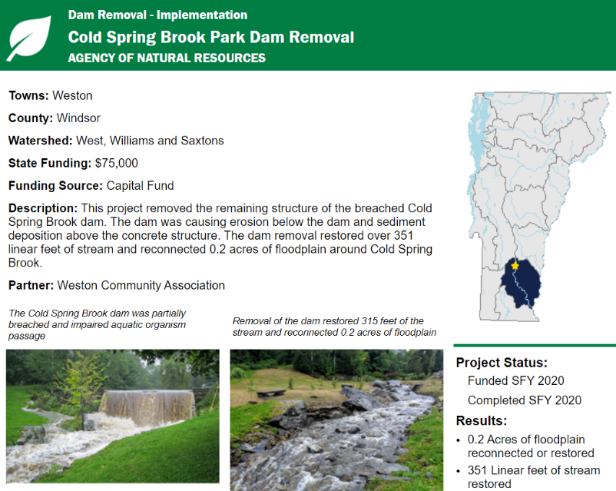
At least one clean water project sign photo taken during project construction must be submitted, if stated in your subgrant agreement. This is a statutory requirement under Vermont Act 84 of 2017, Section 35a.

Photo reporting is an essential component of the grant final reporting process. CWIP collects interim construction photos of implementation projects in order to illustrate the results of clean water projects to the public in the Vermont Clean Water Initiative Annual Performance Report and Clean Water Project Explorer (see example at right).

Photos taken during interim construction with captions can be documented in this form as part of your interim reporting deliverable for implementation projects. If this is a stormwater implementation project that installs multiple BMPs, separate photos must be included for each BMP that will be reported in the Final BMP Report. For these, include Project Name/BMP Type as requested in the template. Below are additional photo templates for this purpose.

Summary of Work to Date:

Precent Progress:

Photos must be a minimum resolution of 300 pixels per inch, and file size must be less than 8 MB. No more than two interim photos with at least one with a visible and readable clean water sign¹

Watershed Projects Database ID
Project Name / BMP Type

Photo #1 w/Signage | Photo #2 (optional)
Photo Caption. Must be one complete sentence describing the location and content of the photo: | Photo Caption. Must be one complete sentence describing the location and content of the photo:
Photo Date: | Photo Date:

¹Clean Water Project signs are required on publicly visible implementation projects, if stated in the grant agreement and the project meets the requirements. Signs should be posted during project construction if the duration of project construction is at least two weeks or if duration of construction is less than two weeks, but the value of the project warrants signage. Signs cannot be posted in areas that may cause traffic hazards and must be located outside road right-of-way. A photo of the sign in place should be submitted with the deliverables. Further information is available at: https://dec.vermont.gov/sites/dec/files/DEC-CWIP_CleanWaterProjectSignsGuidance_FINAL.pdf.

