Appendix H: Enhanced Energy Plan
Introduction
Ludlow’s Enhanced Energy Plan is a component of the Ludlow Municipal Development Plan prepared in accordance with 24 V.S.A., Chapter 117, Subchapter 5. It serves both the Town of Ludlow and Village of Ludlow. The intent of this plan is to address the requirements of Act 174 of 2016 and to meet the enhanced energy planning standards developed by the Vermont Department of Public Service (DPS). This document was prepared based upon the Guidance for Municipal Enhanced Energy Planning Standards (DPS; March 2, 2017) in order for the Ludlow Municipal Development Plan to be given greater weight in the Section 248 process.
The SWCRPC developed a regional energy plan to meet these standards in order to receive Section 248 substantial deference. Ludlow coordinated the development of this municipal energy plan with the SWCRPC so that:
1. The municipal plan is informed by the regional energy planning process; and,
2. The municipal plan is compatible with the regional plan.
This Plan was developed with assistance from the Southern Windsor County Regional Planning Commission (SWCRPC) through funding provided by the Vermont Department of Public Service.
Energy Goals
Through the 2016 Vermont Comprehensive Energy Plan (CEP), the State of Vermont has identified a number of goals and strategies to achieve energy conservation throughout the state. The most significant of these goals being;
By 2050, 90% of Vermont’s total energy will be derived from renewable sources

The CEP includes additional goals to fully achieve the overall, long-term “90x50” goal. These goals serve as the platform for determining energy policies, targets and pathways for the Town and Village of Ludlow, as articulated throughout this plan.
Ludlow’s Energy Goals
The Town and Village of Ludlow hereby adopt the goals established in the 2016 CEP, and through the detailed policies and actions contained in this plan, Ludlow will strive to achieve these goals. Below is a list of some of the methods outlined in this plan to further energy conservation and efficiency efforts within our community:
- Reducing total energy consumption throughout all sectors, including: electricity, space heating, and transportation.
- Support efforts at the local level to choose energy efficient and renewable options.
- Create a diverse mix of energy sources to reduce the impact of supply restriction.
- Utilize local, renewable sources of energy to decrease reliance on out-of-region, and out-of-state forms of fuel.
- Select energy choices that help preserve the environment.
- Strive for both an adequate supply of electricity, as well as a distribution network to meet the region’s needs.
- Maximize energy efficiency by matching fuel type to end use.
- Support adaption and lifestyle changes which are consistent with changes in future energy use and generation.
- Reduce greenhouse gas emissions.
Analysis of Current Energy Use
This section involves a summary and analysis of existing conditions in Ludlow with respect to energy use. Appendix E includes more detailed data figures, which are summarized in this section. This section relies on data analysis provided by the Southern Windsor County Regional Planning Commission and, as such, the Regional Energy Plan for Southern Windsor County contains an important regional context for this analysis of Ludlow’s energy use and targets.
Vermont’s Comprehensive Energy Plan calls for 25% of remaining energy needs will be met by renewable sources by 2025, 40% by 2035, and 90% by 2050.
Electricity
Electricity is provided in Ludlow Village and parts of the Town of Ludlow by Ludlow Electric, and by Green Mountain Power in the rural parts of town. Presently, two transmission lines cross east-to-west across Ludlow. A third transmission line, located in Cavendish, connects into the Coolidge Substation, which is located on the Cavendish/Ludlow town line. Utility Services Map shows these existing facilities. An additional transmission line (i.e. New England Clean Power Link) will bring electricity from Hydro Quebec and connect to the Coolidge Substation has received a Certificate of Public Good, but is not yet constructed [Docket #8400]. The Coolidge Solar project was approved [Docket #8685] and come online in 2019. It involved a short transmission line connection into the Coolidge Substation.
In 2016, residences accounted for 41.5% of the total electricity usage in Ludlow. Commercial and industrial use the remaining 58.5% of the total 46,959,847 kWh used in Ludlow that year. See Figure 2 that summarizes electricity use data provided by Efficiency Vermont. According to Department of Labor statistics, there are 144 commercial establishments in Ludlow. Electricity use has leveled off in recent years.
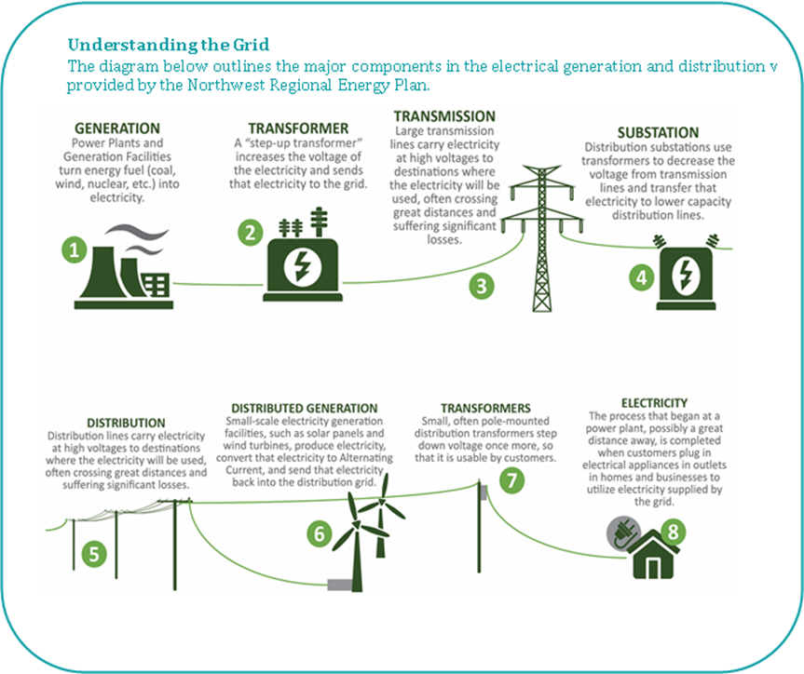
Thermal (Space Heating)
As a ski town, Ludlow has a large number of seasonal housing units. See Figure 3 which summarizes total housing units in Ludlow by type from the 2010 Census Bureau.
According to American Community Survey (ACS) data (2011-2015), the predominant ways to heat homes in Ludlow include fuel oil (61%), propane (17.9%), wood (13.1%) and electricity (6.6%). See Appendix E for home heating data, including estimates for square footage heated and BTUs. Appendix E also includes data about heating the 144 commercial establishments in Ludlow.
Transportation
Ludlow has a network of sidewalks in the village. Bicycling is generally accommodated on the shoulders of the roadway network, some of which are better suited for bicycling than others. Public transportation services are provided by Ludlow Municipal Transit and The Current (Southeast Vermont Transit), with connections to Rutland via The Bus (Marble Valley Transit). In addition, Okemo provides bus service not only for employees but also extensive public ski routes in and around the village. Despite that, the automobile is the primary mode of travel in Ludlow for both commuting and for other daily travel needs, as discussed in more detail in the Transportation Chapter. Common work destinations for residents are Ludlow, Rutland and Springfield. Common home locations for the people who work in Ludlow include Ludlow, Springfield, Chester and Cavendish.
The Green Mountain Railroad hauls freight and offers scenic train excursions, but there is no passenger rail service in Ludlow at this time.
Data was compiled and is presented to understand the existing transportation energy use in Ludlow (see the Appendix E). According to ACS data, there is about 1.7 vehicles per household. The average vehicle miles traveled in a year is estimated at 20,900, which accounts for 1.9 million gallons of fuel used at a total cost of $4.9 million for fuel.
Scenarios (Targets)
The standards that the Department of Public Service has established for targets must be met if this Plan is to receive substantial deference in Section 248 energy siting proceedings. Ludlow is utilizing targets (or scenarios) developed using the Long-Range Energy Alternatives Planning (LEAP) Model and provided to Ludlow by the SWCRPC. The background for the targets are described in more detail in the 2018 Southern Windsor County Regional Energy Plan. The purpose of the targets, when combined with the analysis presented in the previous section, are intended to provide an overview of existing energy use and projections for the pace of change that is needed over the next three-plus decades. In order to meet 90% of Vermont’s energy need from renewable sources by 2050, a significant amount of conservation efforts and the development of new renewable energy generation will be necessary.
In order to meet the 90% by 2050 goal, total energy use in southern Windsor County will need to decrease by 50%. Primarily this must involve a vast reduction in the use of non-renewable fuels, such as gasoline and fuel oil. At the regional level, the LEAP model includes the following generalized assumptions to reach the 90% by 2050 goal:
- Electricity use today is about 20% of total energy consumption, but it will increase to 35% of total consumption in 2050;
- The use of non-renewable fuels will be vastly reduced from about two-thirds today to about 10% by 2050;
- Renewables will increase from about 18% now to more than half by 2050. This involves wood consumption remaining relatively constant and biodiesel usage increasing substantially.
Electricity
Targets for electricity are mixed. Significant efforts to reduce electricity usage through conservation and efficiency measures will be needed. However, the LEAP model utilizes increased use of electricity to achieve the goal for both transportation (i.e. electric vehicles) and space heating (i.e. cold-climate heat pumps). See Figure 1.
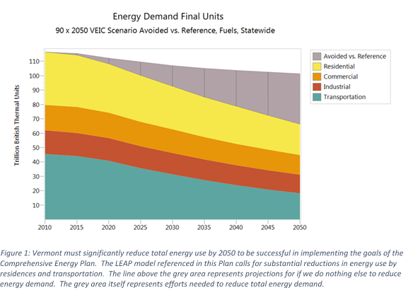
Reducing electricity demand through energy conservation and efficiency measures will involve taking advantage of programs offered by Efficiency Vermont, utilization of high-efficiency/energy star appliances, LED lighting upgrades, and other efforts at energy demand management.
Electricity targets also include the development of renewable energy generation in Ludlow and the surrounding region. The LEAP model also includes additional imported renewable energy from sources such as Hydro Quebec. However, local generation is also required. Targets for local renewable generation are summarized below in Table 1 and discussed in more detail in the renewable siting discussion in the Implementation Actions section.

Table 1: Renewable Generation Targets (in MWh)
 | 2025 | 2035 | 2050
Total renewable generation in MWh | 5,456.25 | 10,912.5 | 21,825
Thermal (Space Heating)
The first step to reduce energy demand for space heating is to encourage homes and businesses to be weatherized (e.g. air sealing, insulation). Table 2 shows the targets for weatherizing existing structures in Ludlow in both percentage of the total existing households and commercial buildings and the number of units of each. We assume that all new structures will comply with the State energy building codes.
Table 2: Thermal Efficiency Targets
Weatherize Homes (percentage, number) | 2025 | 2035 | 2050
 | 17% | 31% | 63%
 | 162 | 296 | 602
Weatherize Commercial Establishments | 4% | 7% | 15%
 | 6 | 10 | 22
The next step is to move toward the widespread utilization of renewable energy to heat homes and businesses. The LEAP model established the following targets for doing so in Ludlow. Table 3 shows the scale to which buildings should switch over to renewable heating systems in order to meet the state energy goals.
Table 3: Use of Renewables for Space Heating
Thermal renewable energy use | 2025 | 2035 | 2050
 | 48% | 63% | 93%
In order to achieve the overall renewable target for heating, the LEAP model is calling for investing in new efficient wood heating systems, cold-climate heat pumps or ground-source heat pumps. (See Table 4.)

Table 4: Thermal Fuel Switching Targets (by Number of Heating Units)
New efficient wood heating systems | 2025 | 2035 | 2050
 | 7 | 18 | 143
New heat pumps | 313 | 846 | 1,630
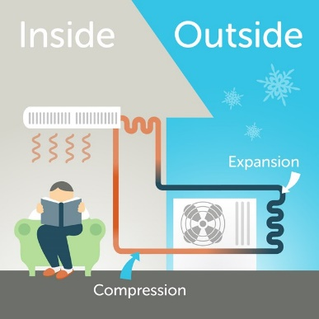
Cold-climate heat pumps are also referred to as air-source heat pumps, mini-splits or ductless heat pumps. These systems are a good option to retrofit existing houses, and can be used to supplement the existing heating system. As explained on the Efficiency Vermont website, “heat is collected from the exterior air, concentrated via an outdoor compressor, and distributed inside through an indoor room unit. Heat pumps require electricity to run, but can deliver more energy than they use.” They also provide air conditioning during the warmer months.
Figure 1: Illustration of how cold-climate heat pumps work. Source: Efficiency Vermont.
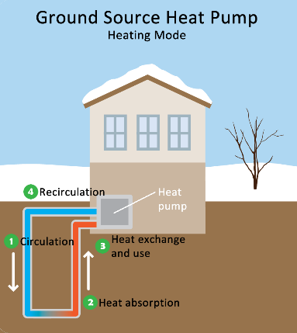
Ground-source heat pumps provide space heating and cooling. It works similarly to an air-source heat pump, but instead pumps water or other fluid through pipes buried in the ground to collect heat. A more detailed description for how these systems work can be found on the US EPA website. These are generally a better option for new construction installations.
Figure 2: Illustration of how ground-source heat pumps work. Source: US EPA.
Heating with wood is common. Wood is a locally-available fuel. However, sustainable wood harvesting is an important consideration to protect the environment and provide a viable, long-term local energy source. New efficient wood stoves that are EPA-certified are encouraged. Wood-chip heating systems are considered a good option to heat larger commercial, industrial or institutional buildings. See the Efficiency Vermont website for more information. A number of schools in the region use such heating systems.
Transportation
Transportation is probably the most difficult area to “bend the curve” in order to meet the energy goals. Changing behaviors is challenging. However, it must be done if we are to achieve the 90% by 2050 goal. The LEAP model used a number of assumptions in addressing this issue. The following targets are based on that LEAP model.

Table 5: Renewable Energy Use for Transportation
Use of renewables for transportation | 2025 | 2035 | 2050
 | 10% | 31% | 90%
Overall, transportation needs to shift to renewable fuel sources as shown in Table 5. The LEAP model is largely expecting this to happen through using electric vehicles, and the use of biodiesel by the trucking industry. Table 6 below shows the fuel switching targets for Ludlow. Efficiency Vermont has information on its website about ways to achieve transportation efficiencies. Also required to meet the goals will be additional efforts to lessen the use of energy for transportation, including land use patterns that encourage walking and bicycling, public transportation, driving less and ride sharing.

Table 6: Transportation Fuel Switching Targets
 | 2025 | 2035 | 2050
Passenger cars switch to electric vehicles | 139 | 955 | 1,965
Trucks switch to biodiesel | 240 | 447 | 744
Implementation Actions (Pathways)
In order to meet our stated energy goals and targets, the Town and Village of Ludlow identify the following implementation actions, also referred to as “Pathways”. The reference numbers used in this section are intended to be consistent with those used in the Guidance for Municipal Enhanced Energy Planning Standards (VDPS; March 2, 2017).
Pathways Standard 6: Conservation and Efficient Use of Energy
a) The Town and Village of Ludlow encourage the conservation and efficient use of energy.
Ludlow has identified the following implementation actions in Sections 6A, 6B, 6C and 6D to achieve this policy.
6A: Encourage Conservation by Individuals and Organizations
Ludlow cannot control the use of energy by individuals and organizations. However, the Town and Village can lead by example, serve as a resource, and encourage individuals and organizations to conserve and use energy efficiently. To do so, Ludlow identifies and promotes the following resources to provide guidance to individuals and organizations:
- Inform residents and businesses about available programs that can assist with energy conservation and efficiency improvements, including:
- Programs available through Efficiency Vermont, such as workshops and educational opportunities to businesses on efficiency in new construction, retrofits, and conservation practices; and,
- Weatherization Assistance Program through SEVCA for low-income households.
- Inform residents about Efficiency Excellence Network (EEN) contractors by providing links to EEN information through the municipal website.
6B: Promote Efficient Buildings
Heating buildings accounts for about 30% of all energy consumed in Vermont. Creating more efficient buildings can be achieved through weatherization and high-performance building methods. Ludlow identifies the following to encourage efficient buildings:
- Promote the use of Vermont’s residential building energy label/score.
- Promote the use of the residential and commercial building energy standards:
- The Planning and Zoning Office will distribute State energy code information to all applicants seeking a zoning permit for a structure that is heated or cooled.
- The Planning and Zoning Office will not issue a certificate of occupancy until the applicant provides a certificate that ensures compliance with the State energy code.
- Promote benchmarking (using the free EPA Portfolio Manager tool and/or with assistance from Efficiency Vermont) for commercial buildings.
- Encourage that all residential and commercial projects follow the stretch energy code or guidelines (see Appendix A in the RBES and Commercial Stretch Building Energy Guidelines).
- Encourage new development to maximize energy efficiencies and to accommodate renewable energy systems. If unable to install renewable energy systems at the time of construction, projects should enable future installation of such systems (i.e. renewable energy ready homes, zero energy ready homes).
- Consider providing incentives (e.g. density bonuses) to developments located in an area identified as appropriate for growth that exceed the state’s energy code.
- Promote the use of landscaping for energy efficiency.
6C: Promote Decreased Use of Fossil Fuels for Heating
Heating buildings accounts for about 30% of all energy consumed in Vermont and is the second largest contributor to greenhouse gas emissions. Home heating is heavily reliant on fossil fuels at this time. Solutions to address this situation involve high-efficiency heating system upgrades and fuel switching. Ludlow identifies the following to encourage using less fossil fuels to heat buildings:
- Provide educational presentations on ways to decrease the use of fossil fuels, in coordination with Efficiency Vermont and Ludlow Electric.
- Promote the use of cold-climate heat pumps for retrofitting existing buildings.
- Support the use of ground-source heat pumps for new construction.
- Promote wood stove change-out programs that take older non-EPA certified stoves out of service and replace them with more efficient and lower emitting cordwood or pellet stoves.
- If renewable energy systems are not practicable, encourage homeowners to replace old furnaces or boilers with a high-efficiency model.
6D: Demonstrate the Municipality’s Leadership by Example with Respect to the Efficiency of Municipal Buildings
Ludlow wishes to lead by example and demonstrate to individuals and organizations the benefits of building efficiency through the following efforts:
- Seek support and guidance from Efficiency Vermont for efforts to improve the efficiency of municipal buildings.
- Assess the life cycle costs of potential energy improvements during design and construction planning. For example, investment in a new, efficient heating system may be more expensive up front, but more economical to operate over time.
- Incorporate weatherization/energy efficiency projects into the municipal Capital Budget and Program.
- The municipality will construct all new public buildings according to standards of energy efficiency at least equivalent to U.S. EPA Energy Star rating or similar certification where it can be demonstrated to be cost-effective.
Pathways Standard 7: Transportation
- The Town and Village of Ludlow encourage the reduction of transportation energy demand and single-occupant vehicle use.
- The Town and Village of Ludlow encourage the use of renewable or lower-emission energy sources for transportation.
Ludlow has identified the following implementation actions in Sections 7A, 7B, 7C, 7D and 7E to help achieve these policies.
7A: Encourage Increased Use of Public Transit
Ludlow operates a municipal public transit service and maintains a municipal park-and-ride lot. Two other public transit operators have routes that serve Ludlow and the additional services provided by Okemo. Maximizing public transit ridership is a priority. Ludlow will implement the following actions to encourage public transit:
- Improve awareness of existing public transit services and taxi service to residents and visitors.
- Assess the coordination of existing services and schedules of the different public transit providers that serve the municipality.
- Plan and advocate for access to public transit, especially during the permit review process for all larger developments.
7B: Promote a Shift Away from Single-Occupancy Vehicle Trips
Public transit can meet the needs of some mobility needs, but additional efforts will be needed in order to reach the energy goals for reducing transportation energy use. Ludlow will work to encourage the following actions to encourage a reduction in single-occupant vehicle trips:
- Encourage improved internet connectivity and speed, especially in the rural parts of Ludlow, in order to enable telecommuting by all residents.
- Promote the Go Vermont webpage, which provides rideshare, vanpool, public transit and park-and-ride options.
- Support employer programs to encourage telecommuting, carpooling, vanpooling, walking and bicycling for employees’ commute trips. Encourage employers to offer such programs and provide information on tax benefits that may be available for doing so.
7C: Promote a Shift Away from Gas/Diesel Vehicles to Electric of Other Non-Fossil Fuel Transportation Options
To meet State energy goals, municipalities will need to contribute toward efforts to reduce the number of vehicle-miles traveled (see 7B), and switch to renewable, non-fossil fuel transportation options. Ludlow has identified the following pathways to shift toward electric vehicles and other non-fossil fuel travel:
- Increase awareness of the benefits of electric vehicles and alternative-fuel vehicles through education and outreach efforts.
- Seek grants to fund the installation of electric vehicle charging infrastructure at strategic locations along major travel corridors and in transit hubs such as park-and-ride locations.
- Encourage the use of the biodiesel in all diesel vehicles without compromising the manufacturer’s engine warranty.
7D: Facilitate the Development of Walking and Biking Infrastructure
Active transportation, such as walking and bicycling, offers significant health benefits and requires no outside energy resources. Ludlow seeks to encourage completing short trips by walking or bicycling instead of by driving, by planning for safe and convenient infrastructure that support “Complete Streets Principles”. In order to do this, Ludlow has identified the following pathways:
- Maintain roads in order to better accommodate travel by bicycles. For example, this includes paving/overlays to maintain a smooth roadway surface as well as sweeping to remove sand, dirt and trash multiple times a year.
- Update municipal road standards (for maintenance and new construction) to reflect complete streets principles.
- Continue to maintain existing walking and bicycling infrastructure in good condition, and seek funding to make strategic improvements to these networks.
7E: Demonstrate the Municipality’s Leadership by Example with Respect to the Efficiency of Municipal Transportation
In order to meet the State energy goals, municipalities should lead by example and demonstrate to individuals and organizations the benefits of energy efficiency in transportation. Ludlow wishes to do so through the following ways:
- Install electric vehicle charging infrastructure on municipal properties.
- Establish minimum fuel efficiency standards for the purchase of new vehicles.
- Provide incentives for employees who commute using methods alternative to single occupancy vehicles, e.g. walking, biking, public-transit, and carpooling.
Pathways Standard 8: Land Use Patterns and Densities
- The Town and Village of Ludlow encourage maintaining the historic settlement pattern of compact village centers surrounded by rural countryside in accordance with 24 V.S.A. §4302.
- The Town and Village of Ludlow recognize that compact development has a number of benefits, including furthering both State planning goals and State energy goals.
- The land use section of the Ludlow Municipal Development Plan (i.e. Section 6: Plan for our Future) encourages the types of land use patterns and densities that are likely to result in the conservation of energy.
- Zoning bylaws adopted by the Town and Village (separately) enable the above land use patterns and densities.
- The State Downtown Board has designated the Village core area as a Village Center under 24 V.S.A. Chapter 76A.
The DPS anticipates that if municipalities are actively participating in the above statutory frameworks for community planning, they will likely meet Pathways Standard 8. Ludlow hereby documents what the municipalities are doing in this area as it relates to encouraging the conservation of energy through land use development patterns and densities.
8A: The Plan Includes Land Use Policies (and Descriptions of Current and Future Land Use Categories) that Demonstrate a Commitment to Reducing Sprawl and Minimizing Low-Density Development
According to the enhanced energy planning guidance, the reduction of sprawl and low-density development not only reduces energy consumption but also can improve the local and regional economy.
- The land use section in the Municipal Development Plan generally calls for growth to occur in the Village Mixed Use area and in discrete nodes of activity, including the Residential-Commercial and Industrial areas, and the Jackson Gore Recreational District. (See Section 6: Plan for our Future and the corresponding Future Land Use Map.)
- Also included in the land use section of the Municipal Development Plan is a statement that discourages sprawl and strip development in the Rural Residential area.
- The transportation section of the Municipal Development Plan (Section 5.3) addresses access management. It notes that VT Route 103 south of the Village and VT Route 100 just north of VT Route 103 both exhibit emerging strip development, and promotes sound access management to address those concerns.
- Ludlow has conducted a sidewalk inventory that assesses existing condition, and has actively been working to seek funding to make sidewalk improvements over the past few years.
8B: Strongly Prioritize Development in Compact Mixed-Use Centers
As indicated in the enhanced energy planning guidance, households within a compact, mixed-use center typically use less energy than those located in outlying areas. The energy savings are realized through reduced vehicle-miles-traveled and generally smaller homes, which require less energy to heat and cool. Transportation energy use can be further reduced by locating services such as shopping or daycare within walking or biking distances to the places that people work and live. This enables people to either choose an alternative to driving a single-occupancy vehicle or to significantly reduce the length of their drive. Ludlow choses to encourage this by:
- Maintaining Village Center Designation, and improving the awareness of property owners of the tax credit opportunities to help pay for improvements to eligible buildings within Ludlow’s Village Center.
- Coordinating with large employers and larger developments to discuss options to promote car-sharing and public transit services, and to install electric vehicle charging stations in convenient locations, such as within the Village Center, municipal park and ride lot or at the ski resort.
- Incorporating priority sidewalk investments, multi-use path needs, parking, and other infrastructure improvements into the Capital Budget and Program in order to support village revitalization.
Pathways Standard 9: Statement of Policy on the Development and Siting of Renewable Energy Resources
The heating, transportation and conservation targets and pathways combined are not sufficient to meet the 90% by 2050 energy planning goal. The LEAP model also assumes the purchase of additional out-of-state renewable energy will help to reach this goal; however, that is also not sufficient to meet the energy goals. New local renewable energy generation is also needed in order to achieve the ambitious “90 by 50” energy goal. The following sections discuss how the municipality wishes renewable energy generation to take place in Ludlow.
9A: Evaluate Existing Renewable Energy Generation
There were 18 known existing solar sites in Ludlow in the 2015 baseline year for this plan, representing 106.7 kW of installed capacity and 130,857 kWh of generation output. There are two known wind turbines in Ludlow at this time; the one off Bixby Roads is net-metered, the one off Holby Road is not. There are no other renewable energy generation sites in Ludlow included in the baseline conditions for the purpose of this plan. In other words, there are no known hydro power or biomass power facilities in Ludlow currently.
There have been proposals in the past to develop biomass or solar generation facilities in the Dean R. Brown Industrial Park, but no such projects are formally being considered at this time.
The Coolidge Solar project was completed and online in 2019. In August 2019, there are 28 solar sites in Ludlow that have a combined annual electricity generation of 24,504 MWh, which already exceeds Ludlow’s 2050 target.
9B: Analyze Generation Potential from Preferred Sites and/or Potentially Suitable Areas
An analysis of renewable energy generation potential was conducted for Ludlow by the SWCRPC. This consisted primarily of an analysis of existing and available GIS mapping data based upon the guidelines established by the DPS for enhanced energy planning. Table 7 below summarizes the findings of this analysis.
Table 7: Potential Renewable Energy Generation
Type | Installed Capacity (MW) | Generation Output (MWh)
Roof-top Solar | 8 | 9,747
Ground-mounted solar | 197 | 242,122
Wind | 1,286 | 3,942,577
Hydro | 0.01 | 28
Total | 1,491.01 | 4,194,474
Based upon this analysis, there is significant potential to generate power from renewable sources in Ludlow, primarily through ground-mounted solar and wind. Potential from hydro and rooftop solar projects is limited. Without ground-mounted solar and/or some forms of wind, there is not adequate generation potential from hydro and rooftop solar to meet the “90 by 50 goal” alone.
9C: Identify Sufficient Land for Renewable Energy Development to Reasonably Reach the 2050 Targets
Table 1 summarizes Ludlow’s overall targets for renewable energy generation. There is more than an adequate land area in Ludlow that has potential for solar power to meet our 2050 renewable energy target of 21,825 MWh. That is the equivalent of approximately 17.8 MW of ground-mounted solar at the installed capacity. The guidance assumes 8 acres of land is generally needed to support 1 MW of solar. This would amount to about 143 acres of land to meet this target. This represents about 9% of the total land area in Ludlow that is estimated to have potential to generate solar power.
A mix of renewable generation types are desirable in order to meet the overall renewable targets for Ludlow. The following more detailed targets represent one scenario for how Ludlow can meet the overall renewable generation target for the municipality. Rooftop solar is desirable. Ground-mounted solar is encouraged in the rural parts of Ludlow only as long as it meets our siting criteria as articulated in this plan. Residential-scale wind is also encouraged in the rural parts of Ludlow only.
Retrofitting existing dams with hydro-power generation facilities is acceptable. We assume that creating new hydro facilities is not feasible considering the existing permitting situation. A biomass facility may be acceptable if it is located in the industrial park and can demonstrate that an adequate and sustainable fuel supply is available and that the fuel transport does not cause undue impacts on the affected infrastructure or neighborhoods.
9D: Ensure that Local Constraints do not Prohibit or Have the Effect of Prohibiting the Provision of Sufficient Renewable Energy to Meet State, Regional or Local Targets
Local constraints for renewable energy generation are as summarized in this section. These constraints have been analyzed, and the Town and Village of Ludlow do not believe that these constraints prohibit or have the effect of prohibiting sufficient renewable projects needed to meet the state, regional or local energy goals.
The following resources are not appropriate locations for renewable energy projects and are hereby excluded from the potential wind and solar sites as depicted on the map:
a) Vernal pools with a surrounding 50 foot buffer;
b) DEC river corridors;
c) FEMA floodways;
d) State significant natural communities and rare, threatened and endangered species;
e) National wilderness areas; and,
f) Class 1 and Class 2 wetlands.
Ludlow has determined that ground-mounted solar and wind turbines at all scales are not appropriate within the state-designated Village Center district and the Preservation District (as depicted on the Official Zoning District Map in effect at the time of the application).
Only residential-scale renewable energy projects are appropriate for the remainder of the area within the Incorporated Village of Ludlow.
The following represent constraints that will require mitigation and which may prove a site unsuitable after a site-specific study has been conducted based upon state, regional or local policies that are adopted and currently in effect.
a) Agricultural soils (NRCS-mapped prime agricultural soils, soils of statewide importance or soils of local importance);
b) Act 250 agricultural soil mitigation areas;
c) FEMA special flood hazard areas (floodplain);
d) Protected lands (state fee lands and private conservation lands);
e) Deer wintering areas;
f) ANR conservation design highest priority forest blocks; and,
g) Hydric soils.
In addition, all renewable energy projects within Ridgeline Overlay District (as depicted on the Official Zoning District Map in effect at the time of the application) must demonstrate that they have taken adequate measures to mitigate their visual impacts as discussed in more detail in the Scenic Resources section of the Ludlow Municipal Development Plan.
9E: Statements of Policy to Accompany Maps
Ludlow hereby promotes the development of renewable energy generation in order to achieve the energy goals and targets as established in this plan. The following statements of policy apply to renewable energy projects:
- Ludlow supports rooftop solar projects.
- Ludlow supports residential-scale wind turbines located outside of the Incorporated Village Boundary, provided they meet all other applicable standards in this section.
- Ludlow is willing to consider additional larger renewable energy projects (i.e. commercial- or utility-scale wind and solar projects over 500kW in capacity) if the proposed project clearly benefits rate payers in Ludlow and meets the other standards in this plan.
- Biomass facilities, ground-mounted solar projects and wind turbines must not be located in the following areas:
- Vernal pools with a surrounding 50 foot buffer;
- River corridors as most recently mapped by the Vermont DEC;
- FEMA floodways;
- State significant natural communities and rare, threatened and endangered species;
- National wilderness areas;
- Class 1 and Class 2 wetlands;
- State-designated Village Center district;
- Preservation District as depicted on the Official Zoning District Map in effect at the time of the application; and,
- Within view of the Scenic Route 100 Byway.
- Residential-scale wind turbines shall be allowed within the Village of Ludlow, outside of the state-designated Village Center and Preservation District.
- Biomass or ground-mounted solar projects must demonstrate that the proposed project siting is appropriate in scale as it relates to the character of the area in which it is to be located, and the applicant must also demonstrate that all reasonable options have been considered in siting the facility.
- All ground-mounted solar projects must meet or exceed the setback standards is 30 V.S.A. §248(s).
- Any biomass facility and all ground-mounted solar projects of 150 kW or greater that are within view of public roadways (i.e. state highways, US routes, and Class 1, 2 and 3 town highways) must provide adequate landscaping in order to screen the project from the view of the traveling public.
- This landscaping must consist of a mix of native plants that provide adequate screening during all months of the year (i.e. conifers or a mix of deciduous and conifers).
- All landscaping materials must be planted at a size that provides adequate screening immediately.
- The applicant must maintain any required landscape mitigation for the entire life of the project, including the replacement of any dead or diseased vegetation serving as part of the landscape mitigation measures throughout the life of the project or until the project ceases commercial operation.
- The applicant must provide a plan for the site to be adequately decommissioned at the time when the project ceases commercial operation. This would involve the removal of all parts of the project from the site including, but not limited to, the solar panels or wind turbine, inverters, metal framework that supports the solar panels, fencing, and any necessary site reclamation.
- Ground-mounted solar facilities and wind turbines must not have undue adverse impacts on significant wetlands, significant wildlife habitat, wildlife travel corridors, stormwater, water quality, flood resiliency, important recreational facilities or uses, scenic resources identified in this plan, or inventoried historic or cultural resources. Project proposals must consider placement of such facilities in locations where aesthetic and wildlife impact is minimal or employ reasonable measures to mitigate undue adverse impacts.
9F: Maximize the Potential for Renewable Generation on Preferred Locations
Preferred locations include specific areas or parcels that are specifically identified to indicate preferred locations for siting a generator or a specific size of type of generator. Identifying preferred sites informs the community where renewable generation is desired. The identification of such sites can help to streamline the permitting process.
Preferred sites for Ludlow include:
a) A canopy over paved parking lots;
b) Brownfield sites;
c) Disturbed portions of extraction sites (i.e. gravel pit, quarry); and,
d) Vacant parcels located within the Dean R. Brown Industrial Park.
9G: Demonstrate the Municipality’s Leadership by Example
The Town and Village of Ludlow will lead by example by working with the Ludlow Economic Corporation and other partners to identify opportunities for local renewable energy generation that benefits the community and furthers the goals and policies of this plan.

Ending in 2020
A Certificate of Energy Compliance was issued for Ludlow’s Plan on February 11, 2019

