Mt. Ascutney outdoor Recreation
Implementation
June 2019
prepared for:
Southern Windsor County Regional Planning Commission
Prepared by:
SE Group
This report is part of a larger recreation plan being compiled by the Southern Windsor County Regional Planning Commission. It summarizes the implementation process strategies around enhancing outdoor recreation in the Mt. Ascutney region. The primary goal of this document is to communicate the strategies the regional planning commission, towns, and other local entities can employ in order to advance the recommendations of this plan. This report takes into account the inputs heard throughout the planning process, the economic analysis, and local capacities towards implementation. A phasing strategy, cost estimates, and list of funding opportunities give those implementing the plan the necessary tools and information to do so. The approach to enhancing outdoor recreation in the region is flexible, allowing the communities to respond to changing conditions and new opportunities.

Scenarios and Phasing Strategy
The Mt. Ascutney Outdoor Recreation Plan recommends the following six scenarios described below. The scenarios are groupings of projects used to develop a phasing strategy and economic impact analysis. The projects were identified and developed by the steering committee and community stakeholders. The scenario groupings were based on improvement type, intended user groups, geographic area, and connection to a larger network. A detailed analysis can be found in the project scenario matrix. It is important to note that additional planning may be needed prior to the implementation of each project. The scenarios are listed according to their phasing/level of priority for implementation.
The phasing strategy should generally direct future investments and implementation efforts, but the local communities in the region and their recreation partners should “chip away” at all of the envisioned projects as specific opportunities or partnerships arise.

1. Around Mt. Ascutney
Mt. Ascutney is a popular destination for hiking, mountain biking, skiing, and horseback riding. The sides of the mountains are under many different landowners, but there is strong interest in connecting these lands (and the trail systems on them) to offer a greater recreation amenity. A trail around Mt. Ascutney would be 14 to 18 miles of multi-use trail connecting the existing trail systems. The Weathersfield Town Forest, on the southern flank of the mountain, currently lacks a formal trail system. The Town Forest Plan outlines a trail system on the town forest that would offer opportunities for beginner and intermediate trail users. Implementation of the Town Forest Plan will also provide access to existing trails from the southern side of the mountain.

Projects
- Trail Around Mt. Ascutney
- Weathersfield Town Forest

Phasing/Implementation
Projects around Mt. Ascutney have the most opportunity to enhance visitation to the area and should be a priority for implementation. The Trail Around Mt. Ascutney is important for the connections it will create within the existing trail networks and for opportunities provided to multiple user groups and ability levels that would support local and visitor use. The trail crosses multiple properties (much of it public land), creating complexities in management and implementation. Acquiring the right-of-way across private land will be a key priority. A trail assessment should be undertaken to inventory needs/issues of the existing trail system. Opportunities do exist to engage volunteer groups to assist with trail construction and maintenance. Outreach to those groups should occur early in the process.
The Weatherfield Town Forest Plan is a significant body of existing planning work ready to be carried forwards towards implementation.
Coordination between the stakeholder groups and land managers will be essential as this project moves forward.

2. Southern Trail Updates (Cross Town Trail)
The Town of Weathersfield, on the southern end of the planning area, has many trails across public and private land. Formalizing these trails into larger system would enhance the recreational opportunities in this area by providing a longer multi-use destination trail for locals and visitors. This connected trail would be known as the Cross Town Trail and would be approximately 8 miles long. It would connect the scenic ridges and valleys of Weathersfield to the Connecticut River. The Crown Point Road Trail is similar in scope and connects numerous recreation areas within the town as well.

Projects
- Formalize existing trail - Weathersfield Center Road to Graveline Road
- Formalize existing trail - Pent Road to Goulden Ridge Road to Yewell Lane
- Formalize existing trail - Yewell Lane to Cooks Pond Road
- Formalize existing trail - Cooks Pond Road to Gird Lot Road and Bowden Hill Road
- Formalize existing trail - Bowden Hill Road to Ferry Road
- Formalize existing trail - Greenbush Road to Stoughton Pond Trail to Plains Road to Crown Point Road to Golf Course Road

Phasing/Implementation
This Cross Town Trail and the formalized connections would provide a high level of community benefit and local use, and is likely to attract visitor use and additional visitors as well. Therefore, this report and the stakeholders have considered this scenario a moderate/high priority.
The challenges towards implementing the project will depend on the existing trail conditions and a trail assessment will be needed to understand the scope. It is possible that new trail segments may be needed. The greatest challenge likely lies in securing access and future management, as each of the existing trail segments cross multiple private parcels. Costs of these projects are expected to be moderate and many funding options do exist towards lowering the financial burden and the projects can easily be completed in phases.

3. Snowmobile Scenario
Snowmobiling is a popular sport in Windsor County as the local Vermont Association of Snow Travelers (VAST) trail network provides many riding opportunities. These projects help address issues around access to the trails by creating a new parking lot and trail connection to the network.

Projects
- Snowmobile Parking in Brownsville
- Trail Connection to VAST Network

Phasing/Implementation:
These projects are expected to bring a strong level of community and economic benefit. The projects will create connections to the existing trail networks and see use from locals and visitors, likely attracting further visitation to the area.
The challenges around implementation are expected to be moderate. The short trail connections would be easy to implement, but the bridge would require engineering. The level of difficulty around securing access is unknown until exact alignments are determined, but likely multiple landowners would be involved. Although costs of the projects could be high, especially with the bridge, the local snowmobiling club is excited to begin work on this project and funding sources are available.

4. Windsor & River (Connections)
This scenario focuses on connecting the Village of Windsor with the surrounding recreational landscape. The Artisan Park Path would create a much-needed off-road connection between the village and the businesses at Artisan Park and a trail opportunity leading right from the village. Creating a connection and amenities around the Connecticut River is another important element of this scenario. A new pocket park, the River Street overlook, would provide people with a place to relax and enjoy the view. Canoe launches in the village and at Sunset Boulevard add access points to the river. Formalizing the Mill Pond Condos trail creates another important connection for the village by linking it to Swoops and Loops, Mount Ascutney State Park, and the future Trail Around Mt. Ascutney.

Projects
- Artisan Park Path
- New Connecticut River Access
- River Street Overlook
- Formalize Trail from Mill Pond Condos to Swoops and Loops

Phasing/Implementation:
These projects create a connection to existing trails and recreational amenities and would likely be well used by locals. Between the projects, there is some variability in expected use among visitors, ranging from moderate (River Street overlook, and the Connecticut River access), to high with the trail connecting Windsor village to Swoops and Loops.
The challenges towards implementing each of the projects varies as well. The new Artisan Park Path would have significant challenges associated with securing access and new trail construction; challenges with the boat ramp would be low to moderate as the town owns the land and a few facilities and structures would need to be added or upgraded and costs are expected to be moderate as well; the River Street overlook would be relatively easy and inexpensive, as the project adds benches, signage, and other small infrastructure and it is town land, but conflict with the neighboring property may occur; formalizing the Mill Ponds Condos trail would be moderately challenging and come at a moderate expense, given the necessary trail assessment, upgrades to existing trails, and multiple private landowners.
Each of these projects could likely be conducted in phases as funds or access becomes available to complete part of the project.

5. Northern Trail Updates
This scenario combines a variety of trail improvements that in combination, enhance the recreational opportunities in the area. These projects focus more on local users and are less likely to bring in visitors. The Ascutney Basin-Yale Heights Trail connection would fill an important gap by increasing the availability of beginner mountain biking trails in the area as much of the existing system focuses on intermediate and advanced riders. Grasslands WMA trail is also a great opportunity to increase equestrian and beginner mountain bike access. The other two projects would reconnect a road (Connection via Brook Road) and create a connection to the Mill Pond Condos trail (Transmission Line trail).

Projects
- Ascutney Basin-Yale Heights Trail Connection
- Connection via Brook Road
- Formalize existing trail - Transmission Line in Windsor
- Formalize existing trail - Grasslands WMA

Phasing/Implementation
Given the moderate local use and low visitor use expected, this scenario is a lower priority. These projects may provide some level of community connection possibly, but the level of community benefit is expected to be moderate. Adding to the challenge, there is no obvious group to volunteer and support these efforts.
Implementation of each of these projects is expected to be moderately challenging. The connection via Brook Road may be the most challenging and expensive, as it would require a new multi-use bridge and trail section and road improvements and would cross multiple privately-owned parcels. The transmission line trail would likely be next most challenging, as coordination with the power company would be necessary and significant trail connections may be required. The Ascutney Basin-Yale Heights Trail Connection would be moderately challenging to implement, as a trail assessment is required, upgrades and a bridge are needed, it would cross multiple privately-owned parcels. However, it would be easy to manage and the costs are expected to be low. The formalization of the Grasslands WMA trail would likely be the easiest, although the level of trail upgrades to the existing social trails is uncertain until a trail assessment is conducted.

6. ATV Scenerio
At present, there are few options in the area for ATV use and opening the sand pit would provide occasional access for riders in the area.

Projects
- ATV use at the sand pit

Phasing/Implementation
At present, ATV use is low in the region and thus this project is not expected to create a connection or encourage much local or visitor use. Although this makes the project relatively low priority, it may not be particularly challenging to implement. The challenges associated with the project would be dependent on the site chosen, but likely it would occur on town land where securing access and management would be relatively easy. The project is not expected to be expensive but funding sources may be limited.

Project Development Process
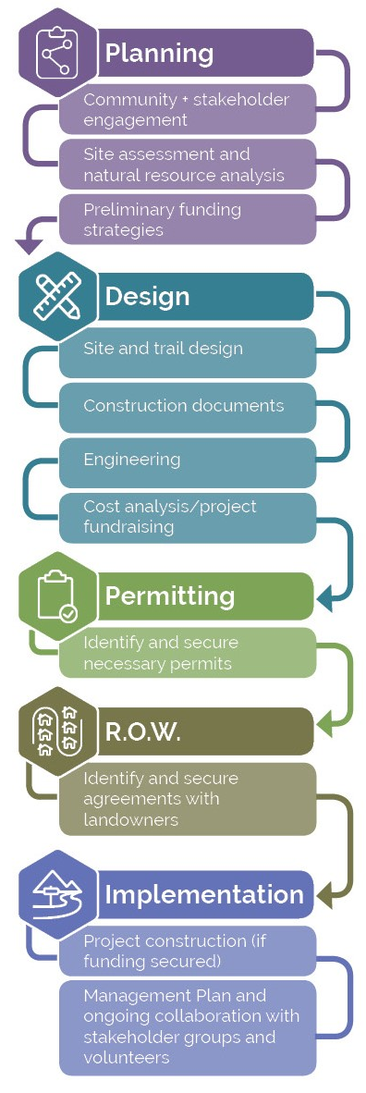
The process of advancing a new trail or recreation project forward from a broader master planning process involves a number of steps. While the sequencing and complexity of these steps will vary widely based on the project, some process steps are almost universally needed to take “ideas” into “action.” The four core steps towards project implementation are planning, design, permitting and right-of-way/ownership.
Planning is foundational to advancing any idea. The various options explored in this document certainly resonated with many in the community, but more planning is needed. A good planning process will include additional community outreach for detailed discussions on the proposed project in and community concerns. This process should look at how projects address local needs and if local policies are needed. More rigorous natural and cultural resource analysis and assessments may be needed to help clarify what local resources might influence the alignment of trails and position of trailheads. Some assessment efforts are time-dependent (e.g., it’s hard to delineate wetlands during the middle of winter). Preliminary engineering should also be undertaken to better define issues related to bridges, grading and stormwater. The planning phase is also a great time to start fundraising. Grants may be available to provide resources to help advance ideas.
Design follows planning. With the clarity of planning, design efforts can be more productive. Then the trail experience can be explored and the pen put to paper. It is during this stage where the ideas for alignments, results of assessments, and input from the public come together. It is also where more detailed engineering analysis occurs, and costs are more refined. At this stage, fundraising should really take off, as more detailed cost estimates are known. Design is often very iterative; projects might need to be re-evaluated or redesigned based on costs, permitting, and other constraints.
Permitting assures what is done is done right. Seeking approvals is often done in conjunction with the design process and the difficulty varies depending on the nature of the improvements. Vermont does not have a pre-determined level of permitting for recreational development, but as a rule, if a project involves trails or recreational improvements in areas of identified natural or cultural resources, some level of permitting is needed. The permitting process is about communicating how the design, construction/project implementation, and proposed operations would not or would minimize potential impacts to natural and cultural resources.
Gaining right-of-way is essential to success. Land access is a common challenge in the implementation of trails and recreational improvements. There are many factors in play through this process: How many landowners must grant access? Do the landowners have conditions that must be satisfied to allow access? Is access granted through a legal instrument or is it handshake deal? Throughout the implementation process, a concerted effort is needed to reach out to landowners to keep them engaged in the planning process, share with them the results of the design efforts and, in some cases, work with them on permitting. Their feedback and requested changes may be essential to realizing the project. Making the landowner a partner in the process will advance the project implementation.

Funding Opportunities
Many recreation enhancement strategies and projects require financial resources. Luckily, there are many grants and alternative funding sources that can help provide the necessary funding. In many cases, the best approach to move a project forward is to select a project with strong community support, secure grant funding, and leverage local resources and volunteers.
Below is a list of grants and funding sources available as of June 2019. The description of each grant below suggests the types of projects the grant funds, the required match if necessary, and a link for more information.
While many of these grant programs are offered year over year, they can evolve, change, or be dismantled over time. Thankfully, the Agency of Commerce and Community Development maintains an updated list of grant opportunities available on their website https://accd.vermont.gov/. Check the site for updates on these and other grant programs in the state.
Non-grant funding sources are included at the bottom of this list. As this is a three-town region and many of the projects cross town boundaries, utilizing many of these funding sources may present an additional challenge. Certain revenue sources may only be available for projects within the town, while other sources could go towards cross-town efforts.

Federal and State Grants and Programs

Land and Water Conservation Fund State and Local Assistance Program (LWCF)
The Land and Water Conservation Fund (LWCF) state assistance program provides matching grants to help local communities enhance the outdoor recreation resources on public land. LWCF funding has benefited nearly every county in America, supporting over 40,000 projects. The grants create parks and open spaces, protect wilderness and forests, and provide outdoor recreation opportunities. Eligible projects are acquisition of land for parks and public outdoor recreation or development and/or renovation of existing facilities for outdoor recreation. This 50:50 matching program is the primary federal investment tool to ensure that families have easy access to public, open spaces. In Vermont, LWCF is administered by Vermont Department of Forests, Parks & Recreation.
http://fpr.vermont.gov/recreation/grants/lwcf

Surface Transportation Block Grant Program (STBG)
The State Surface Transportation Program (STP) is the main program of Federal Transportation Funds, managed by VTrans, for transportation improvements on state highways. Possible projects include recreational trails, pedestrian and biking enhancements, sidewalks, and signed routes.
https://www.fhwa.dot.gov/specialfunding/stp/

USDA Rural Development Loan and Grant Assistance (RD)
USDA Rural Development (RD) forges partnerships with rural communities (defined as towns and villages with less than 20,000 inhabitants), funding projects that bring housing, community facilities (including trails and active transportation facilities), business guarantees, utilities and other services to rural America. This program provides funding to develop essential community facilities in rural areas. An essential community facility is defined as a facility that provides an essential service to the local community for the orderly development of the community. Relevant to this plan, possible projects include transportation facilities, parks, and community gardens
http://www.rd.usda.gov/programs-services/community-facilities-direct-loan-grant-program

National Park Service Rivers, Trails, and Conservation Assistance Program (RTC)
The National Park Service Rivers, Trails, and Conservation Assistance (RTC)program supports community-led natural resource conservation and outdoor recreation projects across the nation. Their national network of conservation and recreation planning professionals can partner with community groups, nonprofits, tribes, and state and local governments to design trails and parks, conserve and improve access to rivers, protect special places, and create recreation opportunities. Current projects include trail rehabilitation, interpretive trails, connector trails, trail master plans, trails collaboratives, and rail trail connectors. No monetary grants are made.
https://www.nps.gov/orgs/rtca/index.htm

FHWA Recreational Trails Program (RTP)
The Recreational Trails Program (RTP) provides funds to communities for development and maintaining recreational trail projects. Grants are awarded to well-planned projects that help to develop, protect, and maintain trails and trail systems that improve connections in the community, livability, user-ability, and are maintained for public recreational use. RTP funds support a wide range of trail activities including hiking, mountain biking, walking, running, cross-country and backcountry skiing, nature-based interpretive trail use, equestrian, snowmobiling, and off-road motorized recreation. Funds can be used for the following types of projects: construction of new trails or trail connections; construction of new trailhead areas/parking facilities; construction of trailside facilities; maintenance, renovation, or restoration of trails; improvements to signage or trail structures along the trail; assessments of existing trail conditions for accessibility and improvements; equipment; and trail-related educational projects (i.e., information about trail safety, appropriate trail use, environmental protection, etc.). The program is administered by Vermont Forest, Parks and Recreation in cooperation with VTrans.
http://fpr.vermont.gov/recreation/grants/rtp

Transportation Alternatives Program (TAP)
The Transportation Alternatives Program (TAP) is a grant program administered by VTrans that provides funding for programs and projects defined as transportation alternatives, including on- and off-road pedestrian and bicycle facilities, sidewalks, and bicycle infrastructure. These funds will cover a maximum of 80% of the project with the remaining portions most likely coming from the project-sponsoring organization or town.
http://vtrans.vermont.gov/highway/local-projects/transport-alt

VTrans Bicycle and Pedestrian Program (BPP)
The Vermont Bicycle and Pedestrian Program provides funds managed by VTrans for scoping, design, and construction of bike and pedestrian facilities, sidewalks, shared-use paths, and bike lanes. A local match is required but varies based on the type of project.
http://vtrans.vermont.gov/highway/local-projects/bike-ped

Downtown Transportation Fund
State grants for municipalities to finance transportation-related capital improvements in support of economic development, within or serving a state designated downtown. Projects can include construction or alteration of roads and highways, parking facilities, pedestrian and streetscape improvement, bike and pedestrian paths, and underground relocation of electric utility, cable, and telecommunications lines. Grants can be awarded up to $100,000, but cannot exceed more than 50% of the overall project costs and a 50% match is required.
https://accd.vermont.gov/community-development/funding-incentives/downtown-transportation-fund

Vermont Community Development Program (VCDP)
The Vermont Community Development Program provides Community Development Block Grants (CDBG) to all Vermont towns and cities, aside from Burlington. The grant provides financial and technical assistance to identify and address local needs in housing, economic development, public facilities, public services, and handicapped accessibility modifications. The four types of grants are Accessibility Modification Grants (AM), Implementation Grants (IG), Planning Grants (PG), Scattered Site Grants (SS). These grants must primarily benefit persons of low and moderate incomes.
http://accd.vermont.gov/strong_communities/opportunities/funding/vcdp

State Grants and Programs

Vermont Community and Urban Forestry Council Grants
(Caring for Canopies Grants, CCG)
These Caring for Canopies Grants (CCG)are awarded to municipalities to aid in taking the necessary actions to developing and sustaining a community-wide tree program, including tree plantings, inventories, maintenance, and planning. There are two grant categories, Caring for the Canopy and Canopy Mini. Caring for Canopy is for projects that help move a community’s tree management program towards a sustained level while Canopy Mini is for smaller projects to help move a tree management program forward. The grants range in size from $500 to $5,000 and require a 50% match.
https://vtcommunityforestry.org/programs-0/financial-assistance/caring-canopy-grants

Municipal Planning Grant Program (MPG)
The Municipal Planning Grants (MPG) are Vermont state grants for a wide range of municipal planning projects including land use plans, zoning and subdivision bylaws, trail networks and walking and biking improvements, resiliency planning, economic plans, and village and neighborhood planning. The range of the grants is from $2,500 to $20,000 with a required 10% match.
http://accd.vermont.gov/community-development/funding-incentives/municipal-planning-grant

Recreational Facilities Grants Program (RFG)
The Recreational Facilities Grants (RFG) program provides matching state grants for capital costs associated with the development and creation of community recreational opportunities. This program provides last gap funding for shovel ready projects and does not support any ongoing fundraising initiatives. The program requires a 100% match and awards are capped at $25,000.
https://bgs.vermont.gov/commissioner/building-communities-grants

ANR Ecosystem Restoration Grant Program (ERG)
The ANR Ecosystem Restoration Grant (ERG) program gives grants for design and construction projects that target nonpoint sources of pollution that cause or contribute to the state’s surface waters.
http://dec.vermont.gov/watershed/cwi/grants#Ecosystem%20Restoration

Better Connections Program (BCP)
The Better Connections Program (BCP) seeks to align state and local investments to increase transportation options, build resilience, and strengthen economic vitality in Vermont’s community centers, through an annual grant program administered by VTrans, in partnership with the Vermont ACCD. Municipalities annually compete for approximately $200,000 in projects funds. A 10% local cash match is required. The program supports implementation-focused, municipal planning initiatives that: provide safe, multi-modal and resilient transportation systems that supports the Vermont economy; support downtown and village economic development and revitalization efforts; and lead directly to project implementation. The program has been used for trails and active transportation master plans, village connection planning and other multi-modal planning efforts.
http://vtrans.vermont.gov/planning/projects-programs/better-connections

Vermont Outdoor Recreation Collaborative Community Grant Program (VOREC)
The Vermont Outdoor Recreation Collaborative (VOREC) launched a community grant program for outdoor recreation in Vermont municipalities. The grant is designed to help communities leverage their local outdoor recreation assets and applying communities must have completed some prior planning or mapping of outdoor recreation assets, have identified outdoor recreation as a component of their local economy through previous plans, and have a dedicated staff and/or volunteers to ensure long-term success of the project. The funds can be used for consultants, small scale outdoor recreation infrastructure improvements, materials or equipment to support outdoor recreation programs, marketing relating expenses, community based outdoor recreation planning, and securing public access through acquisition of land, easements, or rights-of-way. Communities are also responsible for making products and deliverables that could be adapted and reproduced by other communities in the state. The program is administered by Vermont Forests, Parks and Recreation in partnership with ACCD and VOREC and offers grants between $10,000 and $100,000.
https://fpr.vermont.gov/VOREC_Community_Grant

State Organizations Grants

Vermont Community Foundation – General Grants (VCF)
A variety of grants are available to support projects to improve environmental sustainability, cultural heritage, social justice, historic preservation, and vitality of Vermont communities. The different types of grants offered include: Place-Based Grants, Arts Endowment Fund, Special and Urgent Needs, and Nonprofit Capacity Building. Each place-based grant is only available to a specific region of the state. For information about which grants are available for your community, please see the website below.
http://www.vermontcf.org/Nonprofits/AvailableGrants.aspx

Vermont Community Foundation – Nonprofit Capacity Building (NPCB)
The Nonprofit Capacity Building program is small grants to support the cost of consultants to facilitate discussions related to strategic planning, financial sustainability funding, or facilitating a merger. These grants are meant to supplement other funding. This grant is available to both nonprofits and municipalities.
https://www.vermontcf.org/NonprofitsGrants/AvailableGrants/NonprofitCapacityBuilding.aspx

Vermont Housing and Conservation Board Local Conservation Projects (VHCB)
The Vermont Housing and Conservation Board (VHCB) provides funding to conserve natural areas, recreation lands, and historic properties. For public outdoor recreation projects, VHCB provides loans to enable the project to leverage other funds or grants in cases where local efforts to obtain sources of funding have been exhausted. The available funds vary based on whether the parcel has statewide significance. For conserving locally-significant land, other sources must provide one-third of the project funding. VHCB also provides funding for feasibility analysis, project-specific capacity (i.e., engineering work, historic preservation analysis, and hazardous materials analysis).
https://vhcb.org/our-programs/conservation/apply-for-funding

Lintilhac Foundation (LF)
The Lintilhac Foundation’s (LF) central purpose is to support organizations that are making sustainable, positive change for Vermont’s environment and its people. Grants are available in three core giving areas, water quality, energy, and conservation. The conservation giving is primarily to backcountry recreational access to lands and integrative land use planning.
http://www.lintilhacfoundation.org/application-guidelines/

Vermont Arts Council Animating Infrastructure Grant (AIG)
The Animating Infrastructure Grant (AIG) funds projects that integrate public art into existing or proposed infrastructure improvements, which could include buildings, recreational paths, parks, bridges, small-scale renewable energy projects, and water treatment facilities.
http://www.vermontartscouncil.org/grants-and-services/organizations/animating-infrastructure

Ben & Jerry’s Foundation (BJF)
The Ben & Jerry’s Foundation (BJF) funds multiple grants programs to help communities in Vermont. The Vermont Economic Justice Program gives grants to non-profits working to address the economic, social, and environmental impacts of poverty. The Vermont Community Action Team Grant is a small grant awarded to non-profits, schools, and municipalities. The Community Action Teams provide general or project support, and fund the following types of community programs: social services organizations, cultural, recreational, arts programs, and community celebrations.
https://benandjerrysfoundation.org/vermont-grant-programs.html

National Organizations Grants

PeopleforBikes Community Fund (PBCG)
The PeopleforBikes Community Grant Program (PBCG) provides funding for important and influential projects that build momentum for bicycling in communities across the U.S. These projects include bike paths and rail trails, as well as mountain bike trails, bike parks, and large-scale bicycle advocacy initiatives. PeopleforBikes will fund engineering and design work, construction costs, and reasonable volunteer support costs. The maximum grant award is $10,000 and the grant cannot make up more than 50% of the total project budget.
http://www.peopleforbikes.org/pages/community-grants

Robert Wood Johnson Foundation Grants (RWJF)
The Robert Wood Johnson Foundation (RWJF) provides grant funds to improve the health and health care of all Americans. RWJF awards grants for projects creating healthier communities. This funding has gone towards walking and bicycling facilities and upgrading underutilized green space.
https://www.rwjf.org/en/how-we-work/grants-and-grant-programs.html

Trails Connecting People with Nature (TCPN)
Trails Connecting People with Nature (TCPN) is a Sierra Club initiative that works to ensure that access to the outdoors is increasingly equitable and available to all communities. The Sierra Club Foundation awards one-year trail grants ranging from $5,000 to $20,000 towards trail creation or maintenance projects that engage new leaders and provide opportunities for communities to connect with nature.
https://content.sierraclub.org/ourwildamerica/nearby-nature

Non-Grant Funding Sources

Development Impact Fees
A Development Impact Fee is an assessment on development used to pay for its proportionate share of the impacts to public facilities. Some communities assign a standard dollar figure to the public sites, some use a park, pedestrian improvements, trails and open space development impact fee, while others allow for the dedication of parkland, or fee-in-lieu, in place of the impact fee. A full spectrum of leisure services which contain costs for recreation centers, trails and open space, in addition to parks, has been included in some communities’ development impact fees. Some of these development impact fees could contribute to a fund to support enhanced community and pedestrian accommodations.

Bond Issues
Bonds issued by the town may provide important opportunities to leverage other funds, such as required match amounts for federal or state grant programs, and regional bonds may be needed for larger scale projects.

State Infrastructure Bank Loans
A state low interest loan program for the construction or reconstruction of highways, roads and bridges, and pedestrian facilities. Loans may also be available for certain capital facilities such as public transit or electric vehicle charging stations. There is no minimum or maximum but the loan term may not exceed 30 years and requires borrower equity of 10-20%. For municipal borrowers, it is a 1% fixed loan. The program is operated by the Vermont Economic Development Authority in conjunction with VTrans and Federal Highway Administration. There is no deadline, as it is an ongoing program.
https://www.veda.org/financing-options/other-financing-option/state-infrastructure-bank-program/

Tax Credits
State and federal tax credits are available for rehabilitation of historic buildings. From the state of Vermont, tax credit is available for qualified historic rehabilitation, façade, code and technology upgrades for properties constructed before 1983 located within a state designated downtown or village center. The credit can be between 10 and 50% of eligible expenditures.
Federal tax credit is available for 20% of the rehabilitation costs (including labor, materials, and architects and other consultant fees) for income-producing buildings listed in the National Register of Historic Places.

Local Funds
Local funds are sources of funding that are provided by local governments through local budgets or funds other than bonds. Capital Improvement Plans can be leveraged to help advance specific initiatives. Aligning the long-term capital program with initiatives outlined in this master plan should be a priority, particularly for the key initiatives that have been identified.

Private Donors and Fundraising
Funds can be provided by private donors or through special fundraising efforts which can supplement or substitute for local funds. In many communities, the design of specific improvements is often crafted to encourage private donations; donor benches, bricks, trees. The use of private funding is often less constrained and restricted and opens up new or expansive opportunities for creativity in design outcome. Fundraising efforts can be very time consuming and require reaching out broadly to the community, business interests, and others.
The use of crowdsourcing sites such as Kickstarter can make the process of seeking input or funding easier in many ways. The web-based platforms allow communities to broadcast ideas widely, often attracting the interests of people who may never have visited otherwise. Keys to this process include making a compelling case about the reasons for the project, offering up some definitive value to the donor (i.e., a memorial brick, commemorative map, etc.) and communicating how this project supports the broader vision for the area. This last point is important as it is often appropriate to take big ideas and break them down in crowdfunding—smaller projects can be done more quickly and link together to provide bigger outcomes.

Typical Recreation costs
The following list provides standard costs for recreation improvements in your town forest. Since site specific considerations have a significant impact on total costs, these are very high-elevation costs with a large range in the amounts shown. The actual cost for these improvements for each project will vary from the standard costs below. Actual costs may also be lower with volunteer labor and other in-kind donations.

Trails
- Multi-use natural surface/gravel trail – $5,000 to $15,000 per mile
- Purpose-built mountain biking trail – $20,000 to $30,000 per mile
- ADA accessible path – $50,000 to $100,000 per mile

Other Facilities and Structures
- Outdoor Classroom – 0 to $20,000
- Warming Hut – $10,000 to $100,000
- Pause Places – $1,000 to $5,000+
- Recreation Restroom Facility – $25,000 to $125,000 (plus additional maintenance costs)
- Natural Playground – $25,000 to $50,000
- Gravel Parking Lot – $50,000 to $65,000 per acre
- Canopy Tour – $500,000 to $900,000
- Treehouse – $10,000 to $30,000
- Traditional Playground – $30,000 to $100,000
- Aerial Adventure Course – $300,000 to $500,000
- Disc Golf – $5,000 to $10,000

Action Matrix
The following table provides all the information the communities and recreation partners would need to prioritize and begin implementing the recommended projects. Each project has been given a score for level of community benefit, economic benefit, project implementation, project development and project financials. These scores are derived from sub-scores of each of the facets of the project. The facet scores were between one and five, where one was less favorable towards project feasibility and implementation and five was more favorable. A higher overall score indicates that the project is high priority and relatively easy to implement (i.e., low complexity, can be separated into phases, available volunteers, many funding sources available, etc.). The following list explains each of the project facets assessed.
- Community connection – does this project link to a village, point of interest, or existing trail network?
- Stakeholder priority – did the stakeholder group see this project as a high priority?
- Local usage scale – based on the market assessment, are locals likely to use this?
- Visitor usage scale – based on the market assessment, are visitors likely to use this?
- Visitation scale – based on the market assessment, would this project increase visitation to the area (i.e., strengthen an existing draw or create new, popular recreation opportunities in the area)?
- Project needs – how extensive are the proposed improvements? What are the level of needs around planning, design, permitting, and engineering?
- Land ownership – how complex is the existing land ownership towards project implementation?
- Management complexity – how complex will managing the process be (i.e., multiple entities, town and private, etc.)?
- Volunteer capacity – are there groups to help with project construction, implementation, and maintenance?
- Phaseability – could this project be constructed into multiple phases, rather than occur all at once?
- Cost – displayed based on dollar signs below.
$ = 0 - $10,000
$$ = $10,000 - $50,000
$$$ = $50,000 - $100,000
$$$$ = $100,000 - $500,000
$$$$$ = $500,000+
- Funding source – are there additional funding sources available (list of grants is included)?
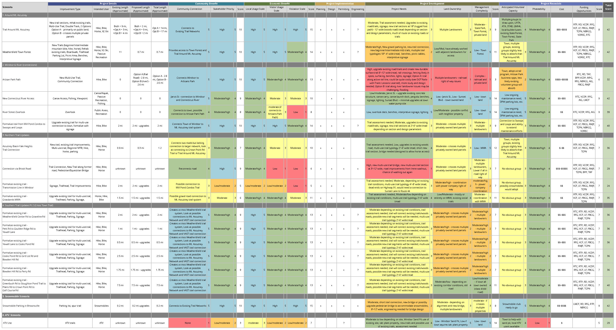
Action Matrix
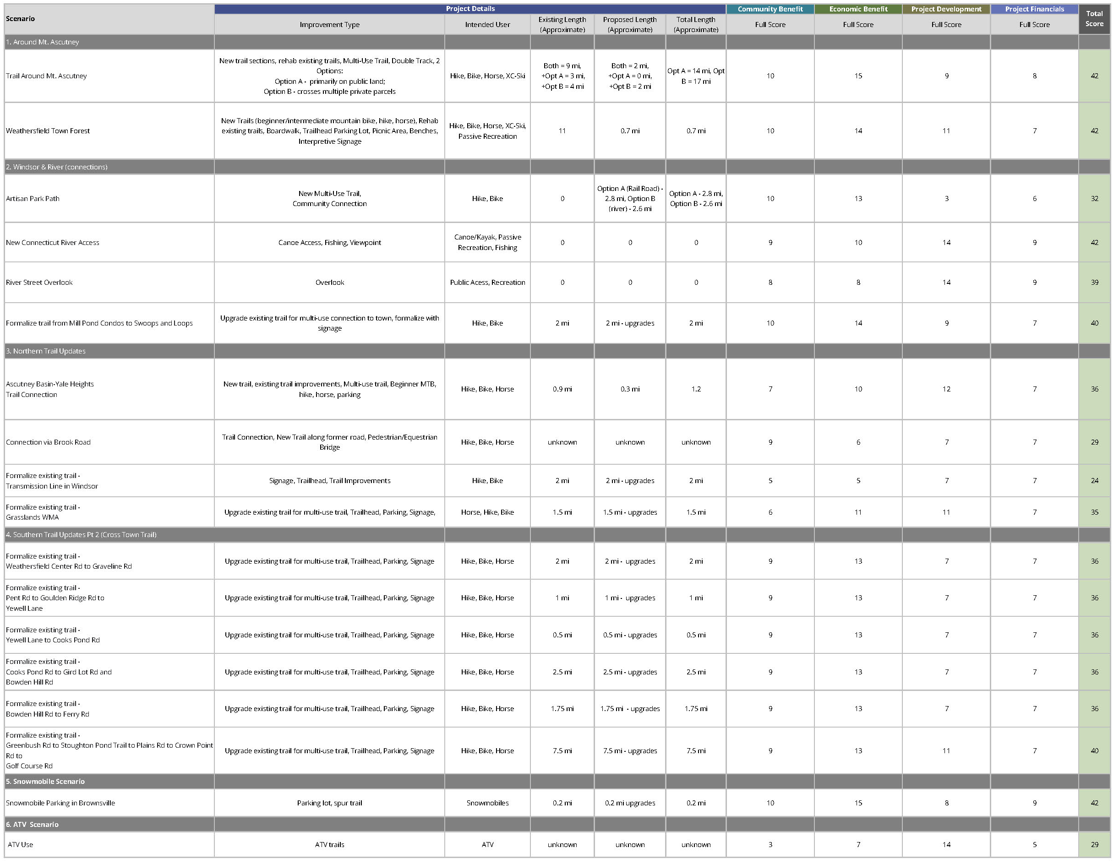
Action Matrix Summary

