Mt. Ascutney outdoor Recreation
Economic Impact of Future Scenarios
June 2019
prepared for:
Southern Windsor County Regional Planning Commission
Prepared by:
SE Group
This report is part of a larger recreation plan being compiled by the Southern Windsor County Regional Planning Commission (SWCPRC). It summarizes the economic impact of future scenarios being considered in the Mt. Ascutney region. The primary goal of this document is to communicate the potential visitation opportunities that would result from recreation development in the region. A range of estimates for visitation for each scenario is utilized to demonstrate potential benefits of each scenario for the regional economy.
An understanding of the economic impact of the future scenarios can empower the SWCRPC and its partners to strategically position themselves in implementing the plan and generate support from the state, the region, the local communities, and their leadership. The economic models also provide specialized insight into implementation and phasing strategies, which have been included in those sections of the document. Economic modeling can greatly increase the competitiveness of recreation projects for grants and other funding opportunities by demonstrating the immense return on investment these projects can provide. They can also help generate excitement for a project and bring partners and potential supporters who may not be mountain bikers into the fold.
Sources of information for this report include information and data from the Mt. Ascutney Outdoor Recreation Survey, The Green Mountain National Forest National Visitor Use Monitoring: Round 2, the MRV Moves Active Transportation Plan, the Agency for Commerce and Community Development’s (ACCD) Benchmark Study of the Economic Impact of Visitor Spending on the Vermont Economy, and other sources.

Future Scenario Analysis

Around MT. Ascutney

Projects
- Trail Around Mt. Ascutney
- Weathersfield Town Forest

Visitation Potential
- Destination-Oriented Facility
- High Local Usage Scale
- High Visitor Usage Scale

Low Visitation
- 7,500 annual visitors
- $730,000 in total sales activity
- 11 full-time-equivalent job positions supported
- $101,000 in tax revenues (federal, state, and local)

Medium Visitation
- 10,000 annual visitors
- $974,000 in total sales activity
- 15 full-time-equivalent job positions supported
- $134,000 in tax revenues (federal, state, and local)

High Visitation
- 20,000 annual visitors
- $1.9 million in total sales activity
- 29 full-time-equivalent job positions supported
- $269,000 in tax revenues (federal, state, and local)
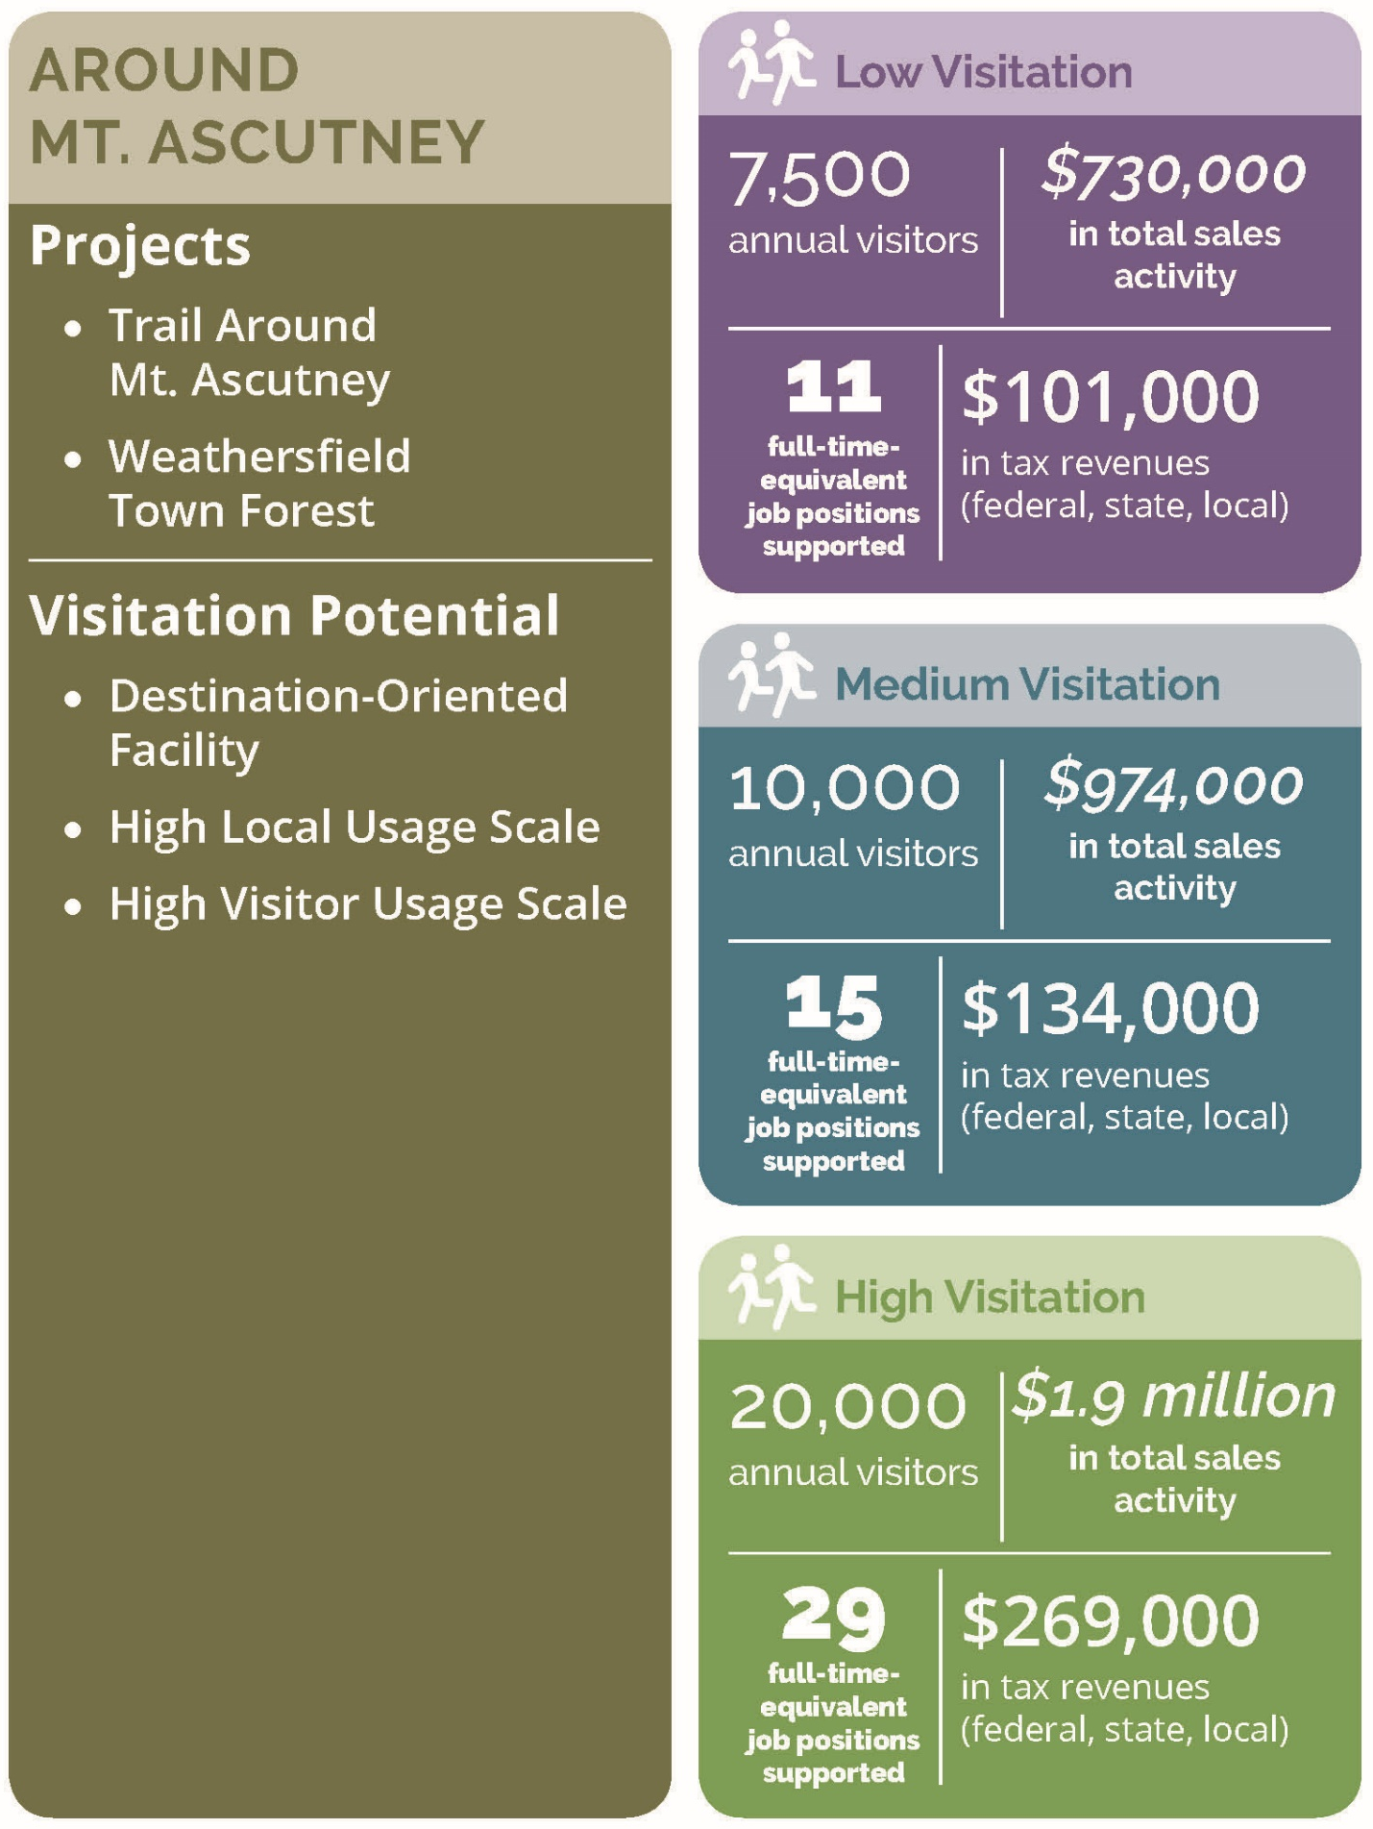

Windsor & River (connections)

Projects
- Artisan Park Path
- New Connecticut River Access
- River Street Overlook
- Formalize trail from Mill Pond Condos to Swoops and Loops

Visitation Potential
- Moderately Destination-Oriented Facility
- Moderate/High Local Usage Scale
- Moderate Visitor Usage Scale

Low Visitation
- 2,000 annual visitors
- $106,000 in total sales activity
- 2 full-time-equivalent job positions supported
- $15,000 in tax revenues (federal, state, and local)

Medium Visitation
- 7,500 annual visitors
- $397,000 in total sales activity
- 6 full-time-equivalent job positions supported
- $54,000 in tax revenues (federal, state, and local)

High Visitation
- 10,000 annual visitors
- $530,000 in total sales activity
- 8 full-time-equivalent job positions supported
- $73,000 in tax revenues (federal, state, and local)
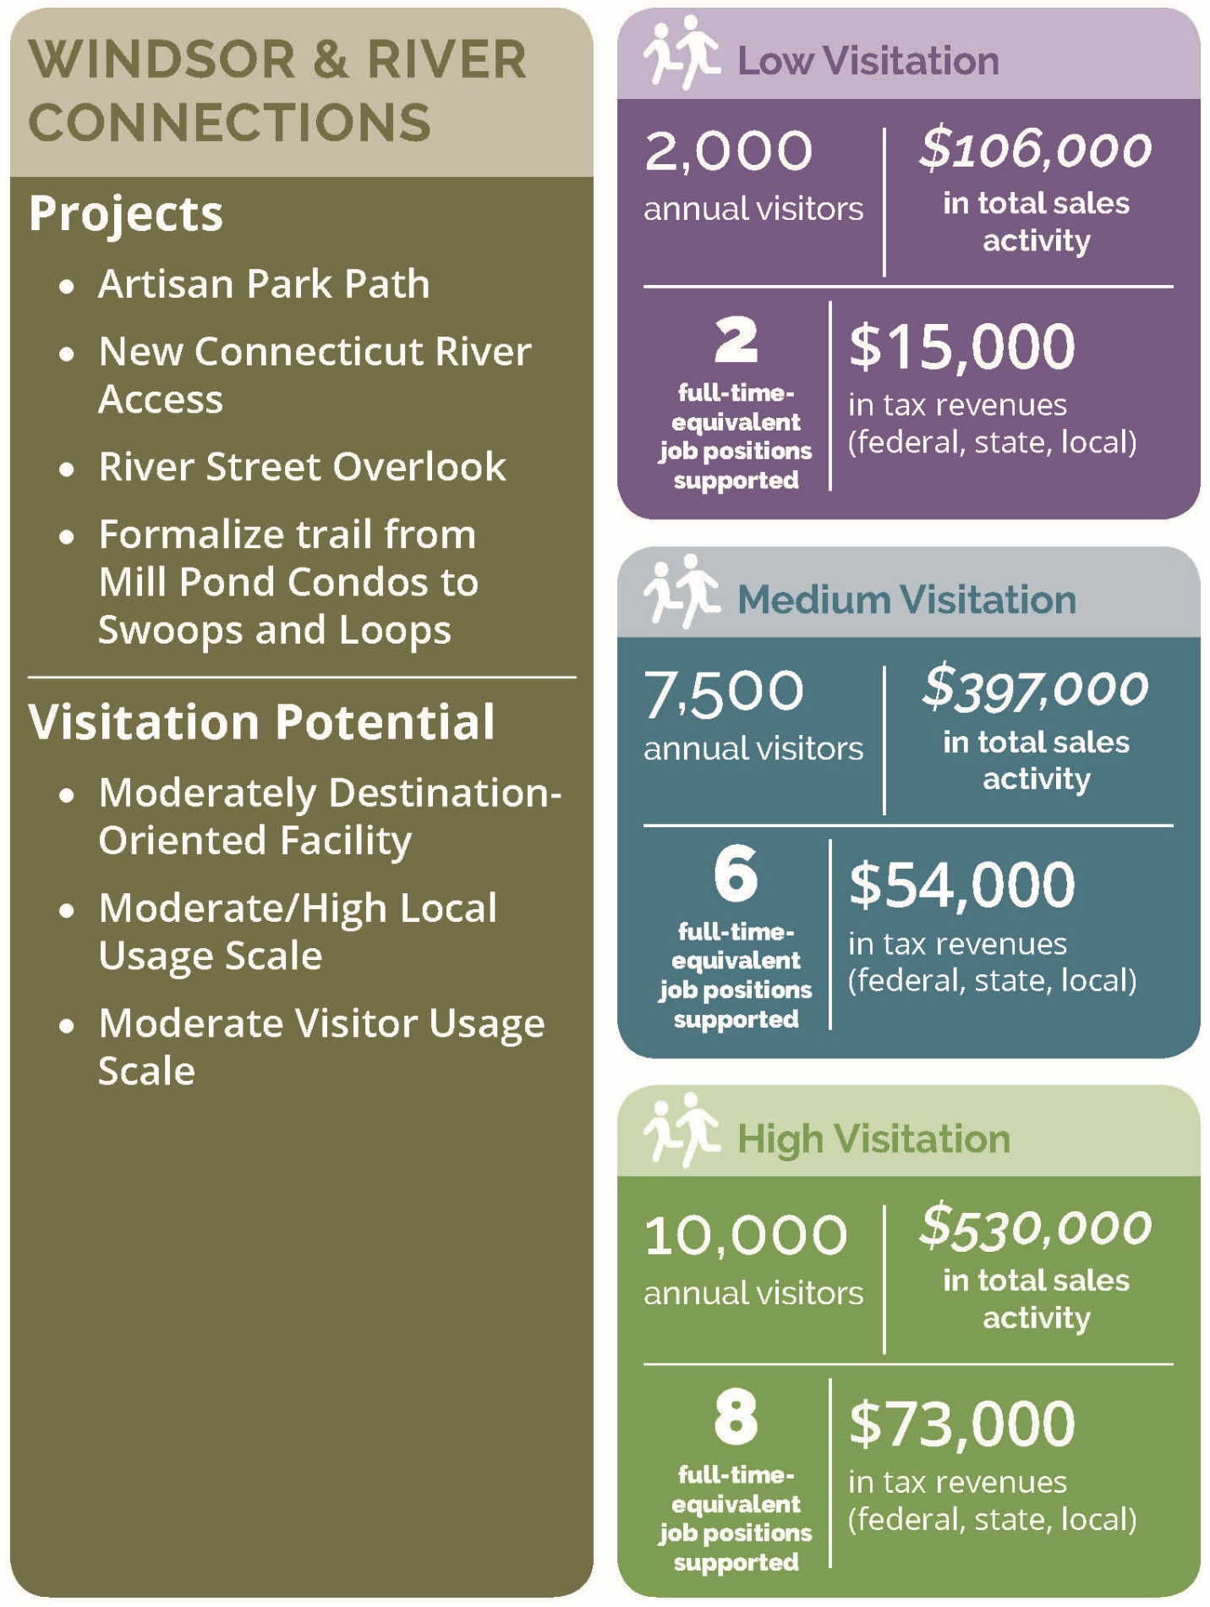

Northern Trail Updates

Projects
- Ascutney Basin-Yale Heights Trail Connection
- Connection via Brook Road
- Formalize existing trail - Transmission Line in Windsor
- Formalize existing trail - Grasslands WMA

Visitation Potential
- Convenience Facility
- Moderate Local Usage Scale
- Low/Moderate Visitor Usage Scale

Low Visitation
- 1,500 annual visitors
- $35,000 in total sales activity
- 1 full-time-equivalent job positions supported
- $5,000 in tax revenues (federal, state, and local)

Medium Visitation
- 3,000 annual visitors
- $70,000 in total sales activity
- 1 full-time-equivalent job positions supported
- $10,000 in tax revenues (federal, state, and local)

High Visitation
- 5,000 annual visitors
- $116,000 in total sales activity
- 2 full-time-equivalent job positions supported
- $16,000 in tax revenues (federal, state, and local)
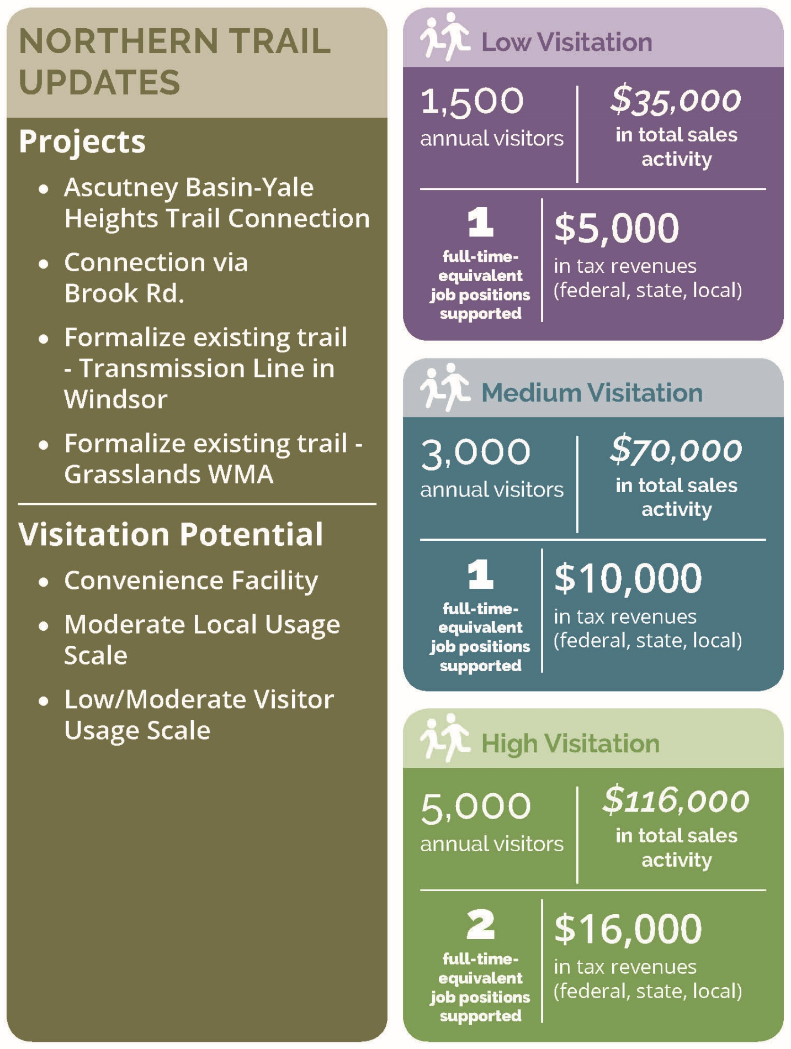

Southern Trail Updates (Cross town trail)

Projects
- Formalize existing trail - Weathersfield Center Road to Graveline Road
- Formalize existing trail - Pent Road to Goulden Ridge Road to Yewell Lane
- Formalize existing trail - Yewell Lane to Cooks Pond Road
- Formalize existing trail - Cooks Pond Road to Girdlot Road and Bowden Hill Road
- Formalize existing trail - Bowden Hill Road to Ferry Road
- Formalize existing trail - Greenbush Road to Stoughton Pond Trail to Plains Road to Crown Point Road to Golf Course Road

Visitation Potential
- Moderately Destination-Oriented Facility
- High Local Usage Scale
- Moderate/High Visitor Usage Scale

Low Visitation
- 5,000 annual visitors
- $265,000 in total sales activity
- 4 full-time-equivalent job positions supported
- $36,000 in tax revenues (federal, state, and local)

Medium Visitation
- 10,000 annual visitors
- $530,000 in total sales activity
- 8 full-time-equivalent job positions supported
- $73,000 in tax revenues (federal, state, and local)

High Visitation
- 15,000 annual visitors
- $795,000 in total sales activity
- 12 full-time-equivalent job positions supported
- $109,000 in tax revenues (federal, state, and local)
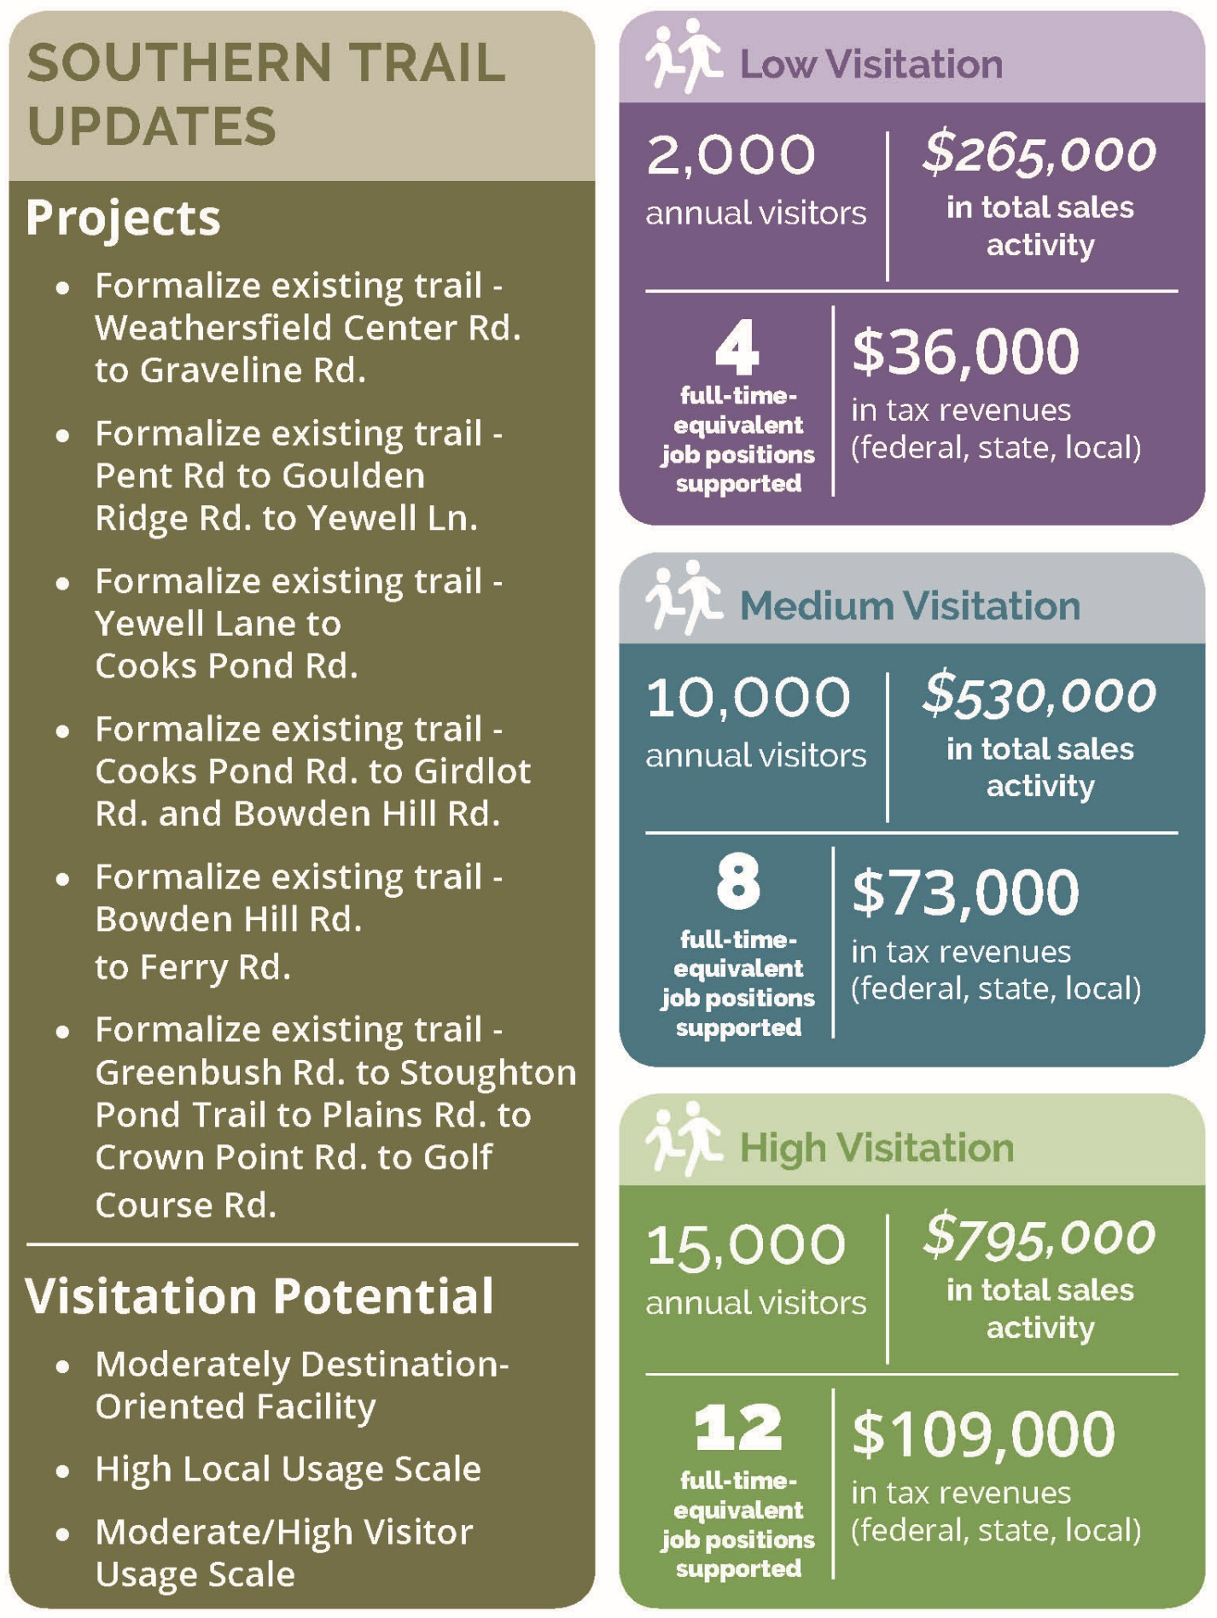

Snowmobile Scenario

Projects
- Snowmobile Parking in Brownsville

Visitation Potential
- Moderately Destination-Oriented Facility
- High Local Usage Scale
- High Visitor Usage Scale

Low Visitation
- 300 annual visitors
- $16,000 in total sales activity
- 0.25 full-time-equivalent job positions supported
- $2,000 in tax revenues (federal, state, and local)

Medium Visitation
- 500 annual visitors
- $26,000 in total sales activity
- 0.4 full-time-equivalent job positions supported
- $4,000 in tax revenues (federal, state, and local)

High Visitation
- 1,000 annual visitors
- $53,000 in total sales activity
- 1 full-time-equivalent job positions supported
- $7,000 in tax revenues (federal, state, and local)
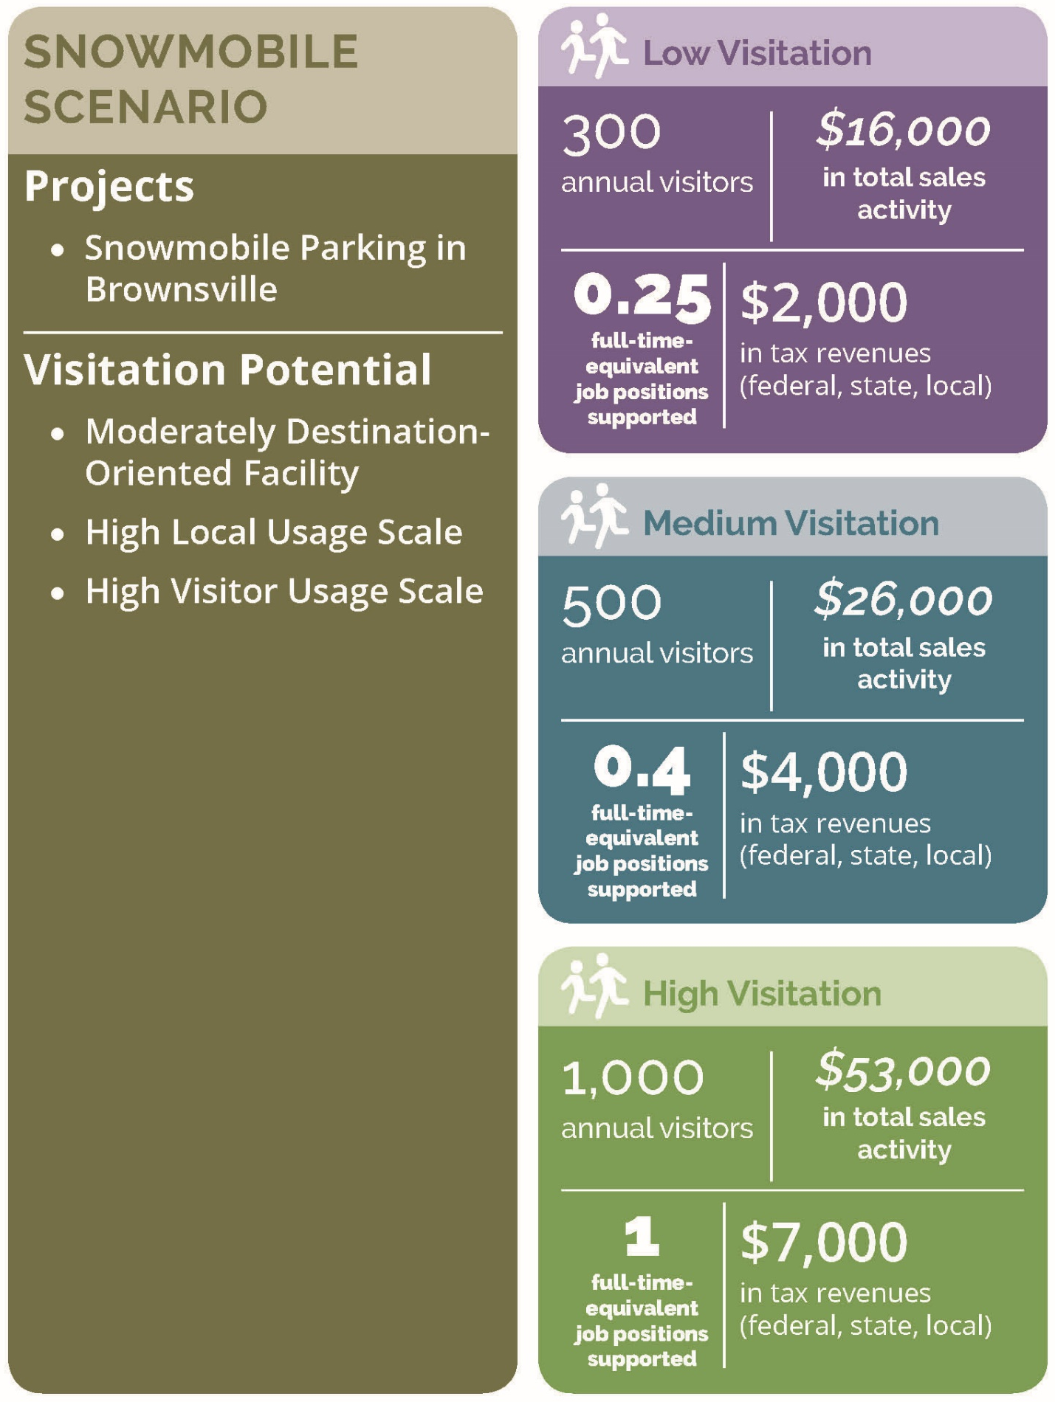

ATV Scenario

Projects
- ATV use at the sand pit

Visitation Potential
- Convenience Facility
- Moderate Local Usage Scale
- Low/Moderate Visitor Usage Scale

Low Visitation
- 100 annual visitors
- $2,000 in total sales activity
- minimal full-time-equivalent job positions supported
- minimal tax revenues (federal, state, and local)

Medium Visitation
- 300 annual visitors
- $7,000 in total sales activity
- 0.1 full-time-equivalent job positions supported
- $1,000 in tax revenues (federal, state, and local)

High Visitation
- 500 annual visitors
- $12,000 in total sales activity
- 0.2 full-time-equivalent job positions supported
- $2,000 in tax revenues (federal, state, and local)
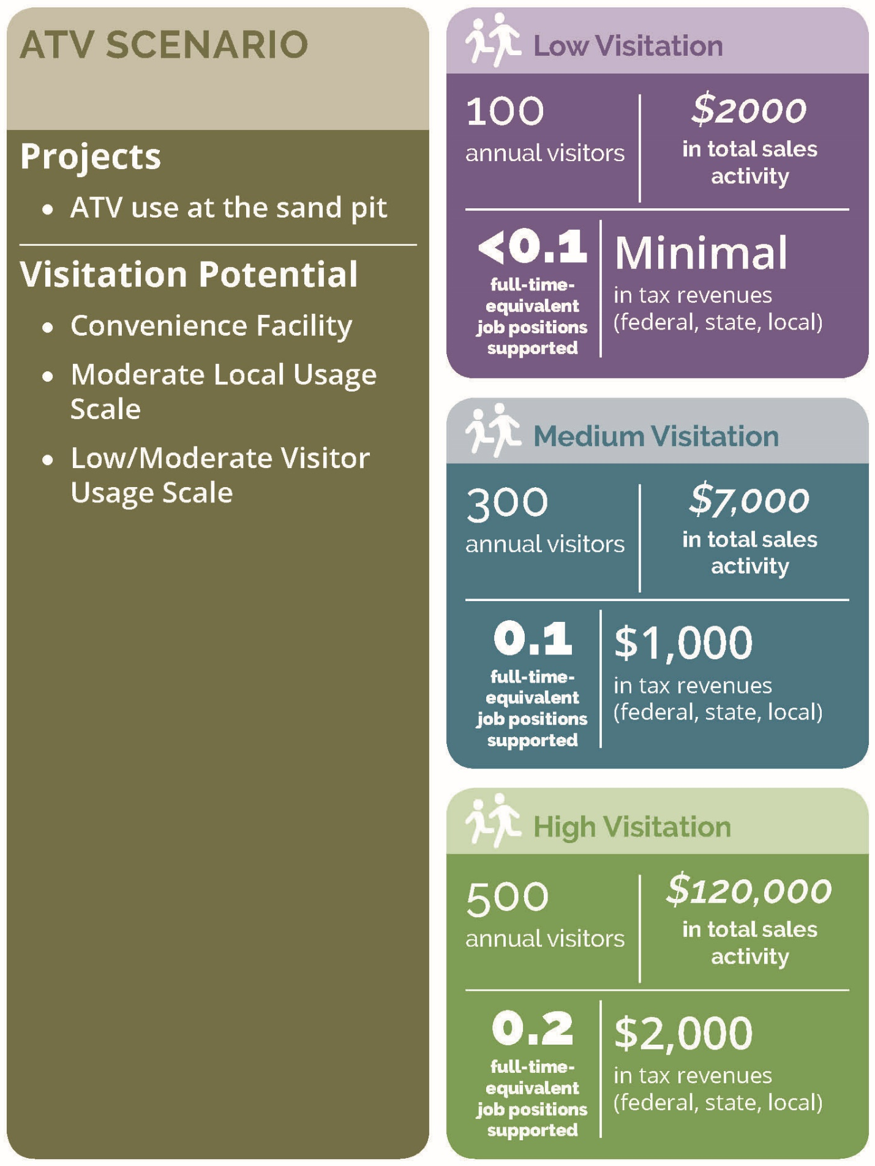

Methodology
The economic impacts of recreational use have been projected using a computer-based model—the Money Generation Model (MGM2). The MGM2 model was developed by the National Park Service and is used to model the economic impact of national parks and other recreational assets across the country. The model demonstrates the immense value of parks, trails, and recreational assets as an economic engine by estimating the economic impact of spending associated with visitation to the area in terms of changes in jobs, tax impacts, and total sales (gross regional product).
MGM2 economic modeling requires the estimation of visitation and visitor spending in order to simulate the effect of these activities on the economy. While MGM2 modeling utilizes observed industry interdependencies calibrated to the local and regional economy, the results of any economic model are only as accurate as the data used to describe the modeled activity (i.e. park visitation and trail use). Therefore, the economic impact analysis required three primary data inputs to model economic impacts: 1) High/Medium/Low visitation projections; 2) visitor profiles (local, non-local day, non-local overnight); and 3) visitor spending profiles.
With reasonable estimates of visitation, visitation by user type, and spending profiles for each user type, the MGM2 model can be completed and run. The model utilizes input-output modeling and industry relationship data from the US Census to estimate total economic impacts. Purchases for final use (i.e., visitor spending) drive the model. Industries that produce goods and services for visitor consumption must purchase products, raw materials, and services from other companies to create their product. These vendors must also procure goods and services. This cycle continues until all the money is leaked from the region’s economy. There are three types of effects measured within an MGM2 Model: the direct, the indirect, and the induced effects. The direct effect is the known or predicted change in the local economy that is to be studied (i.e., the visitor spending). The indirect effect is the business-to-business transactions required to satisfy the direct effect. Finally, the induced effect is derived from local spending on goods and services by people working to satisfy the direct and indirect effects. Total impacts reflect the total changes to the economy as the result of visitor spending (i.e., Direct effects + Indirect effects + Induced effects = Total Impacts).

Projected Vistation and User Counts
Annual visitation projections are estimated to demonstrate potential benefits of the scenarios to the regional economy. Given the uncertainty of future recreational use, high, medium, and low visitation projections are provided. Projections are estimated based on the existing levels of use of similar facilities in the region, as described in the baseline economic impact analysis chapter. The visitation potential of each new project in the scenario is also factored into the estimation of future visitation projections.

User Types
An assumption of recreational use by Local Day Users, Non-Local Day Users, and Overnight Users is a critical datapoint for an economic impact analysis because, on average, these user types spend significantly different amounts in connection with their trail visits (see “Spending Profiles” discussion).
For the purpose of evaluating the economic impact of recreation use in the region, it is important to understand the proportion of trail users who live outside the region and came to the region to recreate (Non-Local Day Users and Overnight Users). Spending by these users is considered “net new” to the region because, if not for the recreation offerings, this spending would not have occurred. Conversely, it was assumed that Local Day Users from within the region would still have spent a similar amount in the region even without the availability of the recreation offerings. In other words, the recreation dollars spent by these Local Day Users in the region could reasonably be assumed to be spent in the region—they would still buy food, drinks, gas, etc. locally. For this reason, ONLY Non-Local Day User and Overnight User visitation and spending information is analyzed in the economic impacts disclosed this report.
The best datapoint available for this locally is Mount Ascutney State Park visitation data because Vermont Forest, Parks, and Recreation has consistently tracked daily visitation by In-State Day Users, Out of State Day Users, and Overnight Users for some time. The average breakdown of these user groups at Mount Ascutney State Park between 2010 and 2017 is approximately 31% In-State Day Users, 37% Out of State Day Users, and 39% Overnight Users. These average values are indicative a more “destination oriented” recreational facility, and as a statewide resource this makes sense for Mount Ascutney State Park. These values were used for analyzing trails and visitation occurring within the park: Hiking Trails, Mountain Biking, and State Park Visitation. These values were also applied to the analysis of Event Participants, as they tend to be more destination-oriented activities.
User Types at Mount Ascutney State Park, 2010–2017
Year | # In State  Day Users | % In State  Day Users | # Out of State  Day Users | % Out of State  Day Users | # Overnight Users | % Overnight Users | # Total Users
2017 | 5,547 | 37% | 3,937 | 26% | 5,515 | 37% | 14,999
2016 | 5,804 | 41% | 3,195 | 23% | 5,131 | 36% | 14,130
2015 | 5,449 | 38% | 3,235 | 23% | 5,489 | 39% | 14,173
2014 | 6,879 | 48% | 2,115 | 15% | 5,389 | 37% | 14,383
2013 | 3,435 | 23% | 5,626 | 37% | 5,992 | 40% | 15,053
2012 | 3,135 | 23% | 5,094 | 37% | 5,611 | 41% | 13,840
2011 | 2,534 | 19% | 4,772 | 37% | 5,757 | 44% | 13,063
2010 | 2,625 | 21% | 5,031 | 39% | 5,081 | 40% | 12,737
Annual Average | 4,426 | 31% | 4,126 | 30% | 5,496 | 39% | 14,047
Another datapoint relative to moderately “destination oriented” recreational facilities are the breakdown of user types on the Green Mountain National Forest (GMNF), which was calculated by the U.S. Forest Service in 2013 and documented in the report “Estimation of National Forest Visitor Spending Averages From National Visitor Use Monitoring: Round 2” (USDA Forest Service 2013). They found approximately 66% of GMNF are Local Day Users, 11% are Non-Local Day Users, and 23% are Overnight Users. These values are a reasonable proxy for “moderately destination-oriented” facilities in the region including water-based recreation, skiing and tubing, and equestrians.
An assumption of 85% Local Day Users, 5% Non-Local Day Users and 10% Overnight Users was utilized for more “convenience facilities” such as local snowmobiling. These values are reflective of such facilities in Vermont and was utilized in the 2017 MRV Moves Active Transportation Plan (MRV Moves 2017).

Spending Profiles
To generate recreational user spending profiles for the region, the Mt. Ascutney Outdoor Recreation Survey data was analyzed; the results were segmented based on the answers to the “How long will you be in the Mount Ascutney area in Vermont?” question. Segmented results were then averaged to create average recreational user spending profiles for Day Users and Overnight Users.
Blank responses for spending categories were imputed as zero dollar amounts when spending data was provided for other spending categories. Responses that left all spending categories blank were omitted from the averages. For example, if a respondent left “gifts/souvenirs and other shopping” blank but entered a specific dollar amount for “food and drinks (restaurant)” and “overnight lodging,” the blank response input to “gifts/souvenirs and other shopping” to be a $0 spending amount for that category for averaging purposes. When a respondent left ALL spending categories blank—including "food and drinks (restaurant),” “overnight lodging,” “gifts/souvenirs and other shopping,” and all the others—the response was omitted entirely. Significant outliers were omitted for averaging purposes. Overnight spending values were also divided by the average length of stay for multiple day visitors of 3.3 days to provide per day estimates.
While the sample size of the Mt. Ascutney Outdoor Recreation Survey is limited—73 respondents who answered the spending question—this data represents the best available spending information for recreational users in the region and provides a meaningful basis for this analysis. The Survey found Day Users spend approximately $70 per person per day and the Overnight Users spend approximately $189 per person per day. These findings are supported by statewide visitor spending estimates from the Agency for Commerce and Community Development’s (ACCD) Benchmark Study of the Economic Impact of Visitor Spending on the Vermont Economy (ACCD 2011). This study analyzed the average spending of all tourists in the State of Vermont and found day visitors spent $70.14 per person per trip and that overnight visitors spent $176.98 per person per trip.
The spending profile of these user groups from the Mt. Ascutney Outdoor Recreation Survey is presented in the following table.
Spending Profiles of Day Users and Overnight Users
Spending Category | Day User | Overnight User
Transportation (Including Gas) | $14 | $29
Food and Drinks (Restaurant) | $24 | $37
Food and Drinks (Grocery or Convenience Store) | $11 | $20
Overnight Lodging | $0 | $71
Gifts/Souvenirs and Other Shopping | $5 | $15
Recreation (e.g., Admission Fees, Rentals, Tours, etc.) | $16 | $17
Total | $70 | $189

Equipment Purchases
In addition to the spending detailed in the profiles above, survey respondents also reported spending on equipment, which is not included in this analysis. The survey focused on spending per trip and while some people did include spending related to major purchases such as new mountain bikes, new ATVs and new skis, it would not be appropriate to attribute those major purchases to each of the trips to the region. Reported equipment purchases ranged from $20 to $35,000, with many reporting spending well over $1,000 on equipment purchases in the region. While none of these purchases are included in the economic impact analyses discussed above, these more one-off purchases can have a significant impact on the local economy

