Mt. Ascutney outdoor Recreation
Market Assessment
JUne 2019
Prepared for:
Southern Windsor County Regional Planning Commission
Prepared by:
SE Group

Introduction
This report summarizes information relevant to the market opportunities for outdoor recreation for Mt. Ascutney and the surrounding region. The information in this draft report is intended to provide perspective on existing and potential users and visitors to the outdoor recreation opportunities of the Mt. Ascutney region. The data and findings presented in this assessment can be used to validate the alignment of recreational enhancements with existing and/or anticipated visitation. This report is part of a larger recreation plan being compiled by the Southern Windsor County Regional Planning Commission.
Sources of information for this report include information and data from the Vermont Statewide Comprehensive Outdoor Recreation Plan, the U.S. Census Bureau, Headwaters Economics, Vermont Department of Tourism and Marketing, Institute for New Hampshire Studies, Snowsports Industries of America, and Outdoor Industry Association, and secondary research on participation in the region.

Location and Study Area
Mt. Ascutney is located in southeastern Vermont in Windsor County. The mountain’s summit is located in the town of Windsor, VT, but the mountain extends into West Windsor and Weathersfield as well. By driving distance, the entrance to Mount Ascutney State Park is located:
- 2.2 miles from Ascutney Village, Weathersfield, VT
- 4.5 miles from downtown Windsor, VT
- 4.5 miles from Brownsville, West Windsor, VT
- 7 miles from Claremont, NH
- 22 miles from Lebanon, NH
- 47 miles from Brattleboro, VT
- 110 miles from Burlington, VT
- 122 miles from Boston, MA
This assessment focuses on the three Mt. Ascutney towns (Weathersfield, Windsor, and West Windsor) and the greater region that is located within easy driving distance of Mt. Ascutney. The following counties comprise the Vermont-New Hampshire Upper Valley: Windsor County, VT; Orange County, VT; Sullivan County, NH; and Grafton County, NH. The Census Bureau identifies the region as the Claremont-Lebanon VT-NH Micropolitan Statistical Area. This designation is due to the shared economy and strong connections within the region. A map of the region is below.
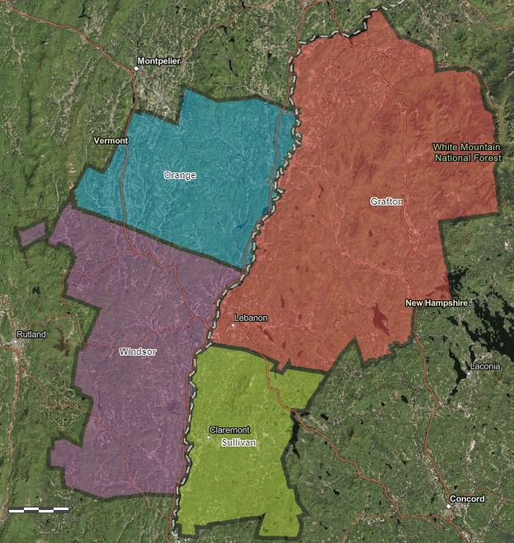

Regional Population/Demographics

Current Population (2017)
- Weathersfield-Windsor-West Windsor population: 7,257
- Windsor County population: 55,100
- Upper Valley (Claremont-Lebanon Micropolitan Statistical Area) population: 216,307 (U.S. Census Bureau 2018)

Population Trends
Since 2010 the population of the region has remained relatively stable, declining by 0.6%. Of the counties in the region, Windsor County saw the largest decline at 2.5%. The region’s population has increased very slightly since 2000, and this stagnation is fairly typical of rural New England communities (U.S. Census Bureau 2010).
In 2013 the Vermont Agency of Commerce and Community Development projected two possible scenarios for population growth based on the strength of the national economy. Under Scenario A, where the national economy is strong, Windsor County and Orange County are expected to grow in population by 6.5% and 3.9%, respectively, between 2010 and 2030. Under Scenario B, where the national economy is weaker, Windsor County’s population is expected to decline by 4% and Orange County’s by 1.7% over the same time period. Under Scenario A, the state as a whole is expected experience a higher rate of growth than Windsor and Orange counties, while under Scenario B, the state’s population is not expected to decline to the same extent (State of Vermont 2013).
New Hampshire prepared population estimates in 2016. The New Hampshire Regional Planning Commissions projected that from 2010 to 2030, Sullivan County’s population would increase by 1.2% and Grafton County’s by 6.4%. The rest of the state is expected to experience greater population growth than those two counties (State of New Hampshire 2016).

Demographics

Age
Northern New England has an older population and the Upper Valley region is no exception. The region’s median age is 45.1, slightly higher than the median ages of New Hampshire and Vermont. Since 2010 the median age has climbed in each of the region’s counties, aside from Grafton. The Weathersfield-Windsor-West Windsor area has an even older population, with a median age of 46.4 (U.S. Census Bureau 2018).
The region has 36,459 school age children (ages 5 to 19), making up about 17% of the population. People 65 and over represent an increasing share of the population, from 15.6% in 2010 to 19.6% in 2017 (Headwaters Economics 2019a). The age breakdown of the region is an important factor in outdoor recreation participation and preferred activities.

Income
The median household income of the region is $58,777 and all the median incomes of all four counties are very close to that. While this figure is very similar to the statewide median household income of Vermont ($57,808), it is significantly lower than that of New Hampshire ($71,305). The median income of the three towns is slightly lower than that of the region ($52,706) (U.S. Census Bureau 2018).
For outdoor recreation participation, a median household income of $75,000 is an important threshold. Above that, the rate of participation and visitor spending dramatically increases. In the region, 38.2% of households earn more than $75,000 annually.

Community Profiles
The following graphics present demographic and community data for each of the three towns (Windsor, West Windsor, and Weathersfield) and for the combined three-town region.

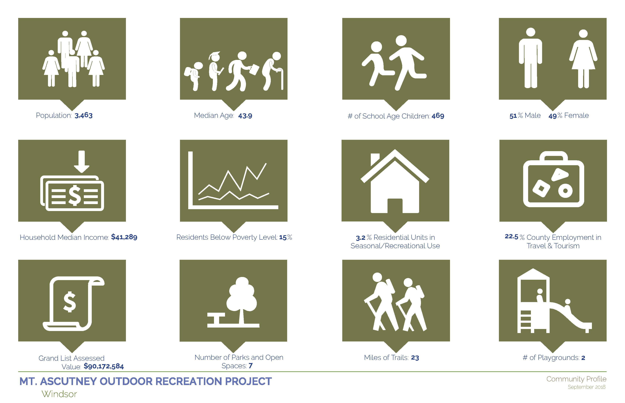
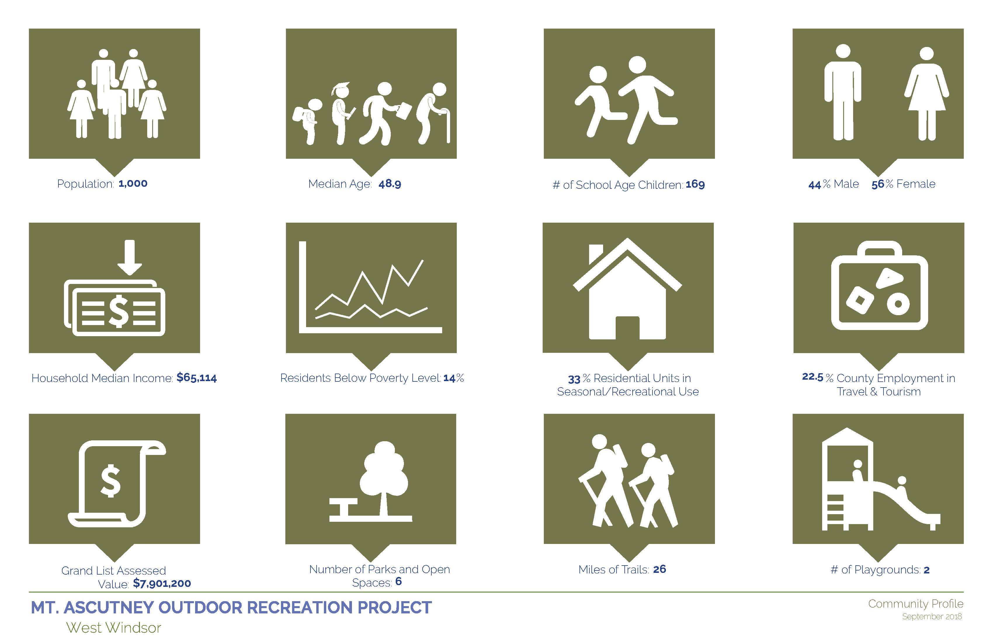
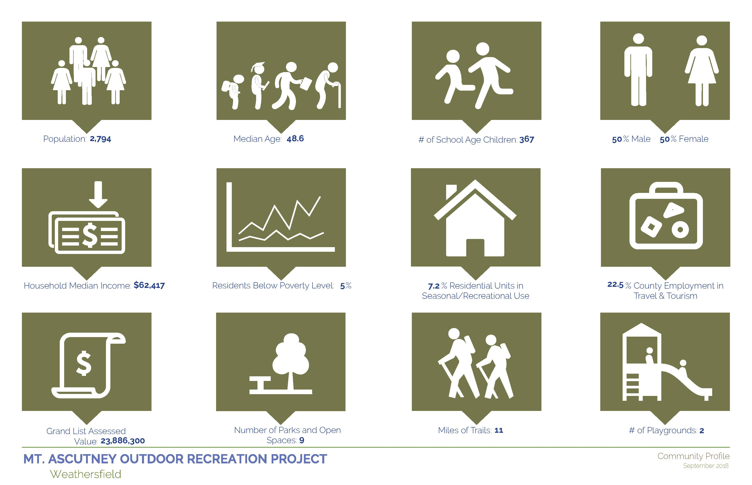
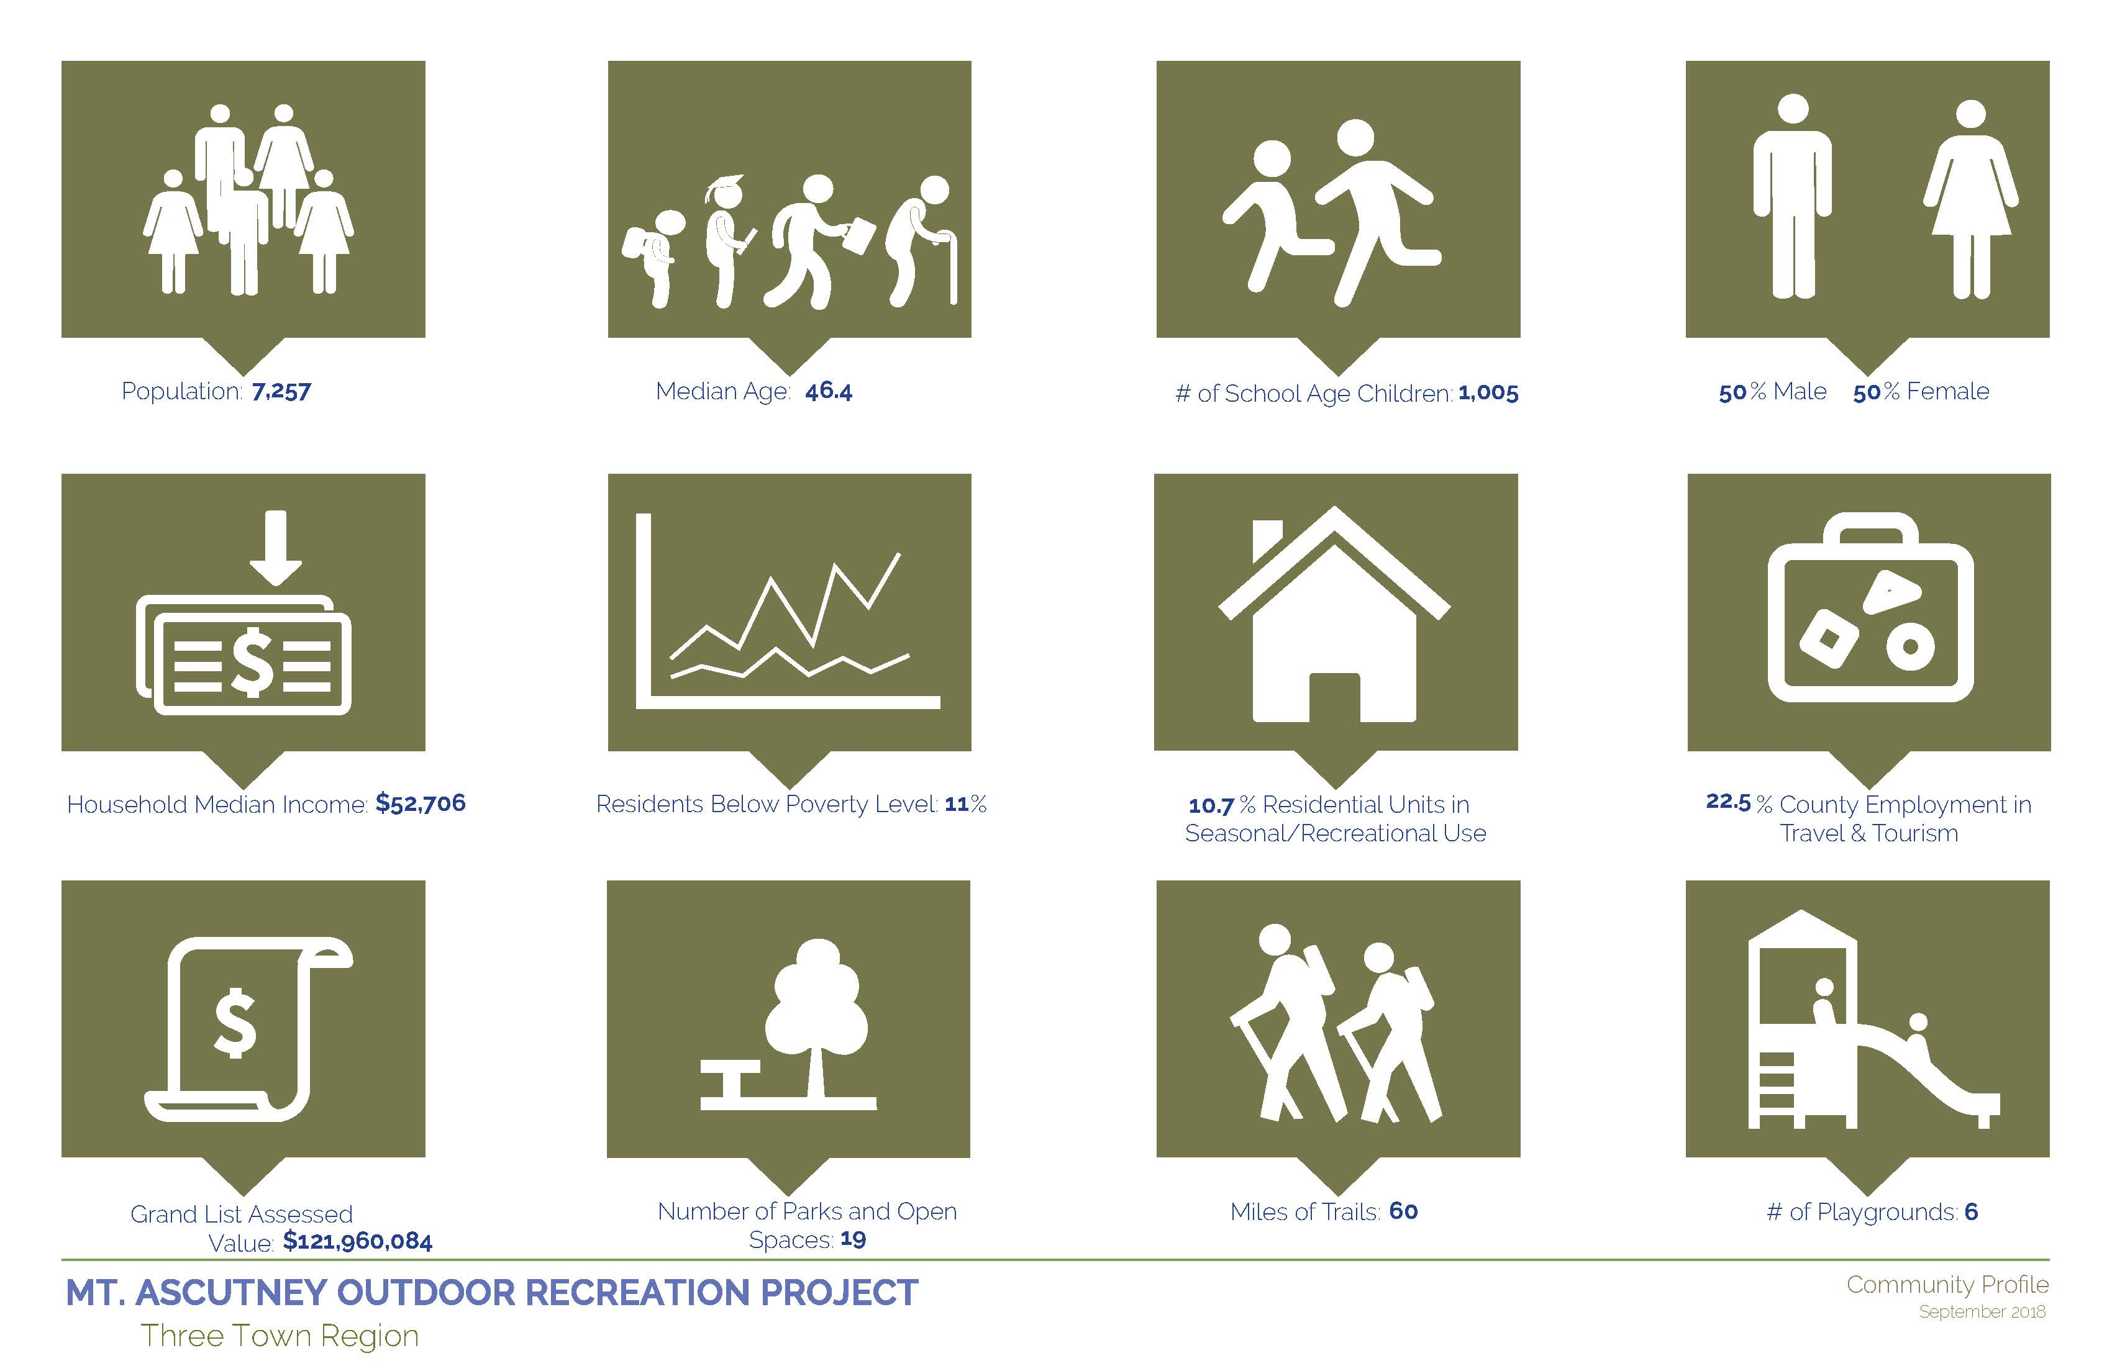

Regional Analysis

Regional Economy
The economy of the Upper Valley is centered on the Lebanon-White River Junction-Hanover area, with tourism an important aspect in that area and other towns throughout the region.
The largest industries (in order by percentage of employment) are healthcare, government, retail, manufacturing, and accommodations and food services. Manufacturing has been in decline in recent decades, while healthcare has grown. The other major industries, by percentage of employment, have remained relatively stable (Headwaters Economics 2019b). The largest private employers in the Upper Valley are Dartmouth-Hitchcock Medical Center, Dartmouth College, Timken Aerospace, Alice Peck Day Memorial Hospital, and TomTom.
The region is effectively at full employment. As of 2017, unemployment was only 2.4% of the region’s workforce. The local job market is fairly resilient. In 2010, during the recession, unemployment in the region reached 5.4%, compared to 10% nationally. The county’s labor force is relatively seasonal, with the lowest unemployment in December and the highest in January and February. Year over year, this variation is about 1% (Headwaters Economics 2019b).
Overall, 16.7% of the region’s employment is in tourism (tourism-related jobs in the passenger transportation; accommodations and food services; arts, entertainment, and recreation; and retail. Windsor County’s percentage of employment in tourism is slightly higher, at 22.3%. Both of these values are above the national average of about 15.8% of employment in these sectors (Headwaters Economics. 2019c).

Regional Tourism and VIsitor Profiles
The Upper Valley does attract many tourists, with its easy access from major metropolitan areas and sightseeing and outdoor recreation opportunities, quintessential New England small towns, and museums. Both interstates I-89 and I-91 cut right through the region, making it easily accessible from the Boston and New York metropolitan areas.
Many of the major tourist destinations, such as the White Mountain National Forest along I-93 and the Kancamagus Highway, Okemo, Lake Sunapee, and Franconia Notch State Park, are on the outer edge of the region analyzed above (Windsor, Orange, Grafton, and Sullivan counties). Many visitors to these attractions are never near the Connecticut River and Mt. Ascutney during their trip; from Boston, tourists drive on I-93 to Okemo, up I-87 through New York State. While connections to those major destinations present an opportunity for the towns close to the Connecticut River, at present, the tourism activity is relatively separated from that of larger region.

Windsor County Tourism Economy
Approximately 22.3% of the employment in Windsor County is within the travel and tourism sectors (i.e., the share of total jobs in industries that include travel and tourism). Travel and Tourism includes sectors that provide goods and services to visitors as well as to the local population, such as Retail Trade, Passenger Transportation, Arts & Entertainment & Recreation, and Accommodation & Food Services.
The exact proportion of jobs in these sectors attributable to expenditures by visitors, including business and pleasure travelers, is not known without additional research such as direct visitor surveys. Some researchers refer to these sectors as “tourism-sensitive.” They could also be called “travel and tourism-potential sectors” because they have the potential of being influenced by expenditures by non-locals.
Data on this share of Travel and Tourism employment was obtained from the U.S. Census Bureau’s County Business Patterns (CBP) series. Compared to other sources, CBP has fewer data gaps (instances when the federal government will not release data to protect confidentiality of individual businesses). It also includes both full- and part-time employment. However, CBP data does not include employment in government, agriculture, railroads, or the self-employed. Also, CBP data are based on mid-March employment and do not account for seasonal fluctuations. For these reasons, the data are most useful for showing long-term trends, displaying differences between places, and showing relationships between sectors over time.
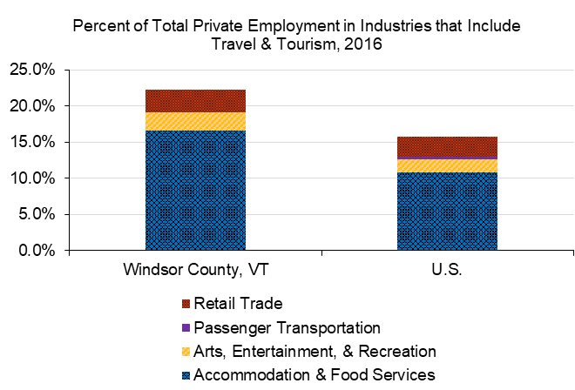
Total employment in Travel and Tourism related sectors in Windsor County has remained flat but has been relatively stable since 1998 compared to other sectors of the economy.
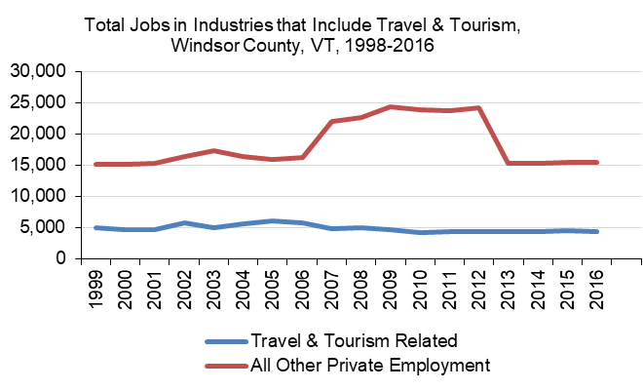
Within the Travel and Tourism sectors, however, there has been substantial fluctuation in which sector these jobs are found. Arts, entertainment, and recreation, for example, significantly declined around 2008, likely accounting for the closure of Ascutney Mountain Resort.
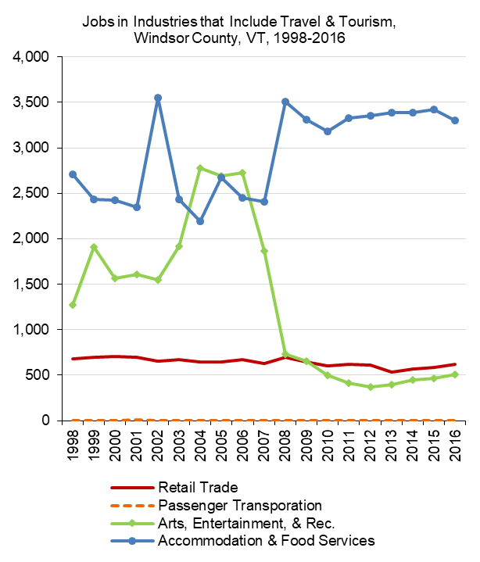
Consistent with findings nationally, wages in the Travel and Tourism sectors in Windsor County ($23,896) are significantly lower than average wages in all private sectors ($42,930). This is commonly a result of the seasonal and part-time nature of many Travel and Tourism jobs, which often require workers to hold more than one position over the course of the year.
Wages and Employment
 |  | Windsor County, VT | U.S.
All Sectors, 2017 (2018 $s) |  | $45,655 | $56,719
Private |  | $42,930 | $56,666
Travel & Tourism |  | $23,896 | $25,376
Retail Trade |  | $21,660 | $23,531
Gasoline Stations |  | $21,613 | $22,033
Clothing & Accessories |  | $26,828 | $22,428
Misc. Store Retailers |  | $19,473 | $27,045
Passenger Transportation |  | $0 | $85,641
Air Transportation |  | $0 | $89,142
Scenic & Sightseeing |  | $0 | $34,131
Arts, Entertainment, & Rec. |  | $24,261 | $38,665
Performing Arts & Spectator Sports |  | $31,298 | $93,368
Museums, Parks, & Historic Sites |  | $32,818 | $35,630
Amusement, Gambling, & Rec. |  | $17,952 | $22,921
Accommodations & Food |  | $24,272 | $21,229
Accommodation |  | $28,420 | $31,827
Food Services & Drinking Places |  | $20,266 | $19,419
Non-Travel & Tourism |  | $49,163 | $62,621
Government |  | $55,795 | $57,022
This table shows wage data from the Bureau of Labor Statistics, which does not report data for proprietors or the value of benefits; the major industry categories (retail trade, passenger transportation; arts, entertainment, and recreation; and accommodation and food) are the sum of the sub-categories underneath them and as shown here do not represent NAICS codes.

Local Tourism
Close to the Connecticut River, most tourism activity occurs during the summer, although there is snowmobile and skiing activity drawing in some non-local visitors during the winter. In the summer, paddlers frequent the Connecticut River, and the Woodstock-Quechee area is a major tourist destination. Visitors also head to Hanover-Norwich in the summer, but many remain on the interstate until those towns. The Windsor-West Windsor-Weathersfield area does attract some visitors through races, the Harpoon Brewery, and the local trail system, but lacks the tourist infrastructure to be a major destination in it of itself.
The area’s outdoor recreation opportunities do not see a huge amount of visitation but are attracting visitors from beyond the immediate area. Mount Ascutney State Park saw 14,999 visits in 2017, one of the lowest totals in the Vermont State Park system. In a 2017 survey by Sports Trails of Ascutney Basin 66% of visitors were from Vermont or New Hampshire; 34% coming from out-of-state—only 12% of trail users surveyed were from Windsor-West Windsor. Of backcountry skier sign-ins at Ascutney Outdoors during winter 2018/19, 49% of sign-ins were from Vermont or New Hampshire. While local users are less likely to sign in, backcountry skiing is seeing strong use from out-of-state. Ascutney Outdoors estimated that 245 people backcountry skied there per month in January/February.
Annual Visitors to Upper Valley Attractions
Attraction | Town | Annual Visitors | Source
Mount Ascutney State Park | Windsor | 14,999 (2017) | Forest, Parks, and Recreation
Vermont Institute of Natural Science (VINS) | Quechee | 38,000 | Valley News
Quechee Gorge | Quechee | 100,000 | VTrans
Montshire Museum | Norwich | 160,000 | Montshire Museum
Marsh-Billings-Rockefeller National Historic Park | Woodstock | 63,886* (2018) | National Park Service
*The 2018 visitation total to Marsh-Billings-Rockefeller NHP is an increase of 87% over 2013 visitation
Across the region, 21% of all housing units are in seasonal, recreational, or occasional use (typically considered second homes). These second homes are concentrated in Grafton and Windsor counties, and likely concentrated further in the major tourist destinations such as Woodstock, VT, Ludlow, VT, and Lincoln, NH (Headwaters Economics. 2019c). In the Weathersfield-Windsor-West Windsor area, 10.7% of all housing units are in seasonal, recreational, or occasional use (U.S. Census Bureau 2010).

Events
The Weathersfield-Windsor-West Windsor area plays host to a few outdoor recreation events that draw visitors from across New England. The area hosts a couple of New England’s preeminent trail running and mountain biking races: the Vermont 100 and the Vermont 50. The major events and number of participants are detailed in the following table.
Major Events
Event | Town | Sport | Participants
Ragnar Trail Vermont | West Windsor | Trail Running Relay | 1,948 (2018)
Point to Point | West Windsor | Biking/Running Fundraiser | 680 (2017)
Ascutney Mountain Run | Windsor | Trail Running | 173 (2018)
Vermont 50 | West Windsor | Mountain Biking/Trail Running | 1,077 (2018)
Harpoon Octoberfest Road Race | Windsor | Running | 671 (2018)
Vermont 100 | West Windsor | Trail Running/Equestrian | 558 (2018)
Vermont Overland | Reading | Biking | 562 (2016)
Vermont Overland Maple Adventure Ride | West Windsor | Biking | 340 (2018)
The Vermont 50 is one of the largest events in the area. With families and friends coming to support racers, the event brings about 1,500 people to the area each year. Of the race participants in 2016, only 23.8% (or 242 people) were from Vermont and only 10 were from Weathersfield, Windsor, or West Windsor. While many participants likely came from nearby Vermont and New Hampshire towns, regardless, the event draws a large number of people to the area who spend money on lodging, food, and retail at local businesses (The Class of 1964 Policy Research Shop 2018).

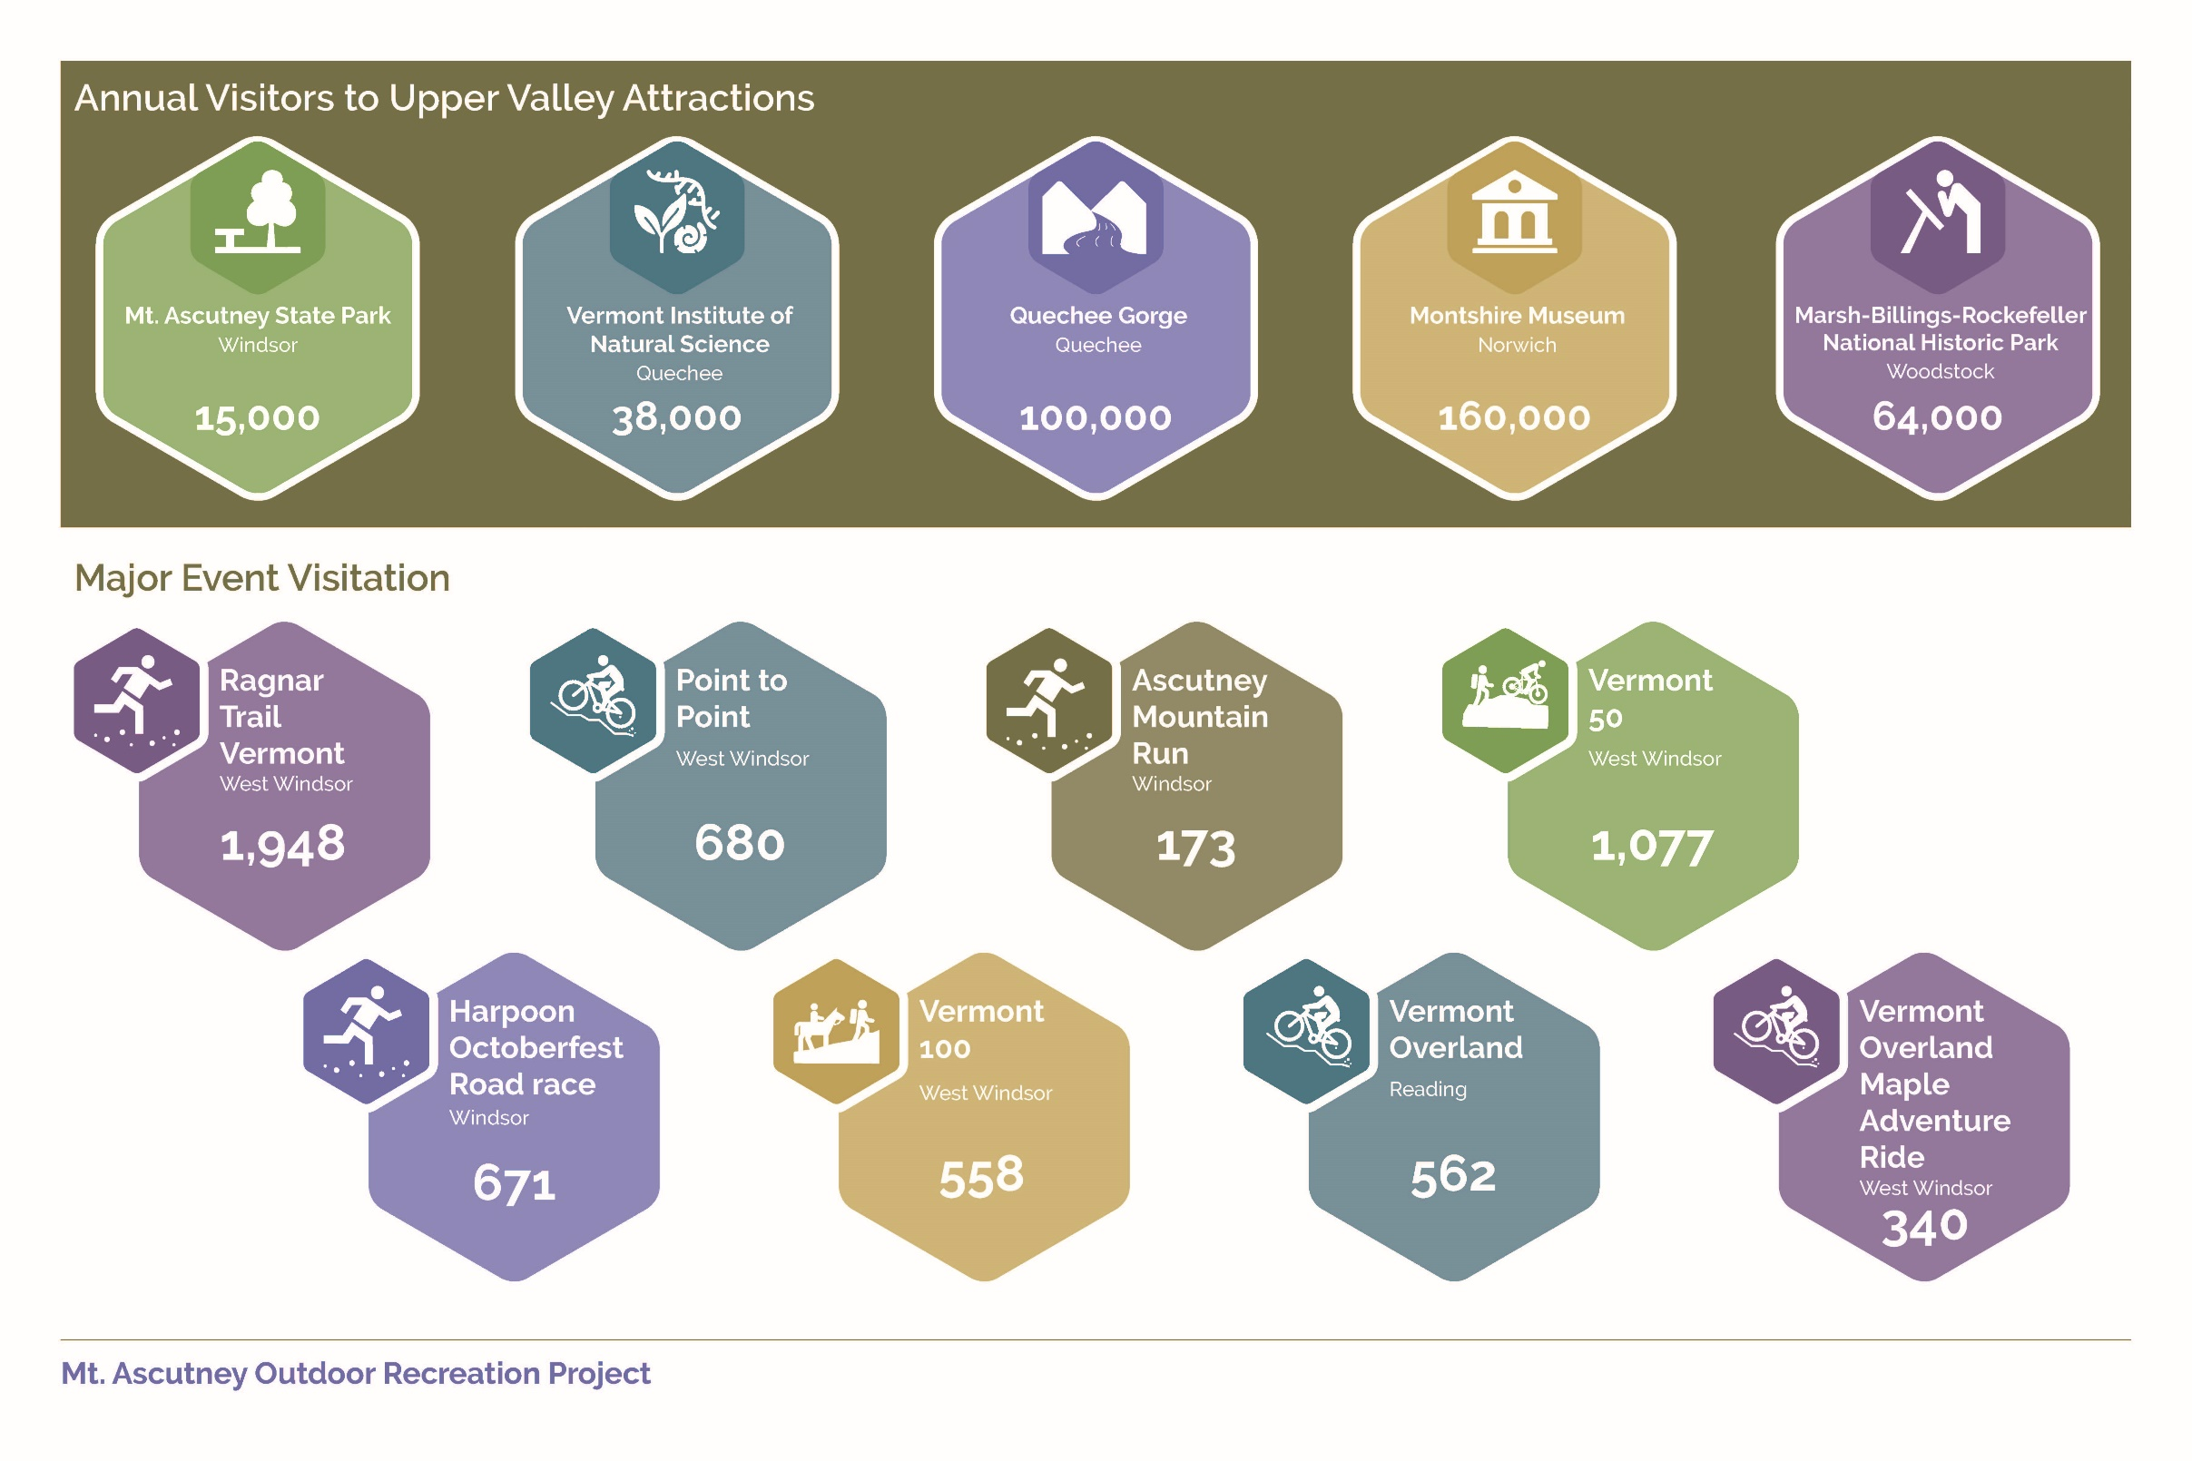

Vermont and New Hampshire Tourism
Vermont collects tourism data at the state level only, while New Hampshire provides some breakdown by region. Based on the data, we can interpret the Upper Valley’s place in state tourism as highly accessible but not a major destination like other areas of the state, especially in the winter.

Vermont
In 2017 the State of Vermont saw 13.1 million visitors, bringing in $2.8 billion dollars to the state economy. July, August, and October are typically the busiest months for tourism, although many parts of Vermont are very busy in the winter due to ski tourism. Tourist visits have been growing, but looking towards the future, the state largely draws tourists from the Northeast, a region with a relatively stagnant population. A 2014 visitor survey found that visitors to the state parks, welcome centers, and attractions were primarily from Vermont itself (~20%), Connecticut, Massachusetts, and New York. Canadians also make up a significant portion of Vermont tourists. Overnight visitors were found to come from largely the same locations. Of visitors to state parks, Vermonters were an even higher proportion, at 33.6% of survey respondents.
The 2014 survey paints a clear picture of who Vermont tourists are and why they come to Vermont. Survey respondents ranked seasonal outdoor recreation as the third most important attraction in their decision to travel to Vermont, behind natural (mountains, wildlife, state parks), and Vermont-made products. Overall, 33.7% of those surveyed participated in hiking/backpacking and 16.3% participated in canoeing/kayaking during their stay. Visitors to Vermont tend to be older, with 58% of those survey over the age of 50. The median household income of visitors was $87,500, well above the statewide median. Visitors to state parks were a slightly different demographic; they were younger and had a lower median household income ($62,500) (Vermont Tourism Data Center 2014).
Camping is an important and growing segment of Vermont tourism lodging. Vermont Forest, Parks, and Recreation reported 410,000 camper nights in 2017, an increase of 17% since 2009 (Vermont Department of Tourism and Marketing 2017). A large proportion of these camper nights are spent by Vermonters (45% in 2018). Many campsites are reserved well in advance and can fill up for most of the summer. Those high visitation parks generally have lake or river access and most are located in the northwestern corner of the state. For example, Grand Isle State Park had 37,000 camper nights in 2018, compared to 5,515 nights at Mount Ascutney State Park. Branbury State Park, on Lake Dunmore, saw 53,000 total visits in 2018, compared to 14,999 at Mount Ascutney State Park (Burlington Free Press. 2019). Given Vermonters’ enthusiasm for their state parks and camping, easy access from Chittenden County tends to be a bigger factor towards visitation than proximity to interstates and major metropolitan areas.

New Hampshire
New Hampshire has a large tourism economy, but tourism in the Upper Valley is relatively weak. In 2014 New Hampshire saw 36.6 million visitors who contributed $4.95 billion to the state’s economy. New Hampshire tourism, more so than Vermont, is oriented around summer. In 2013/14, summer was 42.3% of all visitor days. The 2014 report broke the state into regions, with the Dartmouth-Lake Sunapee region corresponding to the New Hampshire side of the Upper Valley. That region is a very small portion of New Hampshire tourism, with only 3.3% of all visitor days and $220 million in visitor spending. While the state as a whole experienced a 12.1% increase in visitor spending from FY 2012 to FY 2014, visitor spending in the Dartmouth-Lake Sunapee region only grew by 6.9% (Institute for New Hampshire Studies. 2014).

Demographic Profiles
The following section describes participation rates and demographics for outdoor recreation user groups. The demographics of the Upper Valley region, described above, are important to consider in the context of this discussion.

Overall Outdoor Recreation Participation
A 2011 Vermont Outdoor Recreation Demand Survey explored Vermonters’ preferences and participation with regards to outdoor recreation. Two out of every five households surveyed said that outdoor recreation was “very important” to them, and another third stated that it was “moderately important.”
Vermonters are lucky—most can participate in their favorite activity within 5 miles of their home, and 29% can do the activity right out their door. While many Vermonters do travel for outdoor recreation, it is important to note that for many, the nearby opportunities may limit their willingness to travel.
In a ranking of the 14 Vermont counties in outdoor recreation participation, Windsor County was 12th and Orange County was 9th. Windsor County residents are more likely to participate in hiking, biking, and mountain biking while Orange County residents are very in line with the statewide averages (Vermont Department of Forests, Parks and Recreation 2014).
In general, outdoor recreation participants tend to be wealthier. Nationally, 47% of outdoor recreation participants have median household incomes at or above $75,000 (Outdoor Foundation 2018). The country’s median household income is $57,652, and only 38.5% of household incomes are above $75,000 (U.S. Census Bureau 2018).

Hiking
In the 2011 Outdoor Recreation Demand Survey, Vermonters named hiking as their favorite activity, with 16% of survey respondents. Of Vermont households, 40.5% reported that a member participated in hiking in the past year, with 33% individual participation, making it the 6th most participated in activity. On average, hikers participated 10.7 days per year. Windsor County residents participated in hiking at a far higher rate, with 57.9% of individuals participating. In Orange County, the participation rate was very close to the rate statewide (Vermont Department of Forests, Parks and Recreation 2014).
Nationally, almost 35 million people went hiking in 2013, an increase of 17% from seven years prior. In a survey of American Hiking Society members—a subset of enthusiastic hikers—members are increasingly choosing to go on shorter hikes (less than 5 hours) instead of long day hikes and backpacking. However, more members are hiking more frequently, with 60% hiking more than 20 times a year, compared to 54% doing so in 2007. Primarily, these members choose to hike to connect with nature and for exercise (American Hiking Society 2015).
Membership in Vermont trail-based organizations has increased in recent years, although hiking-specific groups have been very flat, especially compared to mountain biking (Vermont Department of Forests, Parks and Recreation 2014).
In recent years, hiking participants have skewed younger, with a median age of 38. In a study of hikers in Seattle, over half of millennials reported hiking in the past twelve months. Most are looking for moderate length hikes (3 to 6 miles), in close proximity to the city (Seattle Times 2018).
The median income of trail users is typically well above the area’s median income. In a 2013 study in Maine, where the median household income was $47,000 at the time, 68% of trail users had incomes greater than $61,0000 and a third had household incomes above $100,000 (Eastern Trail Alliance 2014).

Road Biking
Bicycling on roads and paved pathways is a relatively popular activity in Vermont, with 23.1% of Vermonters participating. On average, Vermont households participate in biking 22.7 days per year. Likely, much of this participation is not purely as recreation, but riding to town, work, or a friend’s house. Windsor County residents participated in bicycling at a significantly higher rate than statewide, with 37.8% participation, while Orange County participation was relatively in line with the average (Vermont Department of Forests, Parks and Recreation 2014).
According to the U.S. Bicycling Participation Study, about 30% of Americans rode a bike recreationally in 2016, with 20% of Americans doing so at least 6 times per year. People living in rural areas, such as the Upper Valley, tend to ride their bike recreationally more frequently. Most Americans who ride a bike do so only where they live (77%) and not where they travel. The study found that riding participation rates (for recreation and transportation) were slightly lower in the northeast, at 29% compared to 32% nationally. To other factors, participation increased with median household income as people with incomes above $60,000 are significantly more likely to ride a bike, and participation declines with age, with a drop-off at driving age and again at 55+ (Corona Insights 2017). Overall, adult participation has remained relatively constant since 2000 (Bicycle Retailer 2017).

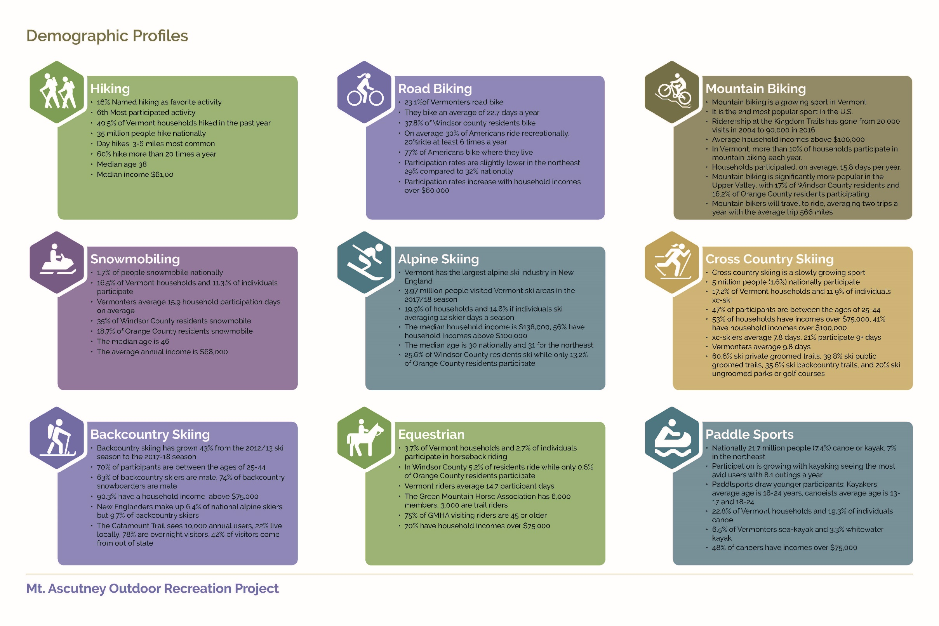

Mountain Biking
Mountain biking, as a sport, has grown tremendously in recent years in Vermont and across the country. Kingdom Trails, a major Vermont mountain biking destination in the Northeast Kingdom, has gone from less than 20,000 visits in 2004 to over 90,000 in 2016 (Kingdom Trails 2017). Membership in Vermont Mountain Bike Association is growing rapidly as well, with an increase of 25% in 2017. The association has also grown their out-of-state membership. In 2017 out-of-state riders represented 21% of all members, compared to 18% the year prior. Of all outdoor recreation activities, mountain biking is the second most popular sport by frequency of participation (Outdoor Foundation 2018).
In Vermont, as of the 2011 survey, 10.7% of households and 7.9% of individuals participated in mountain biking. Households participated, on average, 15.8 days per year. Mountain biking is significantly more popular in the Upper Valley, with 17% of Windsor County residents and 16.2% of Orange County residents participating (Vermont Department of Forests, Parks and Recreation 2014).
Singletracks.com looked at the demographics of mountain bikers using the readership of its website. The analysis found that its readership was predominantly white, male, between the ages of 24 and 44, and wealthier, with household incomes above $100,000 overrepresented.
Mountain bikers frequently travel to ride. A survey by singletracks.com found that on average, mountain bikers take two mountain bike vacations each year, and also bring their bikes on two other trips each year where riding is not the primary purpose. Mountain bikers are willing to travel significant distances—the average among survey respondents was 566 miles. Northeast rider’s top destination is Kingdom Trails, but many travel all over the country to ride (Barber 2015).

River-Based Recreation
New England is a relative hotbed for canoeing and kayaking in the United States. The region has the highest participation rate in both canoeing and kayaking (7%). Nationally, 21.7 million people (7.4% of the population) participated in paddlesports in 2014. Paddlesports includes canoeing, kayaking, rafting, and stand up paddling. Participation in paddlesports is growing slightly, with most of the growth in kayaking. Kayakers are also the most avid paddlers, averaging 8.1 outings per year. Kayakers are young, with the highest rate of participation amongst those 18 to 24. Kayakers tend to have higher incomes, with 55% of participants having household incomes of $75,000 or above (Outdoor Foundation 2015).
Canoeing also skews younger, with the highest rate of participation amongst those 13 to 17 and 18 to 24. Of the population over 45, only 2% participate in canoeing. Of canoers, 48% have household incomes of $75,000 or above (Outdoor Foundation 2015).
New Englanders participate in rafting and stand up paddling at very low rates.
The survey of Vermont outdoor recreation participation found that Vermonters participate in canoeing especially at high rates. According to the survey, 22.8% of households and 19.3% of individuals participated in canoeing. For kayaking, 6.5% of individuals participated in sea-kayaking, while 3.3% participated in whitewater. By labeling the sport sea-kayaking, the percent of kayakers is likely underestimated. Frequency of participation was relatively low, with canoeing at 5.1 days, kayaking at 7.4, and whitewater at 7.0. Windsor and Orange County residents participate in kayaking and canoeing at a slightly higher rate than the statewide average (Vermont Department of Forests, Parks and Recreation 2014).
TransCanada Hydro Northeast collected information on river recreation use along the Connecticut River. They counted users at 48 sites on both the New Hampshire and Vermont sides of the Connecticut River. On the set of boat launches, parks, and other access points that include the Weathersfield-Windsor-West Windsor area, the study counted 546,931 users from April 2014 to April 2015. Based on a subsequent survey, the following table details participation in the following activities.
Activity Participation on the Connecticut River
 | Fishing  from shore | Fishing  from a boat | Canoeing/Kayaking on Flatwater | Swimming/  Sunbathing
Percentage of River Site Visitors | 28% | 16% | 21% | 13%
Estimated Total Participants | 150,800 | 86,730 | 117,200 | 68,760
Note: many visitors participated in multiple activities
The study also recorded the license plate states of visitors to these sites—42% had license plates from New Hampshire, 39% from Vermont, 9% from Massachusetts, and 10% from other states. Most of the New Hampshire and Vermont visitors were from the communities close to the river (Transcanada Hydro Northeast 2016).

Snowmobiling
Nationally, participation in snowmobiling is extremely low (1.7%) (Outdoor Foundation 2018). However, given the favorable climate and immense Vermont Association of Snow Travelers (VAST) trail network, snowmobiling is significantly more popular in Vermont. Across the state, 16.5% of households and 11.3% of Vermonters reported they participate in snowmobiling. As of 2010, the Vermont Department of Motor Vehicles had 31,194 snowmobile registrations, suggesting that many households have multiple users and many residents do not register their snow machines. Snowmobilers are enthusiastic participants, with 15.9 household participant days on average. Windsor County residents are particularly enthusiastic snowmobiling participants, with over 35% of households participating. In Orange County, participation was 18.7%, just slightly above the state average (Vermont Department of Forests, Parks and Recreation 2014).
However, VAST membership has declined significantly in recent years. In 2000 VAST had over 40,000 members. That fell to 32,000 by 2010 and currently, VAST has approximately 24,000 members according to their website.
The median age of snowmobilers is 46, but lately, the sport has attracted younger, more affluent participants (New Hampshire Snowmobile Association 2017). Snowmobiling organizations are currently working to attract that demographic, for the future sustainability of the sport. The annual household income of snowmobilers is $68,000 (International Snowmobile Manufacturers Association 2014).

Skiing
Skiing in the Upper Valley can take a variety of forms—alpine, cross country, or backcountry. The alpine ski areas in the region include Ascutney Outdoors, Dartmouth Skiway, Whaleback Mountain, and Quechee Ski Area at The Quechee Club. On the edges of the upper valley, there are larger ski areas such as Okemo Mountain Resort, Loon Mountain Resort, Mount Sunapee, Cannon Mountain, and Waterville Valley Resort. Cross country skiing is available on groomed trails at Mile Long Field, the Dartmouth Cross Country Center, French’s Ledges, Hartland Winter Trails, and Lake Morey Resort. Popular spots for backcountry skiing are Mt. Ascutney and Mt. Cardigan. Including all types of skiing, 7.3% of Vermonters named the sport their favorite activity. User profiles for each type of skiing are presented in the following discussion.

Alpine Skiing
Vermont has the largest alpine ski industry in New England. The ski areas draw many visitors from Vermont, as well as from outside the area. For the 2017/18 season, Vermont ski areas saw 3.97 million visits, primarily from New England and the Mid-Atlantic. Based on Vermonters participation rates, we can assume that state residents were about a quarter of total skier days in Vermont. That portion would vary based on the resort, with a higher percentage of out of state skiers at destination resorts such as Stowe Mountain Resort or Killington Resort. In the 2011 Outdoor Recreation survey, 19.9% of households or 14.8% of individuals reported skiing and households average 12 skier days per season (Vermont Department of Forests, Parks and Recreation 2014). Overall, Vermonters ski the second most of any state, averaging 5.82 more days per capita than the national average. Many people skiing in Vermont likely do not ski that many days per year—the national average is 7.9 days per year. New Englanders spend 88.4% of their skier days at Northeast resorts (National Ski Areas Association 2018). Most of those spent outside the northeast are likely taken by those living in the Boston or New York metropolitan areas, for whom northeast skiing does not have the convenience factor it has for Vermont residents.
Visitors to northeast ski areas tend to be very wealthy, with a median household income of $138,000 and overall, 56% of participants have household incomes above $100,000. While the highest percentage of skiing participants are 17 and under, the median age has been trending older, as baby boomers make up the core of the skiing population. Skiing participation has declined for visitors ages 13 to 24, held steady for 12 and under and for ages 24 to 54, and grown for 55 to 64 and 65+. Currently, the national median age of skiing participants is 30 and 31 for northeast participants. At smaller ski areas, the median age tends to be significantly younger. At ski areas with 4,500 VTF/H or smaller, family-friendly and learning slopes, the median age is 17 (National Ski Areas Association 2018).
Windsor County residents are strong participants in alpine skiing, with 25.6% participation. In Orange County, only 13.2% participate, slightly below the state average (Vermont Department of Forests, Parks and Recreation 2014).

Cross Country Skiing
Cross country skiing is slowly growing in popularity nationally, with about 5 million participants, or 1.6% of the population, during the 2017/18 season. New England does see a slightly higher rate of participation, about 2.3% of the population (Snowsports Industries America 2018). It trends younger than alpine skiing, with 47% of participants between the ages of 25 and 44. While cross country skiing is typically more affordable than alpine skiing, 53% of participating households have incomes above $75,000 and 41% have household incomes above $100,000 (Snowsports Industries America 2017). The average number of days participated is 7.8, with 21% of skiers as “core skiers,” participating 9 or more times. In comparison, 27% of alpine skiers participate 10 or more days. Youth participation has increased dramatically in recent years, with the New England Nordic Ski Association seeing a dramatic increase in youth race participation and membership, with 1,800 youth members.
In terms of types of trails, 60.6% of participants utilized private groomed trails, 39.8% skied on public groomed trails, 35.6% skied on backcountry, ungroomed trails, and about 20% skied on ungroomed parks and golf courses (Snowsports Industries America 2018).
In Vermont, 17.2% of households and 11.9% of individuals reported participating in cross country skiing. Vermonters reported participating 9.8 days on average (Vermont Department of Forests, Parks and Recreation 2014).

Backcountry Skiing
Backcountry skiing has grown in popularity in recent years due to technological advances in gear, the rising cost of resort skiing, more learning opportunities, strong interest in fitness, uncrowded and remote experiences, and untracked powder. Sales of backcountry ski gear grew by 50% between the 2008/09 and 2013/14 season, with the strongest growth in women’s gear. The 2017/18 Snowsports Industries America Snow Sports Industry Insights Study stated that 900,000 skiers and 1.1 million snowboarders reported skiing or snowboarding in non-resort backcountry terrain. Comparatively, during the 2012/13 season, less than 600,000 skiers and about 800,000 snowboarders reported skiing in non-resort backcountry ungroomed terrain, an increase of 43% across skiing and snowboarding.
Like other outdoor recreation participants, backcountry skiers tend to be wealthier. For those who participated in backcountry skiing only once, 90.3% had incomes above $75,000. That declined somewhat with frequency, of those who participated 5+ times over the season, 61.7% had incomes above $75,000. Participants tend to be younger as well, with about 70% of participants between 25 and 44. Of note, participants tend to be disproportionately male - 64% of backcountry skiers and 74% of snowboarders are male (Snowsports Industries America 2018).
Vermont did not collect information on backcountry skiing in their 2011 survey. New Englanders do participate in backcountry skiing at a higher rate. While New Englanders are 6.4% of national alpine skiers, they are 9.7% of backcountry skiers. The Catamount Trail, a popular backcountry skiing trail in Vermont, estimates it sees 10,000 annual users. Of those users, 22% live in the surrounding area but 78% are overnight visitors. Further, the survey found that 42% of Catamount trail users were from out of state and 88% of those came to Vermont for the trail (Vermont Trails and Greenway Council 2016).

Equestrian
Horseback riding, while relatively low in participation statewide, is vibrant in the Upper Valley. The Green Mountain Horse Association (GMHA) in South Woodstock is a center for horseback riding. The Center has almost 6,000 members, with about 3,000 identifying as trail riders. The smaller, local clubs (Hartland Riding Club, North Country Hounds, and Vermont Equine Riding and Driving Association) also host rides in the area. GMHA estimates that there were over 1,000 riders on West Windsor trails during the 2018 season.
Statewide, equestrian participation is 3.7% of households and 2.7% of individuals. However, in Windsor County, 5.2% of residents participate, compared to Orange, where only 0.6% of residents participate. The state residents who do participate are enthusiastic, with an average of 14.7 participant days (Vermont Department of Forests, Parks and Recreation 2014).
GMHA conducted a survey of its visitors to understand the local economic impact. Of visitors, 75% of respondents were 45 or older. By income, over 70% of survey respondents reported household incomes of at least $75,000. The survey respondents were almost exclusively from the Northeast, with about 30% from Massachusetts and ~25% from Vermont (GHMA 2011). In effect, Vermonters represented only a quarter of GMHA visitors, with significant visitation from out of state.

https://lebanonchamber.com/area-jobs/
https://vmba.org/about/
www.vtvast.org
https://www.nensa.net/

