Mt. Ascutney outdoor Recreation
Baseline Economic Impact of Recreation
June 2019
prepared for:
Southern Windsor County Regional Planning Commission
Prepared by:
SE Group
This report is part of a larger recreation plan being compiled by the Southern Windsor County Regional Planning Commission. It summarizes the baseline economic impact of current recreational activity in the Mt. Ascutney region. The primary goal of this document is to communicate the current economic impact of recreation in the region, but important secondary goals also include documenting participation levels of various recreational activities and defining important user and spending profiles relative to the various recreational activities being considered in the broader plan.
Sources of information for this report include information and data from the Vermont Statewide Comprehensive Outdoor Recreation Plan, the U.S. Census Bureau, Headwaters Economics, Vermont Department of Tourism and Marketing, Institute for New Hampshire Studies, Snowsports Industries of America, Outdoor Industry Association, the VT and Greenways Council, Mount Ascutney State Park visitation reporting, trail usage data from Sports Trails of Ascutney Basin/Upper Valley Land Trust, the Dartmouth College, Vermont Horse Council Economic Impact Studies, and secondary research on participation in the region.

Introduction
Parks, open space, trails and recreational opportunities are important community amenities that help to spur economic development. From homeowners choosing to live along a trail to tourists who choose their destinations based on the availability of recreation, the Mt. Ascutney region’s parks, forests, rivers, and trails are important community assets that attract both people and dollars. The economic effects of these facilities are sometimes readily apparent (as in the case of trailside businesses) and are sometimes more subtle, like when a company decides to move to a particular community because of recreational amenities, but mounting new evidence shows an almost universal positive connection between the availability of parks, trails, and recreation facilities and important economic development indicators.
In Vermont, outdoor and forest-based recreation and the associated tourism are major drivers of the economy. Outdoor and forest-based recreation brings people into our communities. In the Mad River Valley, 78% of visitors have reported that trails and access to the outdoors was important in their decision to visit (MRV Moves 2017). Trail users, both residents and visitors, will visit local restaurants and shops, bringing in tax revenue and creating jobs as well. Across the state, just four trail systems—the Catamount Trail, the Long Trail, the Vermont Association of Snow Travelers (VAST) system, and Kingdom Trails—have been found to generate over $30.8 million annual economic activity, over $2 million in annual tax revenues, and have supported over 365 jobs annually (VT Trails and Greenways 2017).
Many people when moving to Vermont will choose a location based on its natural features and recreational opportunities. Nationwide, the National Association of Realtors found that 80% of Americans consider having trails and places to take a walk one of their top priorities when deciding where they would like to live. This ranked higher than even “high quality public schools” in their Community Preference Survey, which was selected by 74% of survey respondents (National Realtors Association 2015). This sentiment is also echoed in surveys of second-home owners and resort properties. For example, every annual Kelsey & Norden Resort Real Estate Survey since 2009 has identified trails as the #1 amenity sought by resort real estate owners and purchasers (Kelsey & Norden Resort Real Estate Survey 2014).
Access to the outdoors is increasingly being seen as a cornerstone of quality of life, particularly in rural communities, and having this access allows communities to attract and retain their workforce, which in turn helps attract and retain businesses. Therefore, outdoor recreation is increasingly being seen as a key factor for strengthening the economic vitality of Vermont towns.

Why outdoor recreation?
Because:
- Recreation improves quality of life
- Recreation contributes to tourism and economic development
- Recreation increases tax revenues
- Recreation increases property values
- Recreation attracts residents, businesses and a high-quality workforce

Why conduct an Economic Impact Analysis?
While economic impact analyses have been widely used in the fields of economic development and tourism, the tradition in parks and recreation planning has always been to provide financial reports for an agency or organization’s projects and operations. The difference between these two reporting methods is significant, and illustrates a fundamental divide between the way recreation assets and tourism assets are being considered and developed in many communities around the country. Financial reports focus on capital and operational costs compared against the revenues generated by the facility, while economic impact analyses consider these same costs and benefits while also acknowledging the role these resources play in drawing additional visitors and tourism revenues into the broader community.
While the same holds true for most recreation facilities, trails are a perfect example of how financial reporting fails to capture the true benefits of a resource. Trail development and maintenance can be costly, and often trail user fees are minimal or non-existent. As a result, financial reports often show trails as relatively high-cost centers in communities’ annual budgets because operational costs generally exceed revenues. However, trails and opportunities to walk and bike are absolutely critical attractors for tourists and can be a powerful tool for economic development, especially in rural and mountain communities like Windsor County. While the town or managing organization often receives little or no direct revenue from trail users, the local economy benefits immensely from bringing these new visitors, residents, and businesses into the community. Trail users may not always pay to be on the trail, but they typically buy goods, gas, food, and lodging. It is this visitor spending that is tracked in an economic impact analysis.
The financial and economic implications of trail and outdoor recreation development must be well understood in order to properly leverage these assets for the greatest community benefit. To better understand the role trails and outdoor recreation resources play in the economic fabric of the Mt. Ascutney region, an economic impact analysis has been conducted on current levels of recreation activity to establish a baseline economic impact. This baseline can then be used to project the potential economic impact of recreational development being considered throughout the region to provide valuable insight into implementation and phasing strategies. The analysis can also greatly increase the competitiveness of projects for grants and other funding opportunities by demonstrating the immense return on investment these projects provide.

Baseline Economic Impact Summary
Recreation is a key component of the culture and economy of the Mt. Ascutney region, and has been for many years. In the late 19th and early 20th centuries, Mt. Ascutney inspired a thriving community of artists in Cornish and Plainfield, New Hampshire as well as Windsor to build their homes in places with views of the mountain. Many of the houses from these early mountain-lovers remain on the landscape at the base of Ascutney. In fact, the estate of the artist Augustus Saint-Gaudens is now a National Historic Park, with, of course, a lovely view.
In the 1930s, Mt. Ascutney began to draw even more people to the region. Mount Ascutney State Park was one of the first Vermont State Parks, built by the Civilian Conservation Corps between 1935 and 1938. In1938 the Mt. Ascutney Ski Club also cut the first trail—Screaming Eagle—which marked the start of what would become Ascutney Mountain Resort. In 1946 tourism-oriented real estate was developed on the mountain and over the next few decades, groomers, snowmaking, rope tows, and eventually lifts were installed. The ski trail system continued to evolve, as did other recreation offerings in the region. Commensurate with the ski area growth, tourism-oriented businesses and real estate also proliferated throughout the region, particularly in West Windsor.
Today, recreation related businesses constitute approximately 23% of the employment in Windsor County. While available data is somewhat limited—and certainly not exhaustive—the economic impact analyses presented here are intended to dig in a bit deeper on the economic contribution of recreation to the Mt. Ascutney region by demonstrating the economic impact of various user groups. As described below under “Visitation and User Counts,” the economic impact projections presented here are based on visitation to limited portions of the total recreation system—in some cases single trails, boat launches or sites—and are not intended to describe the total impact of all recreation in the region.
It is also important to note that the economic impact analyses of the various forms of recreation are not necessarily “apples to apples” either. For example, as a fee-based offering with staff at the welcome station for the primary operating season there is detailed and fairly comprehensive data for visitation to the state park. Conversely, as a generally free and more dispersed use there is limited data on the number of mountain biking trips being made in the region. For this reason, the economic impact of the various uses should not be compared against one another.

Economic Impact Analysis Summary By Use

Hiking
- 23,400 annual trips on the hiking trails at Mount Ascutney State Park
- $2.3 million in total sales activity
- 34 full-time-equivalent job positions supported
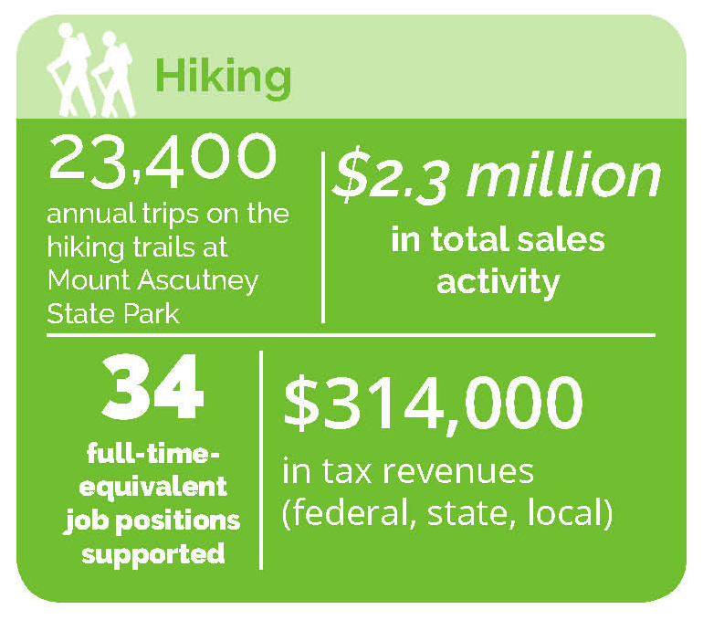
- $314,000 in tax revenues (federal, state, and local)

Mountain Biking
- 297 annual trips on the Swoops and Loops mountain biking trail
- $29,000 in total sales activity
- 0.44 full-time-equivalent job positions supported
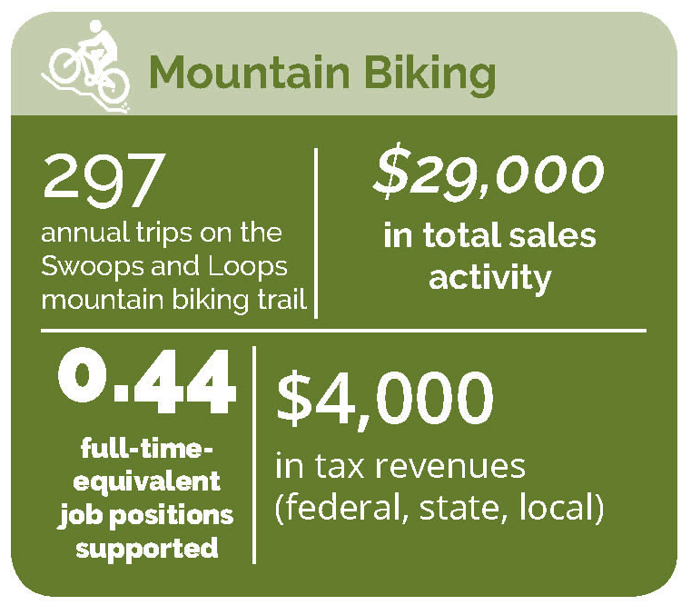
- $4,000 in tax revenues (federal, state, and local)

Water-Based Recreation
- 4,032 annual recreationalists utilizing the Cornish Boat Landing near Windsor
- $214,000 in total sales activity
- 3 full-time-equivalent job positions supported
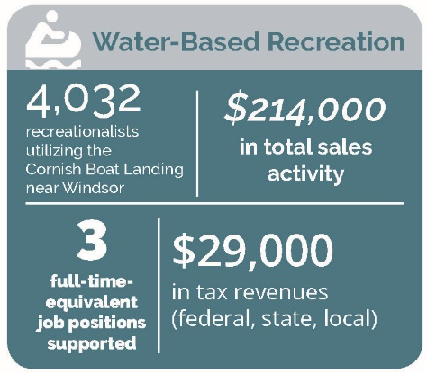
- $29,000 in tax revenues (federal, state, and local)

Snowmobiling
- 2,100 annual snowmobile trips
- $49,000 in total sales activity
- 1 full-time-equivalent job positions supported
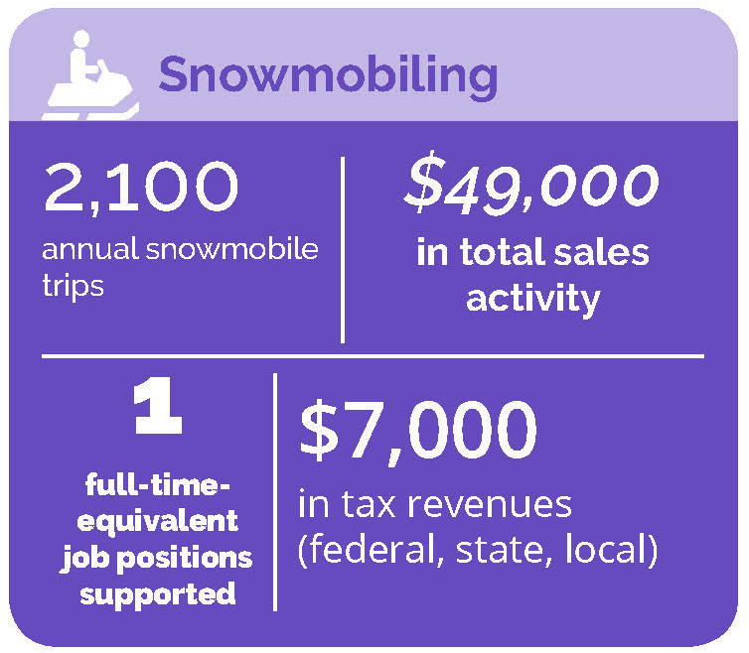
- $7,000 in tax revenues (federal, state, and local)

Skiing and Tubing
- 3,191 annual users skiing and tubing at Ascutney Outdoors
- $169,000 in total sales activity
- 3 full-time-equivalent job positions supported
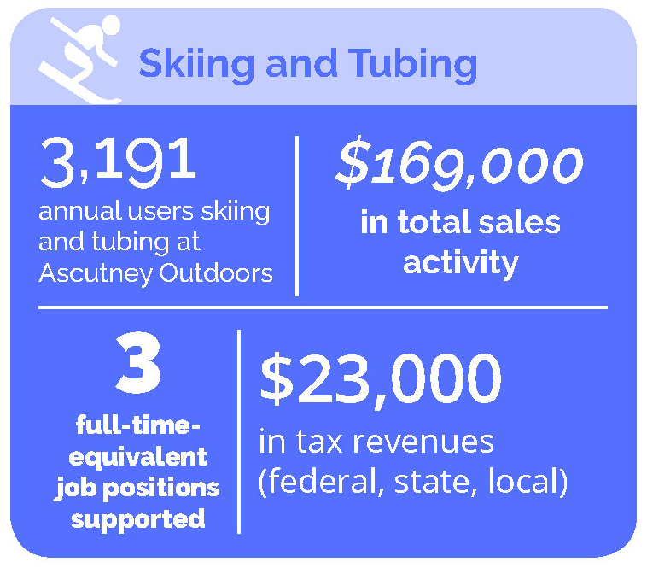
- $23,000 in tax revenues (federal, state, and local)

Equestrians
- Over 1,000 equestrians participating in organized rides every year in the region
- $53,000 in total sales activity
- 1 full-time-equivalent job positions supported
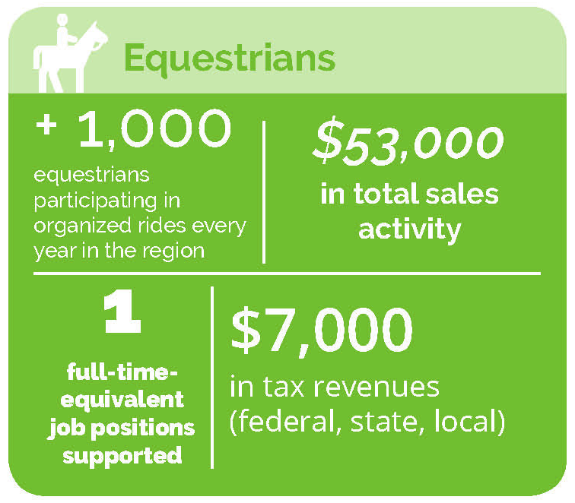
- $7,000 in tax revenues (federal, state, and local)

State Park Visitors
- 14,047 annual visitors to Mount Ascutney State Park
- $1.4 million in total sales activity
- 21 full-time-equivalent job positions supported
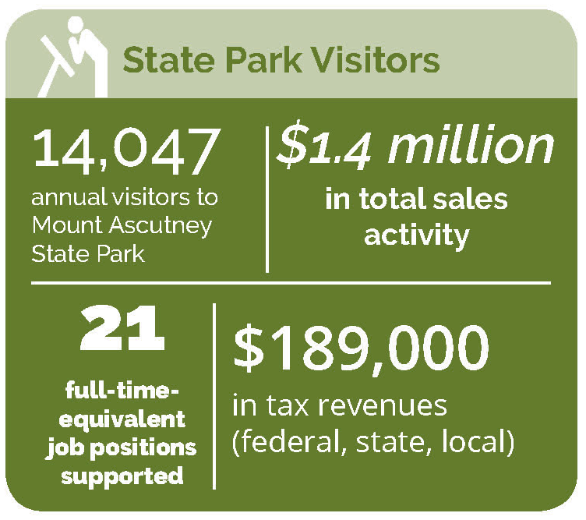
- $189,000 in tax revenues (federal, state, and local)

Event Participants
- 5,700 annual participants in the Ragnar Trail Vermont, Point to Point, Ascutney Mountain Run, Vermont 50, Harpoon Octoberfest Road Race, Vermont 100, Vermont Overland, and Vermont Overland Maple Adventure Ride events
- $555,000 in total sales activity
- 8 full-time-equivalent job positions supported
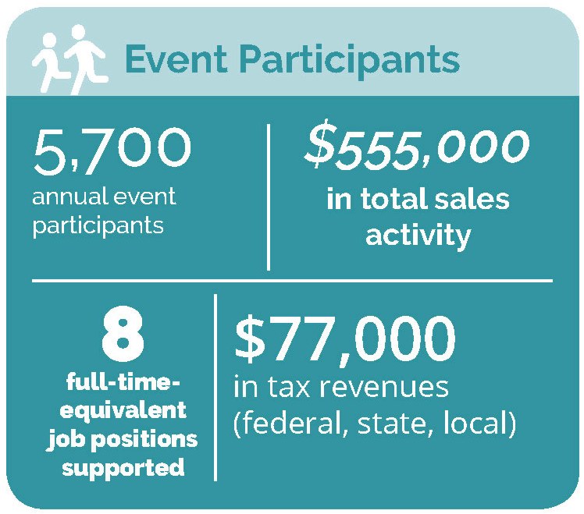
- $77,000 in tax revenues (federal, state, and local)

Methodology
The economic impacts of recreational use have been projected using a computer-based model—the Money Generation Model (MGM2). The MGM2 model was developed by the National Park Service and is used to model the economic impact of national parks and other recreational assets across the country. The model demonstrates the immense value of parks, trails, and recreational assets as an economic engine by estimating the economic impact of spending associated with visitation to the area in terms of changes in jobs, tax impacts, and total sales (gross regional product).
MGM2 economic modeling requires the estimation of visitation and visitor spending in order to simulate the effect of these activities on the economy. While MGM2 modeling utilizes observed industry interdependencies calibrated to the local and regional economy, the results of any economic model are only as accurate as the data used to describe the modeled activity (i.e., park visitation and trail use). Therefore, our economic impact analysis required three primary data inputs to model economic impacts: 1) user counts/visitation; 2) visitor profiles (local, non-local day, non-local overnight); and 3) visitor spending profiles.
With reasonable estimates of visitation, visitation by user type, and spending profiles for each user type, the MGM2 model can be completed and run. The model utilizes input-output modeling and industry relationship data from the U.S. Census to estimate total economic impacts. Purchases for final use (i.e., visitor spending) drive the model. Industries that produce goods and services for visitor consumption must purchase products, raw materials, and services from other companies to create their product. These vendors must also procure goods and services. This cycle continues until all the money is leaked from the region’s economy. There are three types of effects measured within an MGM2 Model: the direct, the indirect, and the induced effects. The direct effect is the known or predicted change in the local economy that is to be studied (i.e., the visitor spending). The indirect effect is the business-to-business transactions required to satisfy the direct effect. Finally, the induced effect is derived from local spending on goods and services by people working to satisfy the direct and indirect effects. Total impacts reflect the total changes to the economy as the result of visitor spending (i.e., Direct effects + Indirect effects + Induced effects = Total Impacts).

Vistation and User Counts
Annual visitation estimates are provided below for hiking, mountain biking, water-based recreation, snowmobiling, skiing and tubing, equestrians, state park visitors, and event attendees in the Mt. Ascutney region. While all available visitation and user count information has been incorporated, none of the visitation estimates should be considered exhaustive of all trails, facilities, and venues in the region. Take, for example, the estimate of annual hiking visitation presented here. While there are many hiking trails throughout the region on both public and private lands, trail counts are only available for the following trails: the Brownsville Trail, the Summit Trail, the Weathersfield Trail, and the Windsor Trail. These trails represent only a small portion of all the hiking trails in the region. Similarly for mountain biking, trail count data is only available for the Swoops and Loops Trail, but there are many more mountain biking trails in the region. For this reason, the annual estimates provided here should be considered highly conservative estimates that tend to UNDERESTIMATE annual visitation and the related economic impacts. These should be considered “at least” or “not less than” estimates.

Hiking
Infrared trail count data is available for the dates listed for the following hiking trails at Mount Ascutney State Park:
- Brownsville Trail (2015 to 2016)
- Summit Trail (8/03/2011 to 9/18/2011)
- Weathersfield Trail (2011 to 2017)
- Windsor Trail (2017)
Where less than a years’ worth of trail count data is available, the data has been extrapolated for an annual estimate using the National Bicycle and Pedestrian Documentation Project methodology (http://bikepeddocumentation.org/). Where more than a years’ worth of data is available, annual counts were averaged to develop an estimate of a typical year’s worth of trail use across all the trails for which there is data. Below are the annual trail traffic volume estimates for each trail.
Annual Trail Traffic Volume Estimates
Trail | Annual Trail Traffic  Volume Estimate
Brownsville Trail | 2,350
Summit Trail | 10,500
Weathersfield Trail | 6,200
Windsor Trail | 4,350
Total | 23,400
Based on the above, there are approximately 23,400 trips made on these hiking trails annually. Again, this represents only a small portion of the total hiking trail system in the region and should be considered an “at least” value for regional hiking activity.

Mountain Biking
Mountain biking trail count data is available for the Swoops and Loops Trail. A magnetic trail counter was placed on the trail from approximately May through October in 2015, 2016, 2017 and 2018.
Swoops and Loops Trail Magnetic Counter Data
Year | Annual Trail Traffic Volume Estimate
2015 | 220
2016 | 366
2017 | 181
2018 | 421
Annual Average | 297
Based on the above data, there are approximately 300 mountain biking trips made on the Swoops and Loops Trail annually. Again, this represents only a VERY small portion of the total mountain biking trail system in the region and should be considered an “at least” value for regional mountain biking activity.

Water-Based Recreation
The Connecticut River represents the largest water-based recreation resource in the region. As part of their permitting process, TransCanada Hydro Northeast is required to collect information on river recreation use along the Connecticut River. Users were counted at 48 sites on both the New Hampshire and Vermont sides of the Connecticut River in 2014 and 2015. While use is documented throughout the region, the closest site to the three-town study area is the Cornish Boat Landing in Cornish, NH—directly across the river from Windsor, VT. Between March 1, 2014 and February 28, 2015, 4,032 recreational users were counted at the site.

Snowmobiling
No trail count data is currently available for snowmobiling in the Mt. Ascutney region. However, the Weathersfield Pathfinders has about 150 members per year and based on the Mt. Ascutney Outdoor Recreation Survey data local snowmobilers take about 14 trips per year on average, which translates to an estimated 2,100 total snowmobile trips made each year by local snowmobiling residents.

Skiing and Tubing
Ascutney Outdoors operates a Rope Tow, a Tubing Lift, and backcountry skiing terrain. Based on partial season log in data, it appears at least 850 backcountry skiers and splitboarders utilize the venue each season. Ascutney Outdoors recorded 1,281 users on the tubing lift and 1,060 users on the rope tow for the 2018/19 season. In total, approximately 3,191 users skiing and tubing users were estimated at Ascutney Outdoors in the 2018/19 season.
2018/19 User Types and Visitation Numbers at Ascutney Outdoors
User Type | 2018/19 Visitation
Backcountry Users | 850
Tubing Lift | 1,281
Rope Tow | 1,060
Total | 3,191

Equestrians
Looking at simply organized rides, there were at least 1,000 equestrian users on the trails in the Mt. Ascutney region last year. This includes 720 people who participated in the Green Mountain Horse Association organized trail rides, 110 who participated as riders in the Vermont 100, 35 who participated in the Ascutney Outdoors Grand Opening trail ride, 55 who participated through the Hartland Riding Club, 73 who participated through the Vermont Equine Riding and Driving Association, and 60 who participated through the North Country Hounds has 60 members. These organized rides alone combine to almost 1,000 riders, and this doesn’t account for local casual trail riding and visitors to local horse B&B’s.

State Park Visitors
Vermont Forests, Parks and Recreation has tracked the visitation to Mount Ascutney State Park for some time. Visitation data from 2010 through 2017 is demonstrated in the following table. On average, Mount Ascutney State Park received approximately 14,047 annual visitors each year, which includes in-state and out-of-state as well as overnight and day use visitors.
Mount Ascutney State Park Visitation Data, 2010–2017
Year | Overnight |  |  | Day Use |  |  | Grand Total
 | In State | Out of State | Overnight Total | In State | Out of State | Day Use Total
2010 | 1,731 | 3,350 | 5,081 | 2,625 | 5,031 | 7,656 | 12,737
2011 | 1,521 | 4,236 | 5,757 | 2,534 | 4,772 | 7,306 | 13,063
2012 | 1,796 | 3,815 | 5,611 | 3,135 | 5,094 | 8,229 | 13,840
2013 | 1,712 | 4,280 | 5,992 | 3,435 | 5,626 | 9,061 | 15,053
2014 | 1,463 | 3,926 | 5,389 | 6,879 | 2,115 | 8,994 | 14,383
2015 | 1,494 | 3,995 | 5,489 | 5,449 | 3,235 | 8,684 | 14,173
2016 | 1,355 | 3,776 | 5,131 | 5,804 | 3,195 | 8,999 | 14,130
2017 | 1,188 | 4,327 | 5,515 | 5,547 | 3,937 | 9,484 | 14,999
Annual Average | 1,533 | 3,963 | 5,496 | 4,426 | 4,126 | 8,552 | 14,047

Event Participants
The Weathersfield-Windsor-West Windsor area plays host to a few outdoor recreation events that draw visitors from across New England. The area hosts a couple of New England’s preeminent trail running and mountain biking races, the Vermont 100, and the Vermont 50. The major events, with number of participants, are listed in the following table.
Major Events
Event | Town | Sport | Participants
Ragnar Trail Vermont | West Windsor | Trail Running Relay | 1,948 (2018)
Point to Point | West Windsor | Biking/Running Fundraiser | 680 (2017)
Ascutney Mountain Run | Windsor | Trail Running | 173 (2018)
Vermont 50 | West Windsor | Mountain Biking/Trail Running | 1,077 (2018)
Harpoon Octoberfest Road Race | Windsor | Running | 671 (2018)
Vermont 100 | West Windsor | Trail Running/Equestrian | 558 (2018)
Vermont Overland | Reading | Biking | 562 (2016)
Vermont Overland Maple Adventure Ride | West Windsor | Biking | 340 (2018)
The Vermont 50 is one of the largest events in the area. With families and friends coming to support racers, the event brings about 1,500 people to the area each year. Of the race participants in 2016, only 23.8%, or 242 were from Vermont and only 10 were from Weathersfield, Windsor, or West Windsor.

User Types
An assumption of recreational use by Local Day Users, Non-Local Day Users, and Overnight Users is a critical datapoint for an economic impact analysis because, on average, these user types spend significantly different amounts in connection with their trail visits (see “Spending Profiles” discussion).
For the purpose of evaluating the economic impact of recreation use in the region, it is important to understand the proportion of trail users who live outside the region and came to the region to recreate (Non-Local Day Users and Overnight Users). Spending by these users is considered “net new” to the region because, if not for the recreation offerings, this spending would not have occurred. Conversely, it was assumed that Local Day Users from within the region would still have spent a similar amount in the region even without the availability of the recreation offerings. In other words, the recreation dollars spent by these Local Day Users in the region could reasonably be assumed to be spent in the region—they would still buy food, drinks, gas, etc. locally. For this reason, ONLY Non-Local Day User and Overnight User visitation and spending information is analyzed in the economic impacts disclosed this report.
The best datapoint available for this locally is Mount Ascutney State Park visitation data because Vermont Forest, Parks, and Recreation has consistently tracked daily visitation by In-State Day Users, Out of State Day Users, and Overnight Users for some time. The average breakdown of these user groups at Mount Ascutney State Park between 2010 and 2017 is approximately 31% In-State Day Users, 37% Out of State Day Users, and 39% Overnight Users. These average values are indicative a more “destination oriented” recreational facility, and as a statewide resource this makes sense for Mount Ascutney State Park. These values were used for analyzing trails and visitation occurring within the park: Hiking Trails, Mountain Biking, and State Park Visitation. These values were also applied to the analysis of Event Participants, as they tend to be more destination-oriented activities.
User Types at Mount Ascutney State Park, 2010–2017
Year | # In State  Day Users | % In State  Day Users | # Out of State  Day Users | % Out of State  Day Users | # Overnight Users | % Overnight Users | # Total Users
2017 | 5,547 | 37% | 3,937 | 26% | 5,515 | 37% | 14,999
2016 | 5,804 | 41% | 3,195 | 23% | 5,131 | 36% | 14,130
2015 | 5,449 | 38% | 3,235 | 23% | 5,489 | 39% | 14,173
2014 | 6,879 | 48% | 2,115 | 15% | 5,389 | 37% | 14,383
2013 | 3,435 | 23% | 5,626 | 37% | 5,992 | 40% | 15,053
2012 | 3,135 | 23% | 5,094 | 37% | 5,611 | 41% | 13,840
2011 | 2,534 | 19% | 4,772 | 37% | 5,757 | 44% | 13,063
2010 | 2,625 | 21% | 5,031 | 39% | 5,081 | 40% | 12,737
Annual Average | 4,426 | 31% | 4,126 | 30% | 5,496 | 39% | 14,047
Another datapoint relative to moderately “destination oriented” recreational facilities are the breakdown of user types on the Green Mountain National Forest (GMNF), which was calculated by the U.S. Forest Service in 2013 and documented in the report “Estimation of National Forest Visitor Spending Averages From National Visitor Use Monitoring: Round 2” (USDA Forest Service 2013). They found approximately 66% of GMNF are Local Day Users, 11% are Non-Local Day Users, and 23% are Overnight Users. These values are a reasonable proxy for “moderately destination-oriented” facilities in the region including water-based recreation, skiing and tubing, and equestrians.
An assumption of 85% Local Day Users, 5% Non-Local Day Users and 10% Overnight Users was utilized for more “convenience facilities” such as local snowmobiling. These values are reflective of such facilities in Vermont and was utilized in the 2017 MRV Moves Active Transportation Plan (MRV Moves 2017).

Hiking
- 23,400 annual trips on the hiking trails at Mount Ascutney State Park
- Local Day Users; 31%; 7,254
- Non-Local Day Users; 30%; 7,020
- Overnight Users; 39%; 9,126

Mountain Biking
- 297 annual trips on the Swoops and Loops Trail
- Local Day Users; 39%; 116
- Non-Local Day Users; 30%; 89
- Overnight Users; 31% ; 92

Water-Based Recreation
- 4,032 annual recreationalists utilizing the Cornish Boat Landing near Windsor
- Local Day Users; 66%; 2,661
- Non-Local Day Users; 11%; 444
- Overnight Users; 23% ; 927

Snowmobiling
- 2,100 annual snowmobile trips made
- Local Day Users; 85%; 1,785
- Non-Local Day Users; 5%; 105
- Overnight Users; 10% ; 210

Skiing and Tubing
- 3,191 annual users skiing and tubing at Ascutney Outdoors
- Local Day Users; 66%; 2,106
- Non-Local Day Users; 11%; 351
- Overnight Users; 23% ; 734

Equestrians
- Over 1,000 equestrians participating in organized rides every year in the region
- Local Day Users; 66%; 660
- Non-Local Day Users; 11%; 110
- Overnight Users; 23% ; 230

State Park Visitors
- 14,047 annual visitors to Mount Ascutney State Park
- Local Day Users; 31%; 4,355
- Non-Local Day Users; 30%; 4,214
- Overnight Users; 39%; 5,478

Event Participants
- 5,700 annual participants in the Ragnar Trail Vermont, Point to Point, Ascutney Mountain Run, Vermont 50, Harpoon Octoberfest Road Race, Vermont 100, Vermont Overland, and Vermont Overland Maple Adventure Ride events
- Local Day Users; 31%; 1,767
- Non-Local Day Users; 30%; 1,710
- Overnight Users; 39%; 2,223

Spending Profiles
To generate recreational user spending profiles for the region, the Mt. Ascutney Outdoor Recreation Survey data was analyzed; the results were segmented based on the answers to the “How long will you be in the Mount Ascutney area in Vermont?” question. Segmented results were then averaged to create average recreational user spending profiles for Day Users and Overnight Users.
Blank responses for spending categories were imputed as zero dollar amounts when spending data was provided for other spending categories. Responses that left all spending categories blank were omitted from the averages. For example, if a respondent left “gifts/souvenirs and other shopping” blank but entered a specific dollar amount for “food and drinks (restaurant)” and “overnight lodging,” the blank response input to “gifts/souvenirs and other shopping” to be a $0 spending amount for that category for averaging purposes. When a respondent left ALL spending categories blank—including "food and drinks (restaurant),” “overnight lodging,” “gifts/souvenirs and other shopping,” and all the others—the response was omitted entirely. Significant outliers were omitted for averaging purposes. Overnight spending values were also divided by the average length of stay for multiple day visitors of 3.3 days to provide per day estimates.
While the sample size of the Mt. Ascutney Outdoor Recreation Survey is limited—73 respondents who answered the spending question—this data represents the best available spending information for recreational users in the region and provides a meaningful basis for this analysis. The Survey found Day Users spend approximately $70 per person per day and the Overnight Users spend approximately $189 per person per day. These findings are supported by statewide visitor spending estimates from the Agency for Commerce and Community Development’s (ACCD) Benchmark Study of the Economic Impact of Visitor Spending on the Vermont Economy (ACCD 2011). This study analyzed the average spending of all tourists in the State of Vermont and found day visitors spent $70.14 per person per trip and that overnight visitors spent $176.98 per person per trip.
The spending profile of these user groups from the Mt. Ascutney Outdoor Recreation Survey is presented in the following table.
Spending Profiles of Day Users and Overnight Users
Spending Category | Day User | Overnight User
Transportation (Including Gas) | $14 | $29
Food and Drinks (Restaurant) | $24 | $37
Food and Drinks (Grocery or Convenience Store) | $11 | $20
Overnight Lodging | $0 | $71
Gifts/Souvenirs and Other Shopping | $5 | $15
Recreation (e.g., Admission Fees, Rentals, Tours, etc.) | $16 | $17
Total | $70 | $189

Equipment Purchases
In addition to the spending detailed in the profiles above, survey respondents also reported spending on equipment, which is not included in this analysis. The survey focused on spending per trip and while some people did include spending related to major purchases such as new mountain bikes, new ATVs and new skis, it would not be appropriate to attribute those major purchases to each of the trips to the region. Reported equipment purchases ranged from $20 to $35,000, with many reporting spending well over $1,000 on equipment purchases in the region. While none of these purchases are included in the economic impact analyses discussed above, these more one-off purchases can have a significant impact on the local economy.

